Slide 1 - Slide 1
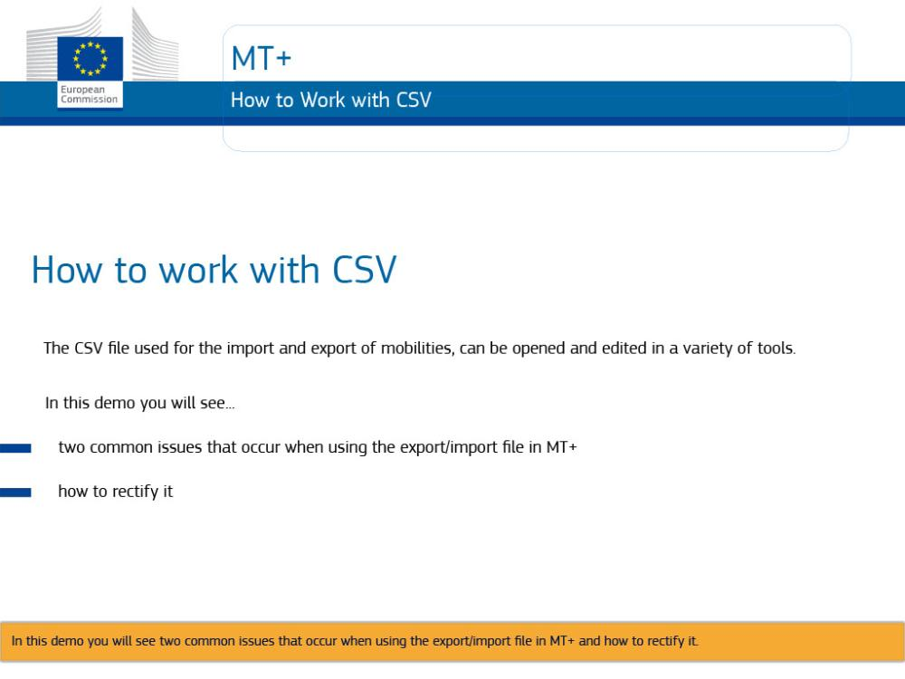
Text Captions

MT+

How to work with CSV

How to work with CSV. The CSV file used for the import and export of mobilities, can be opened and edited in a variety of tools.

In this demo you will see two common issues that occur when using the export/import file in MT+ and how to rectify it.

Slide 2 - Slide 2
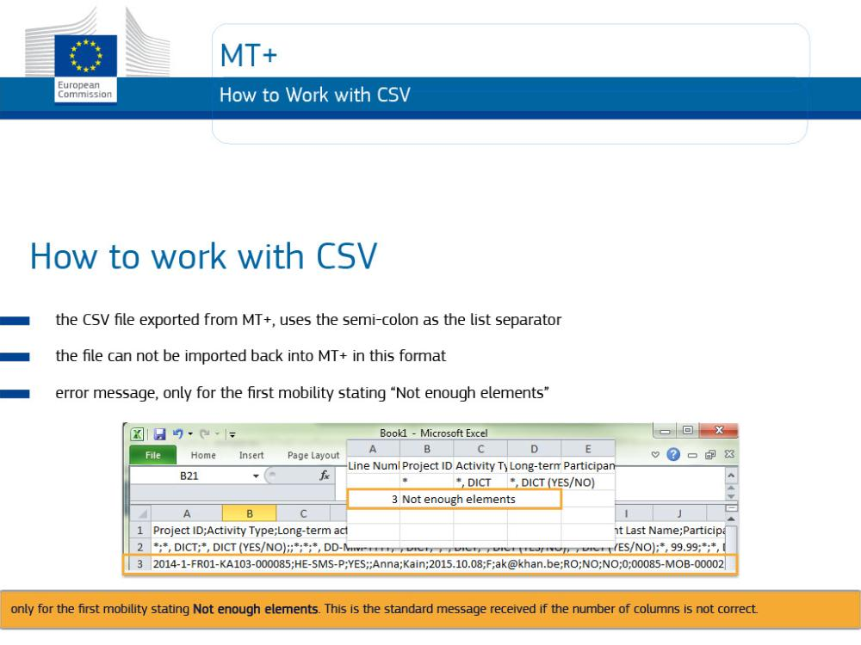
Text Captions

The CSV file exported from MT+, uses the semi-colon as the list separator. If the same value is not set in the regional settings of your PC, on opening this file, the contents of each row is entered in the first cell. This makes the content, difficult to read and update.

The file can not be imported back into MT+ in this format. If you attempt you will receive an error message, only for the first mobility stating Not enough elements. This is the standard message received if the number of columns is not correct.

Slide 3 - Slide 3
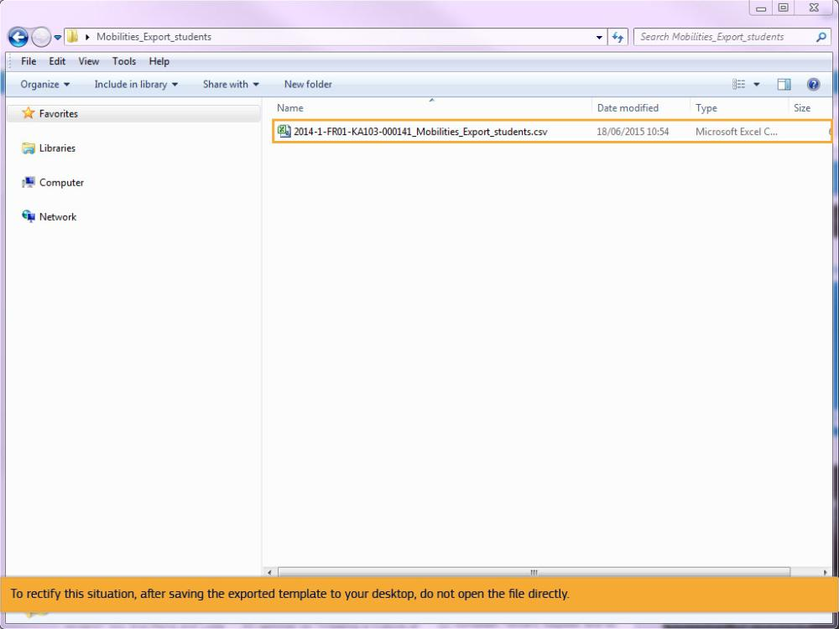
Text Captions

To rectify this situation, after saving the exported template to your desktop, do not open the file directly.

Slide 4 - Slide 4
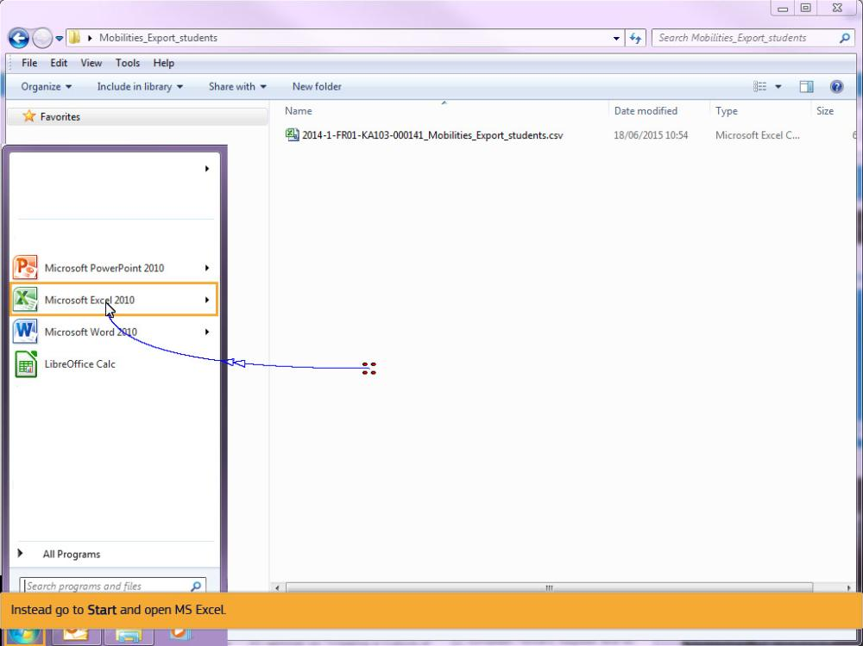
Text Captions

Instead go to Start and open MS Excel.

Slide 5 - Slide 5
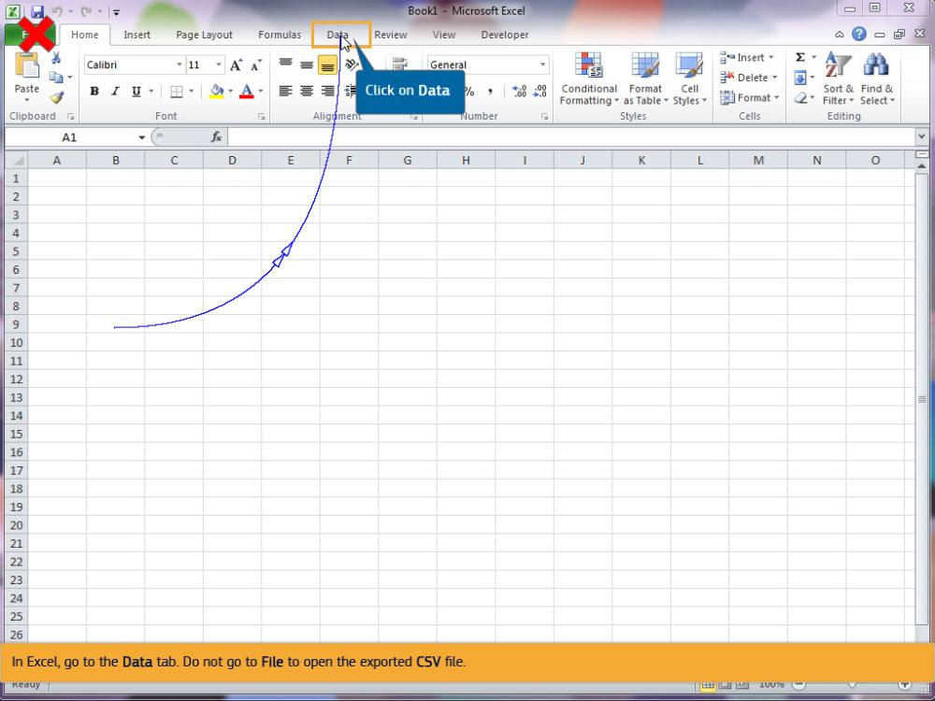
Text Captions

In Excel, go to the Data tab. Do not go to File to open the exported CSV file.

Click on Data

Slide 6 - Slide 6
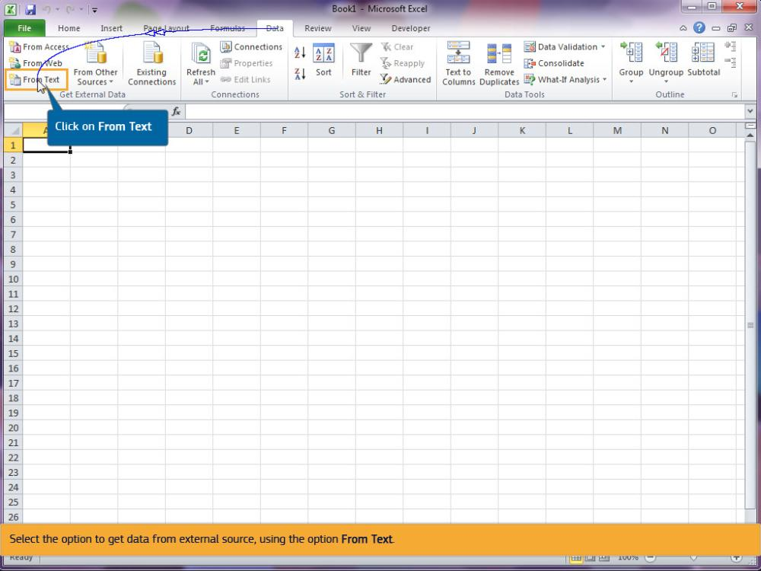
Text Captions

Select the option to get data from external source, using the option From Text.

Click on From Text

Slide 7 - Slide 7
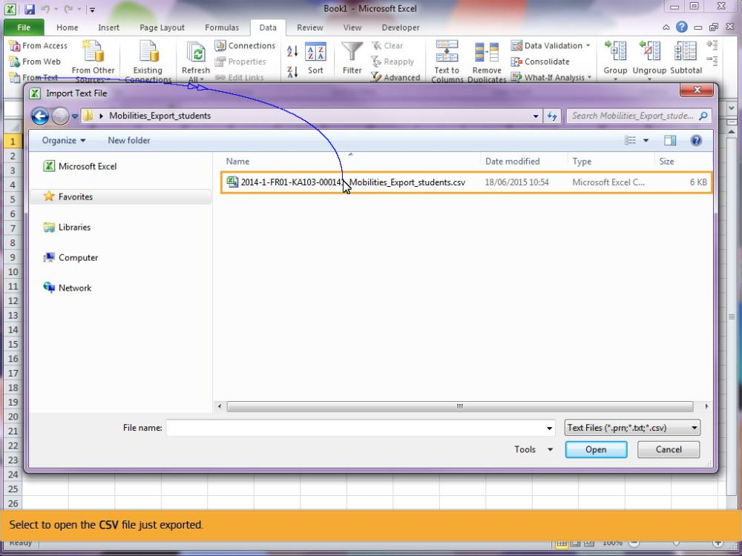
Text Captions

Select to open the CSV file just exported.

Slide 8 - Slide 8
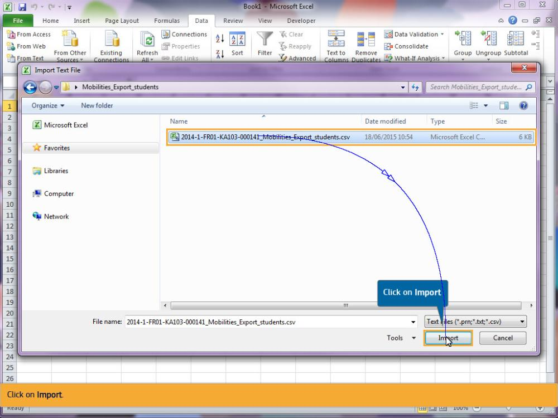
Text Captions

Click on Import.

Click on Import

Slide 9 - Slide 9
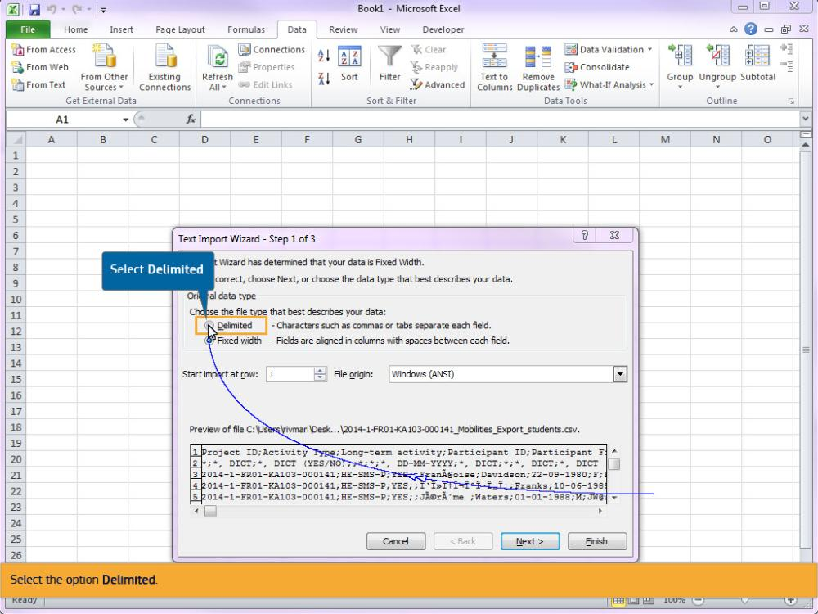
Text Captions

Select the option Delimited.

Select Delimited

Slide 10 - Slide 10
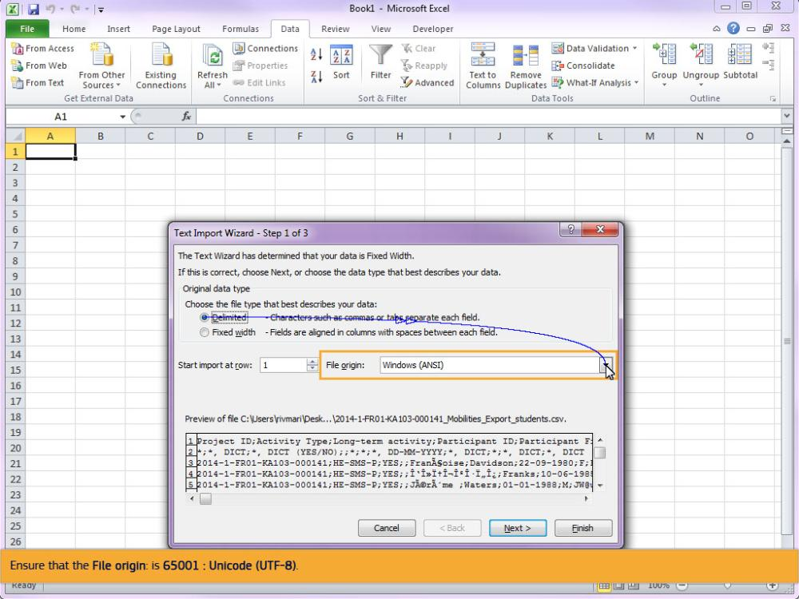
Text Captions

Ensure that the File origin: is 65001 : Unicode (UTF-8).

Slide 11 - Slide 11
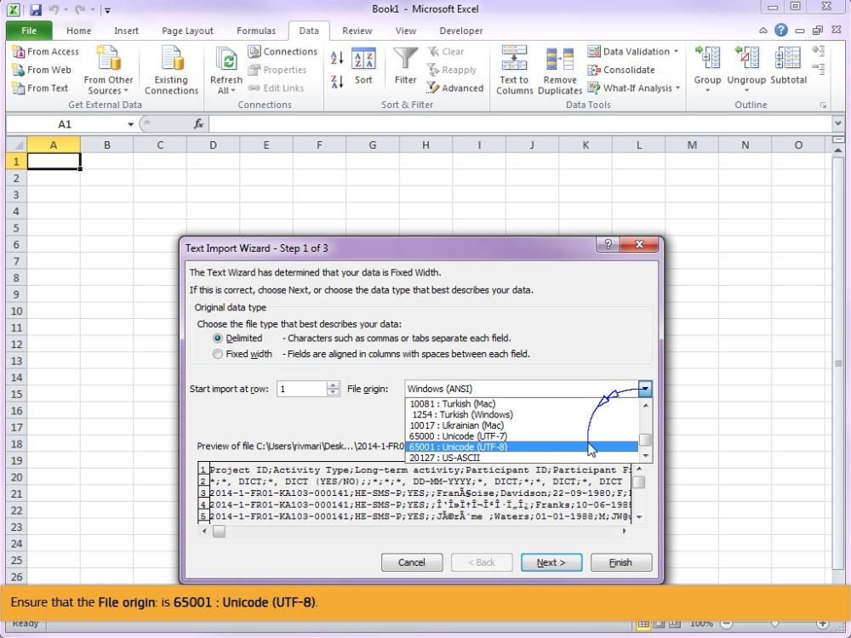
Text Captions

Ensure that the File origin: is 65001 : Unicode (UTF-8).

Slide 12 - Slide 12
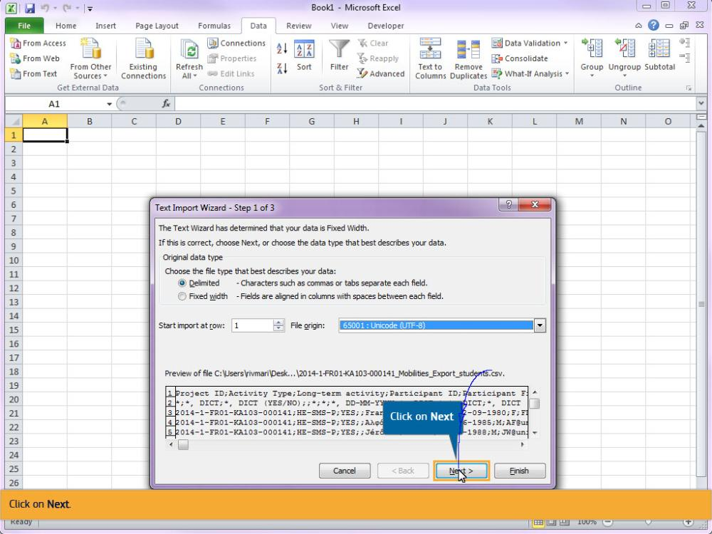
Text Captions

Click on Next.

Click on Next

Slide 13 - Slide 13
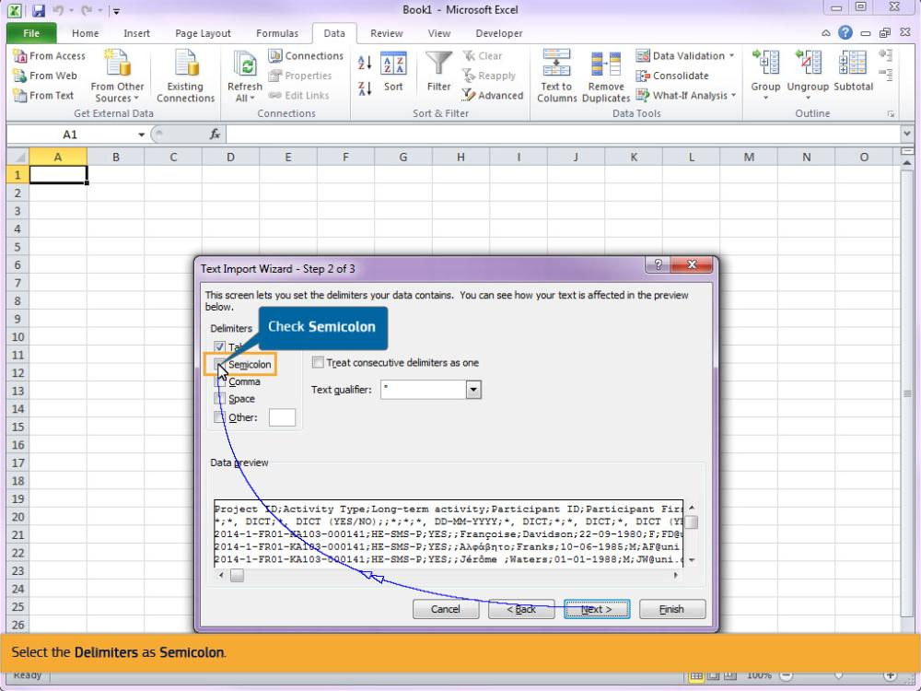
Text Captions

Select the Delimiters as Semicolon.

Check Semicolon

Slide 14 - Slide 14
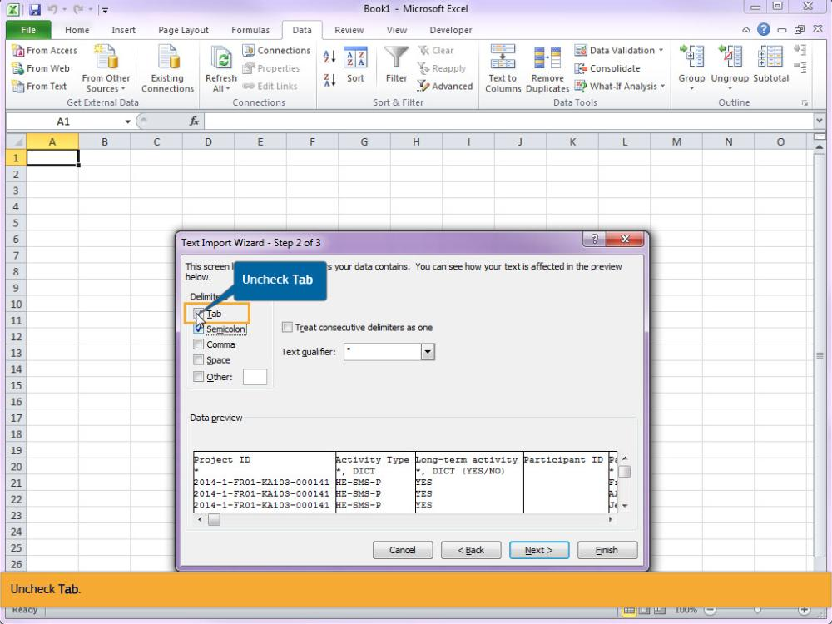
Text Captions

Uncheck Tab.

Uncheck Tab

Slide 15 - Slide 15
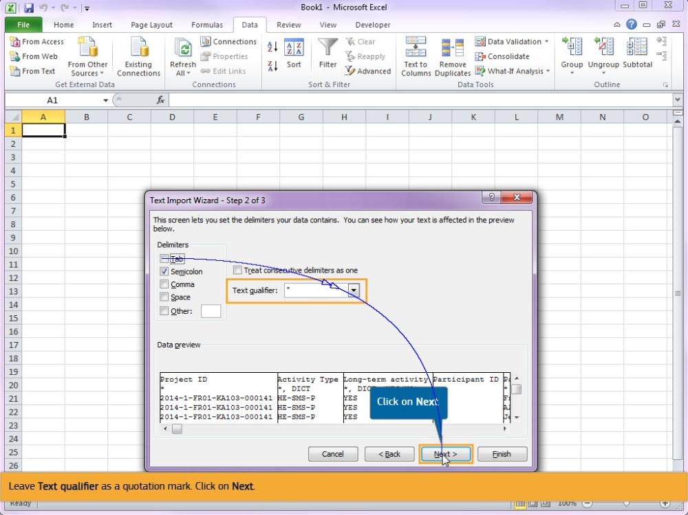
Text Captions

Leave Text qualifier as a quotation mark. Click on Next.

Click on Next

Slide 16 - Slide 16
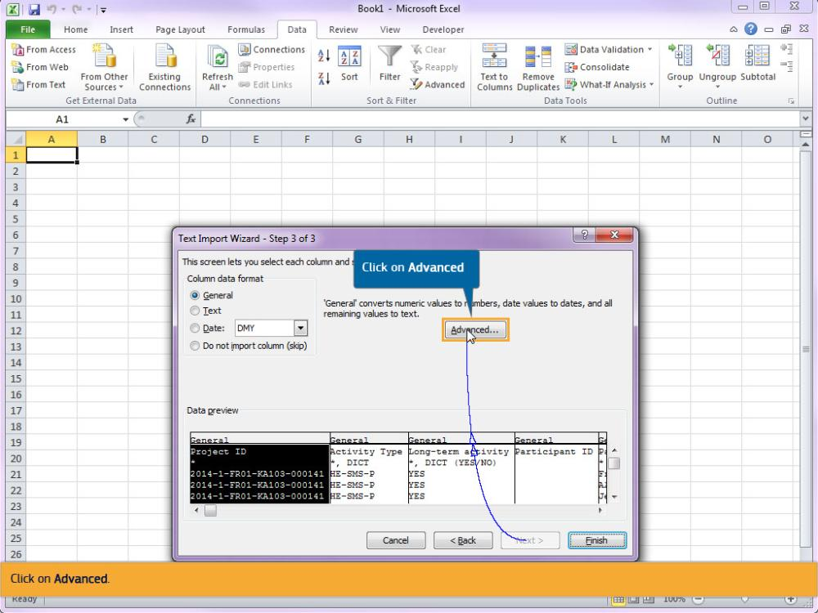
Text Captions

Click on Advanced.

Click on Advanced

Slide 17 - Slide 17
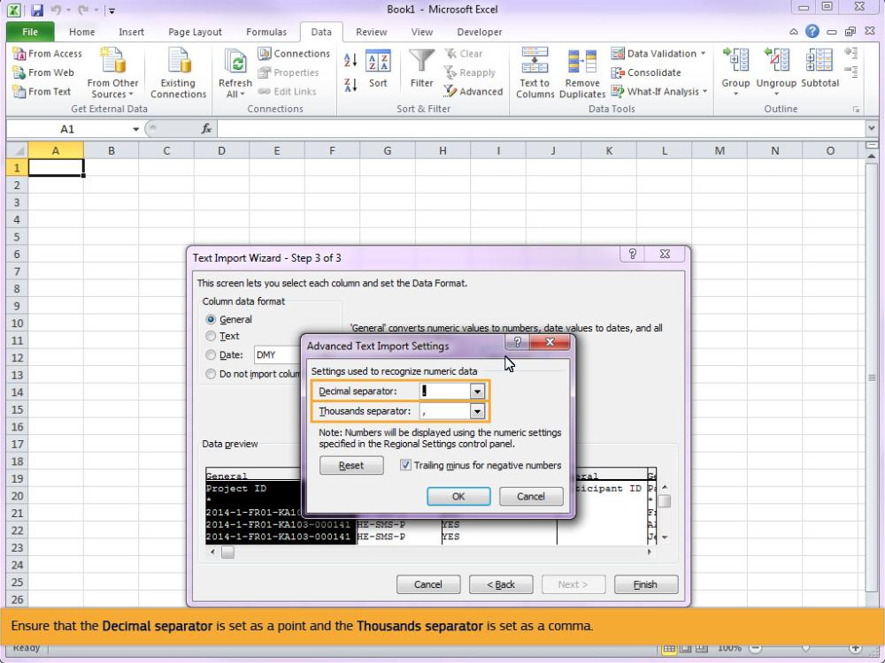
Text Captions

Ensure that the Decimal separator is set as a point and the Thousands separator is set as a comma.

Slide 18 - Slide 18
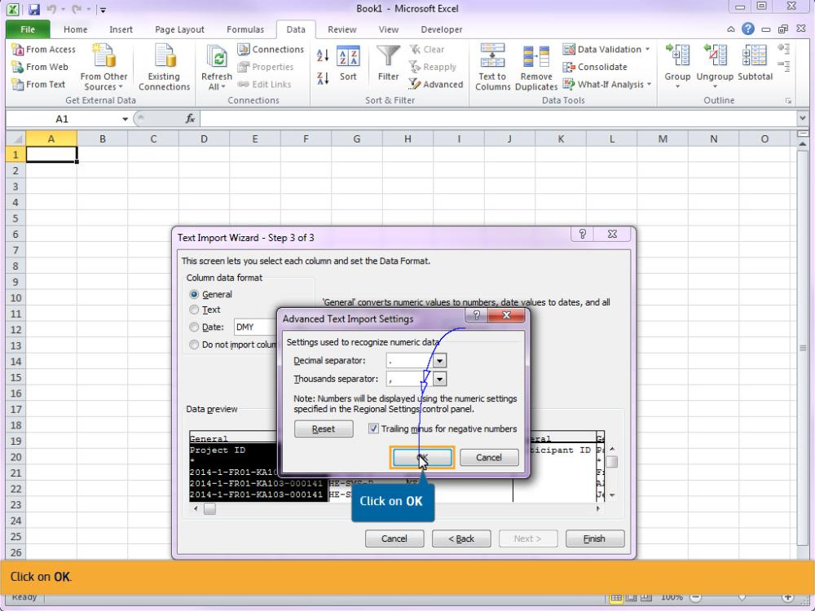
Text Captions

Click on OK.

Click on OK

Slide 19 - Slide 19
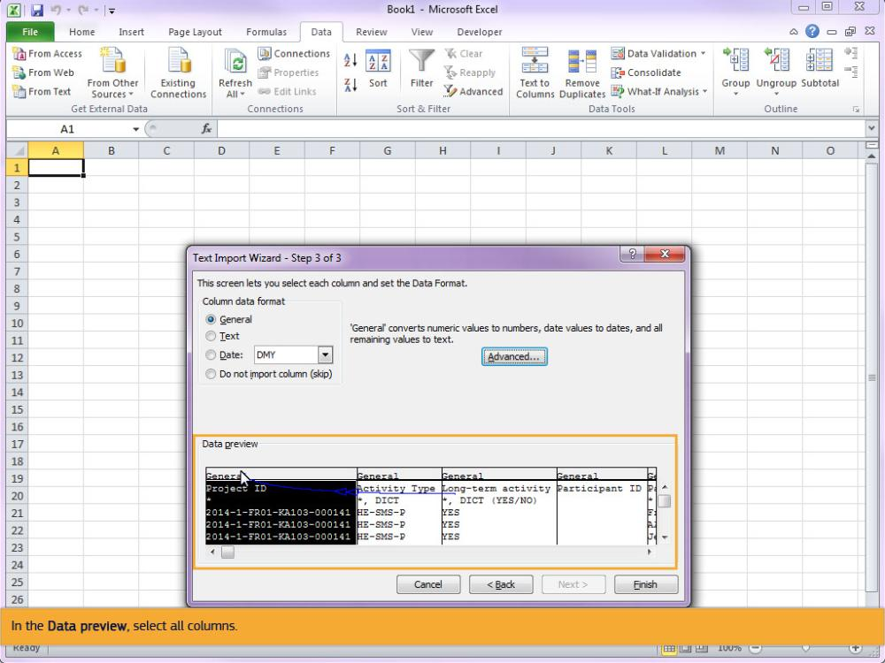
Text Captions

In the Data preview, select all columns.

Slide 20 - Slide 20
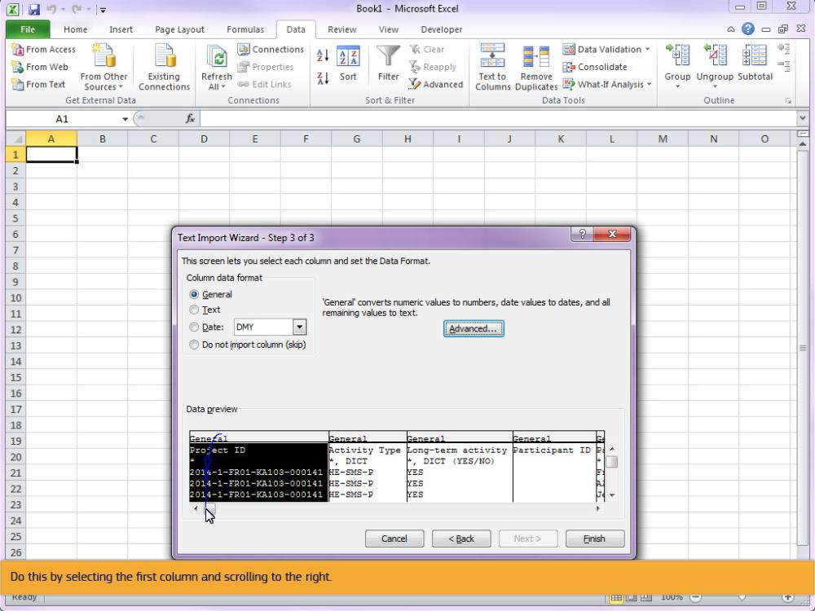
Text Captions

Do this by selecting the first column and scrolling to the right.

Slide 21 - Slide 21
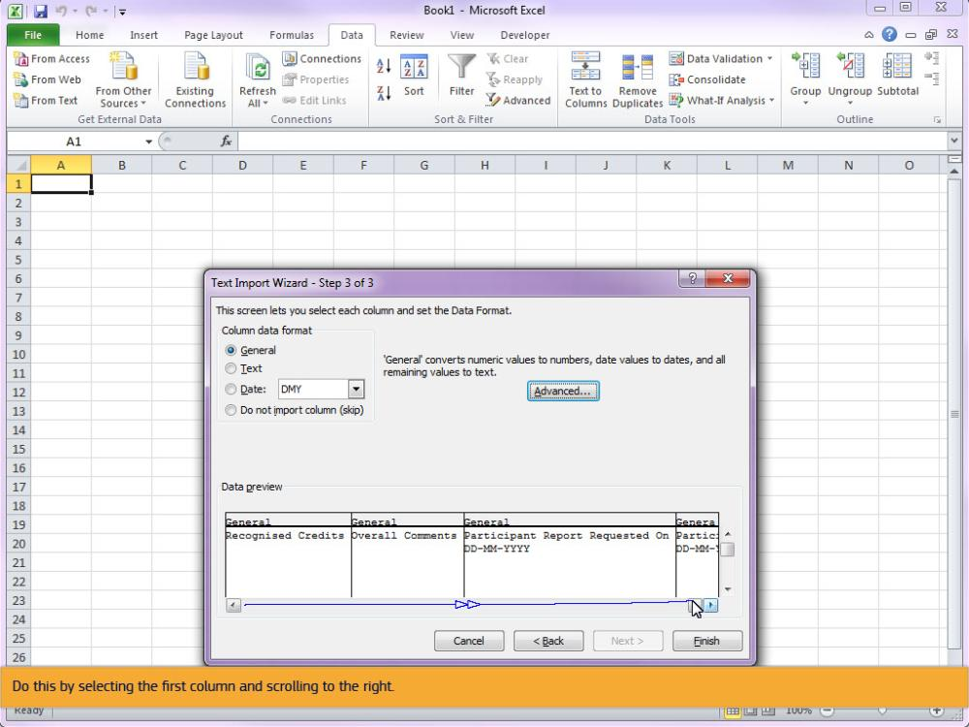
Text Captions

Do this by selecting the first column and scrolling to the right.

Slide 22 - Slide 22
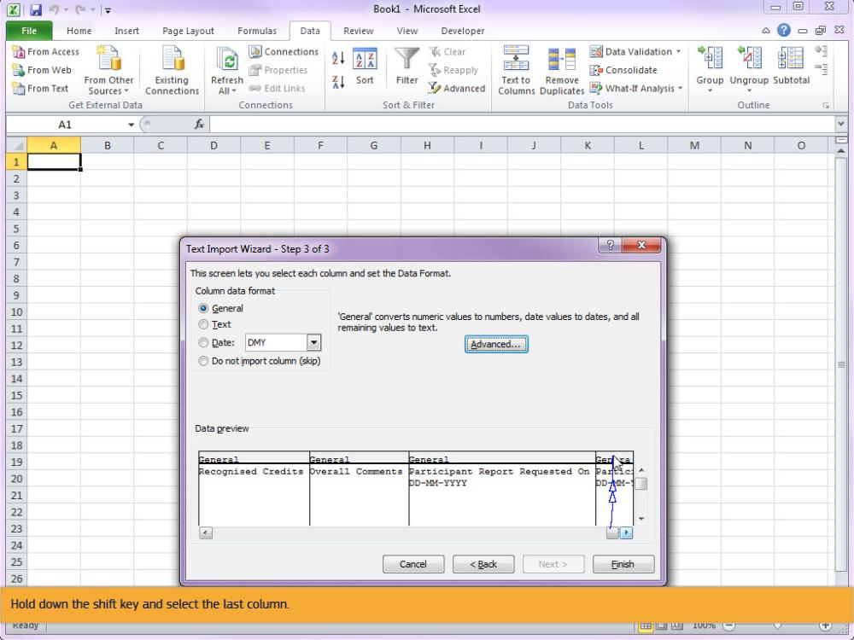
Text Captions

Hold down the shift key and select the last column.

Slide 23 - Slide 23
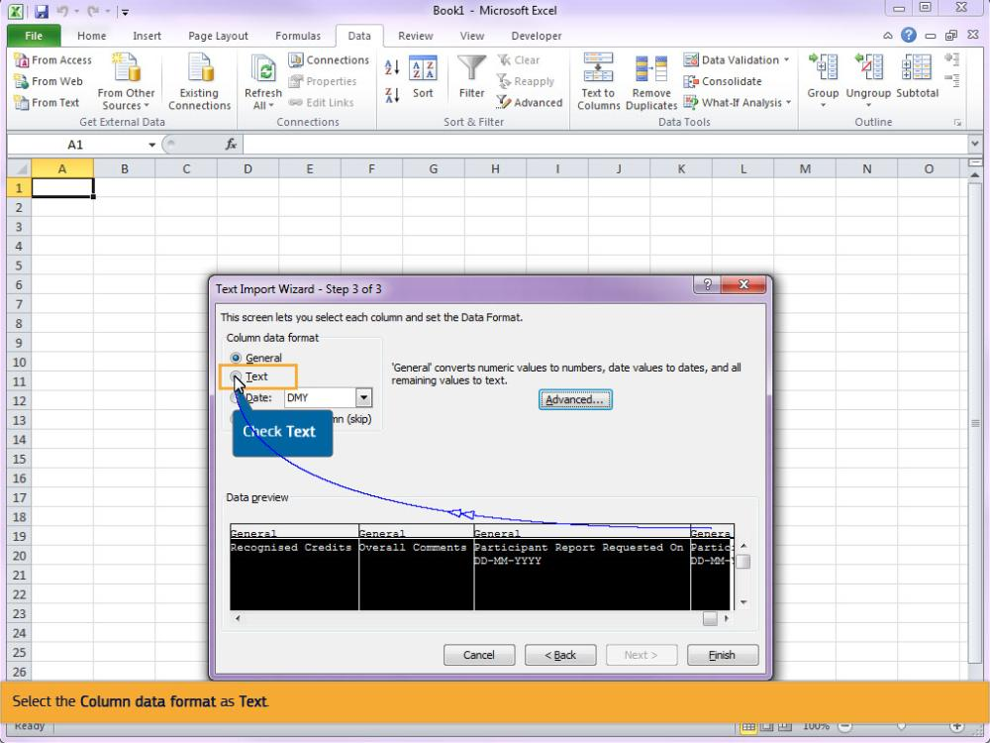
Text Captions

Select the Column data format as Text.

Check Text

Slide 24 - Slide 24
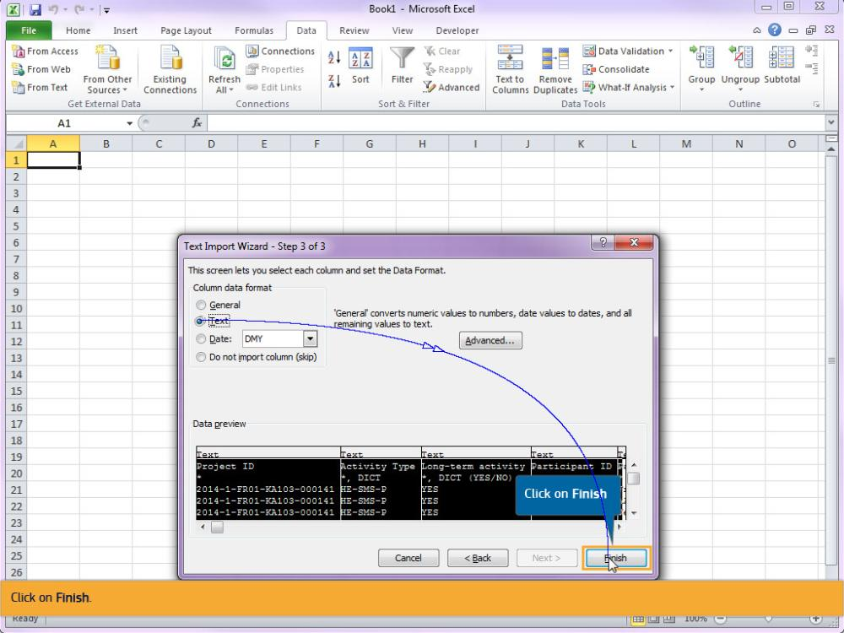
Text Captions

Click on Finish.

Click on Finish

Slide 25 - Slide 25
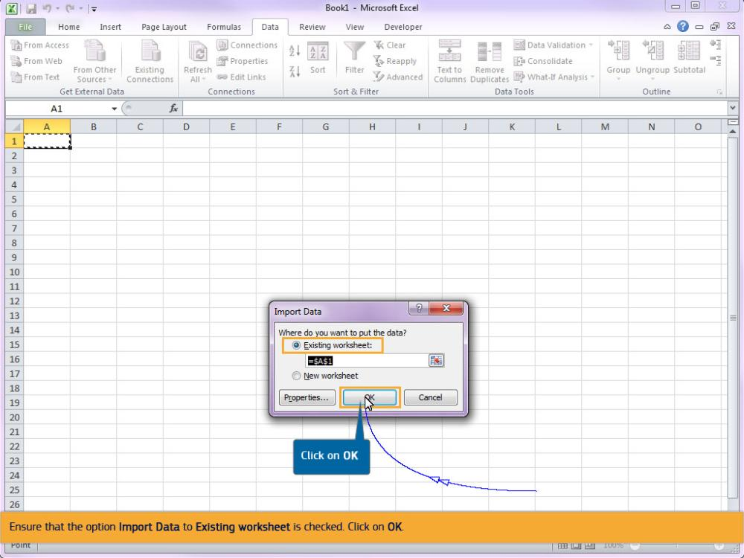
Text Captions

Ensure that the option Import Data to Existing worksheet is checked. Click on OK.

Click on OK

Slide 26 - Slide 26
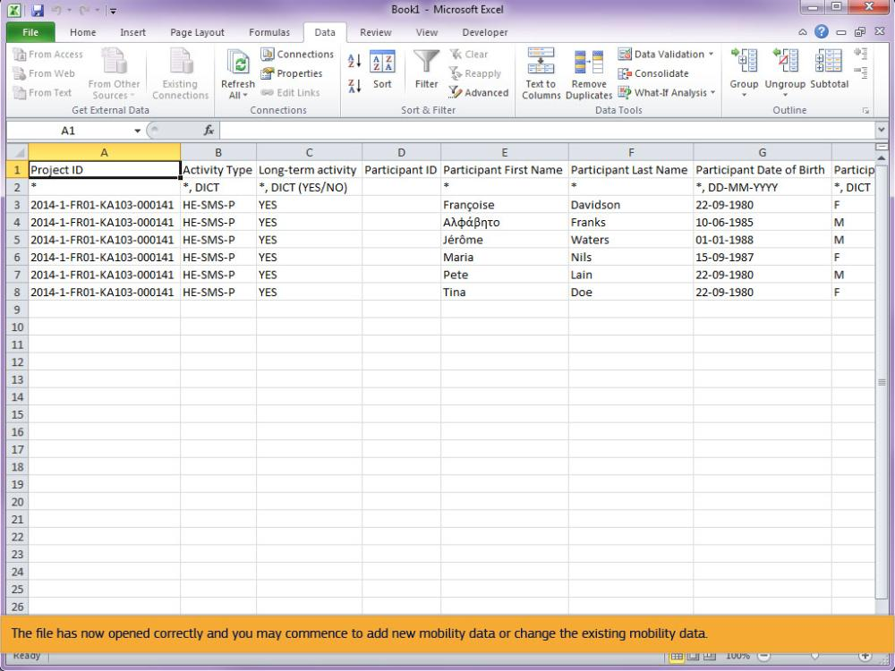
Text Captions

The file has now opened correctly and you may commence to add new mobility data or change the existing mobility data.

Slide 27 - Slide 27
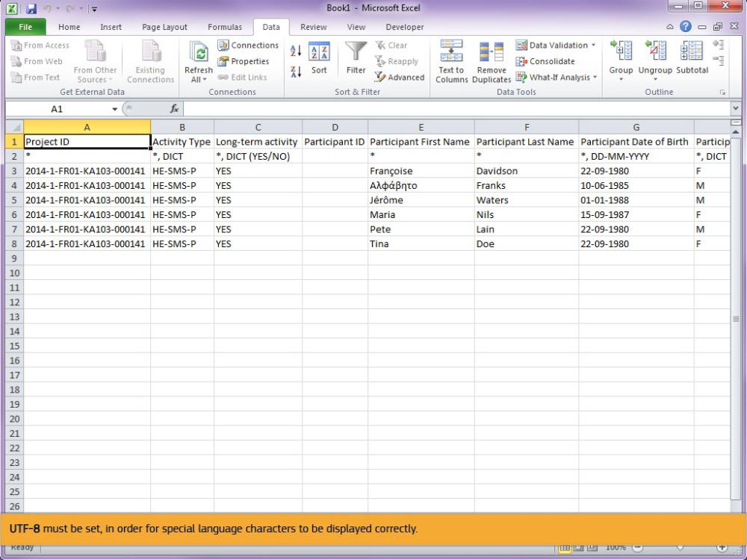
Text Captions

Before the template can be imported, the web encoding must be set to UTF-8.

UTF-8 must be set, in order for special language characters to be displayed correctly.

Slide 28 - Slide 28
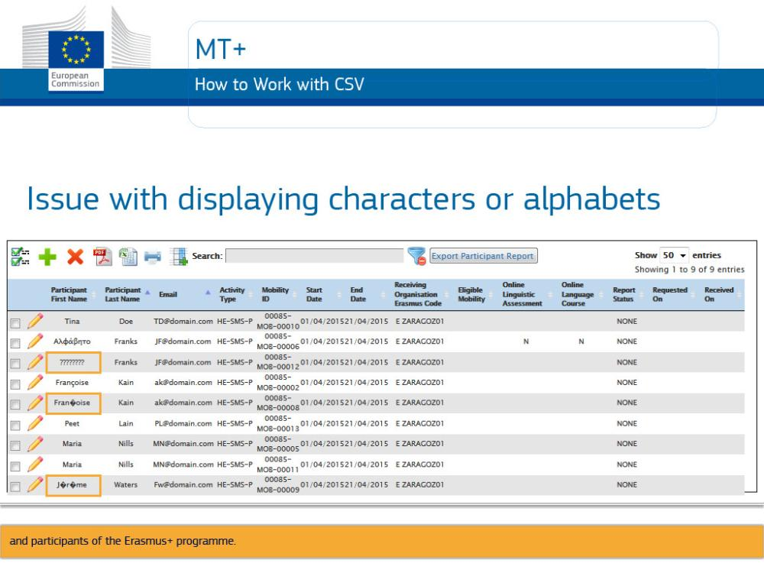
Text Captions

MT+

Issue with displaying characters or alphabets
How to Work with CSV

There is a known issue after import mobilities using MS Excel, affecting most national characters of the 27 alphabets used by National Agencies and participants of the Erasmus+ programme.

Slide 29 - Slide 29
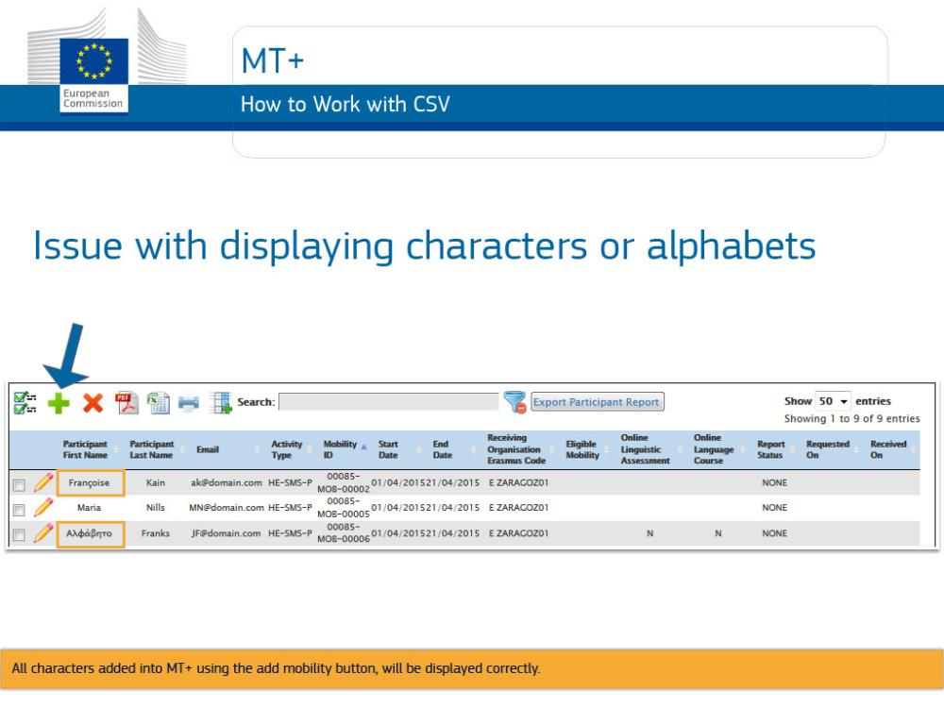
Text Captions

All characters added into MT+ using the add mobility button, will be displayed correctly.

Slide 30 - Slide 30
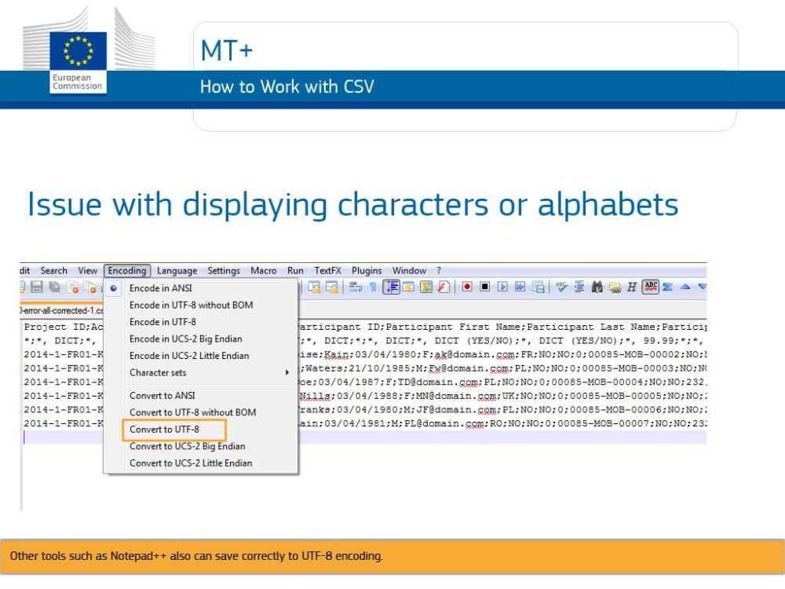
Text Captions

How to Work with CSV
In order to have all characters displayed correctly, either edit the entries via the interface, or use an alternative tool such as, LibreOffice Calc, Apache Open Office Calc or iworks Numbers.

Other tools such as Notepad++ also can save correctly to UTF-8 encoding.

Slide 31 - Slide 31
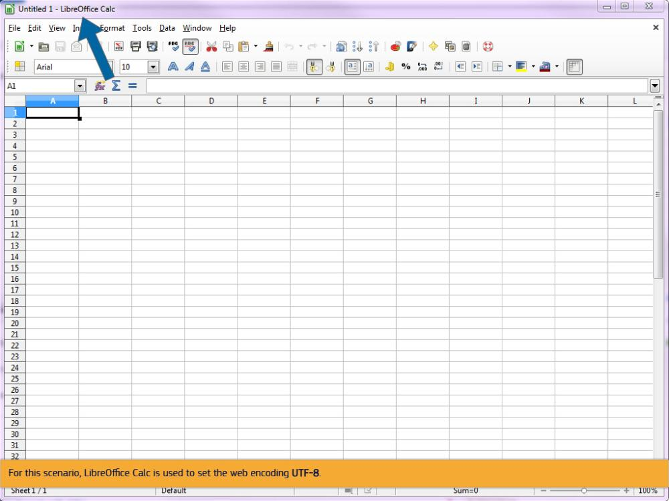
Text Captions

For this scenario, LibreOffice Calc is used to set the web encoding UTF-8.

Slide 32 - Slide 32
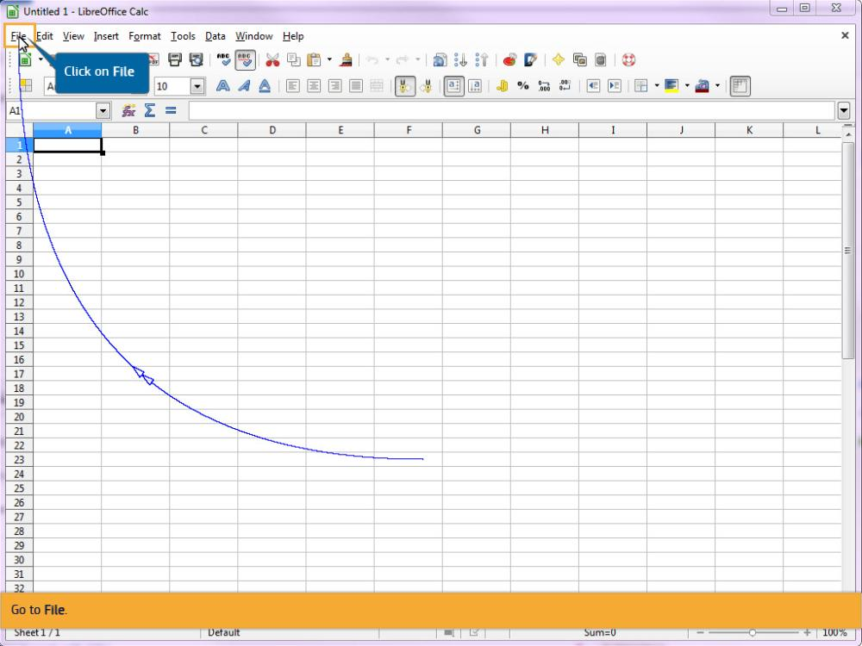
Text Captions

Go to File.

Click on File

Slide 33 - Slide 33
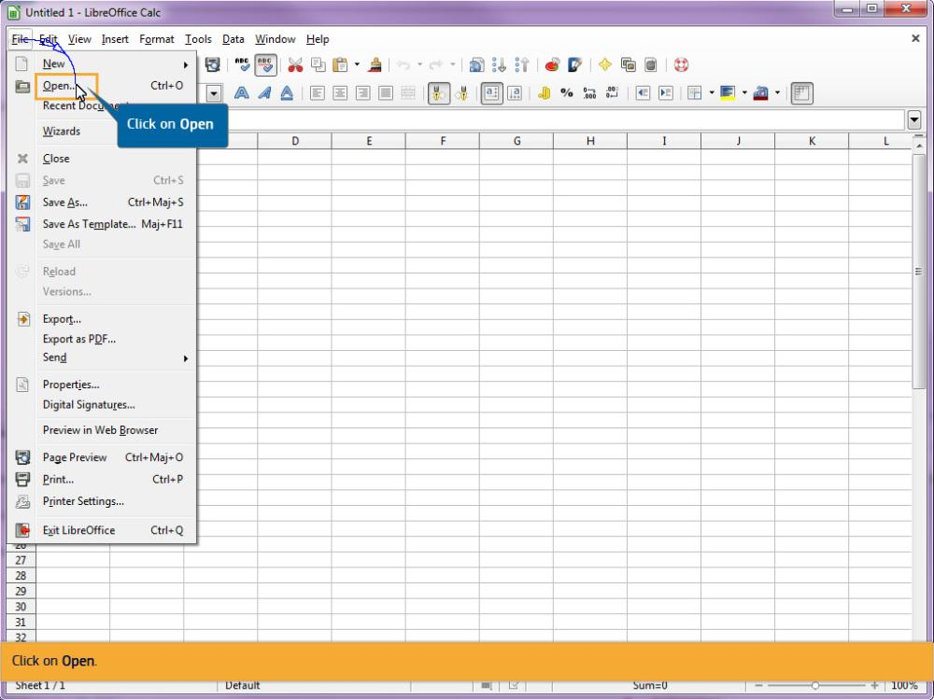
Text Captions

Click on Open.

Click on Open

Slide 34 - Slide 34
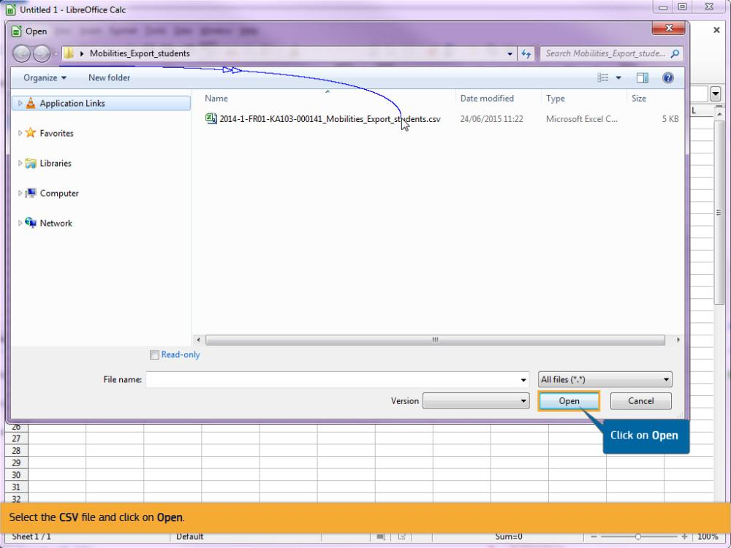
Text Captions

Select the CSV file and click on Open.

Click on Open

Slide 35 - Slide 35
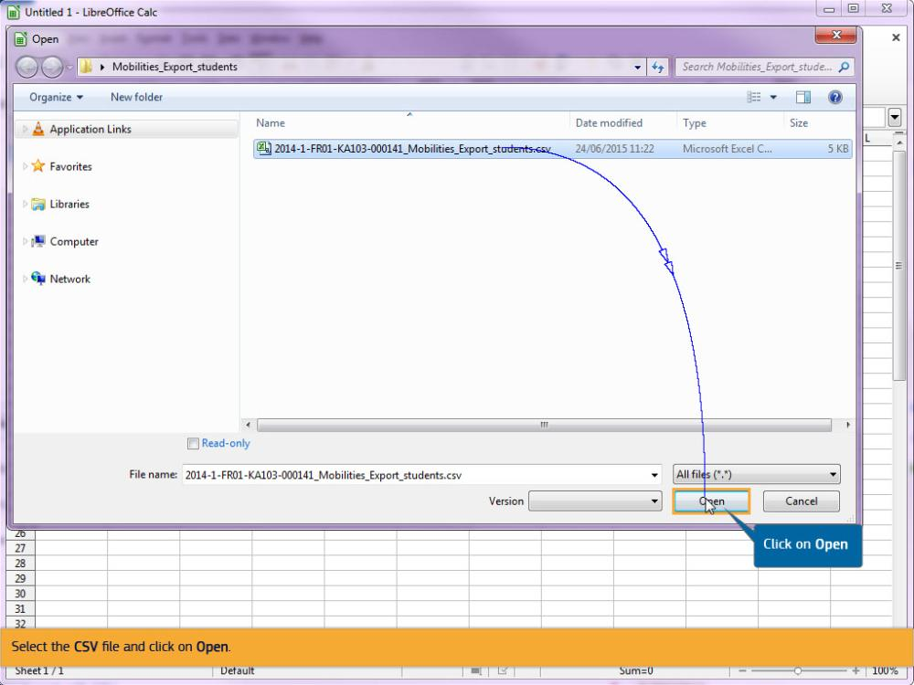
Text Captions

Select the CSV file and click on Open.

Click on Open

Slide 36 - Slide 36
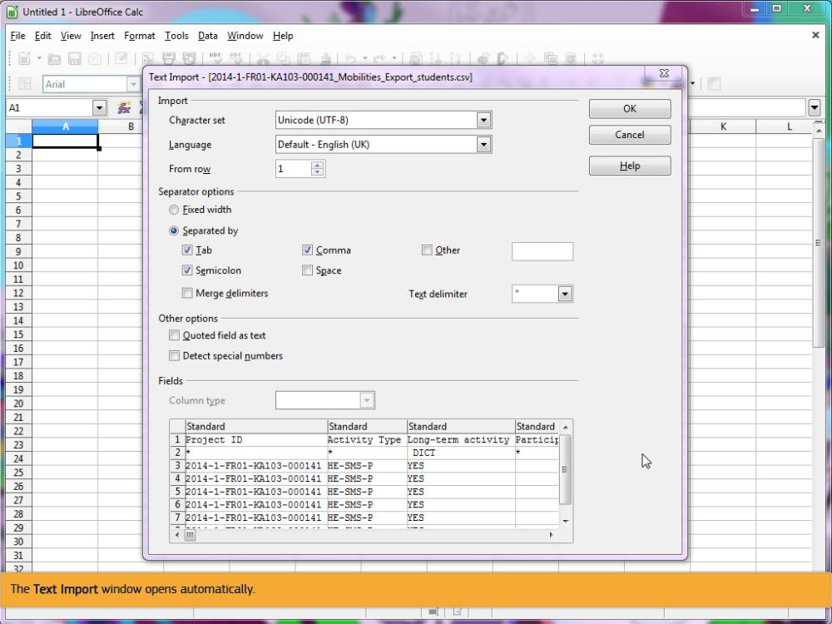
Text Captions

The Text Import window opens automatically.

Slide 37 - Slide 37
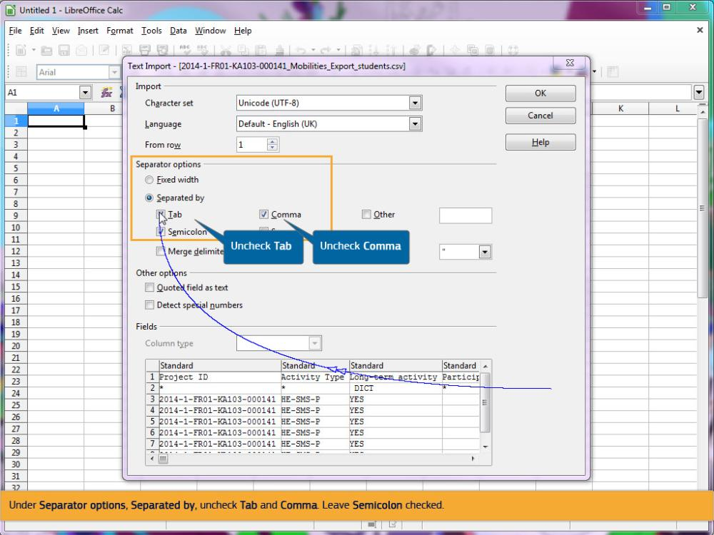
Text Captions

Under Separator options, Separated by, uncheck Tab and Comma. Leave Semicolon checked.

Uncheck Tab

Uncheck Comma

Slide 39 - Slide 39
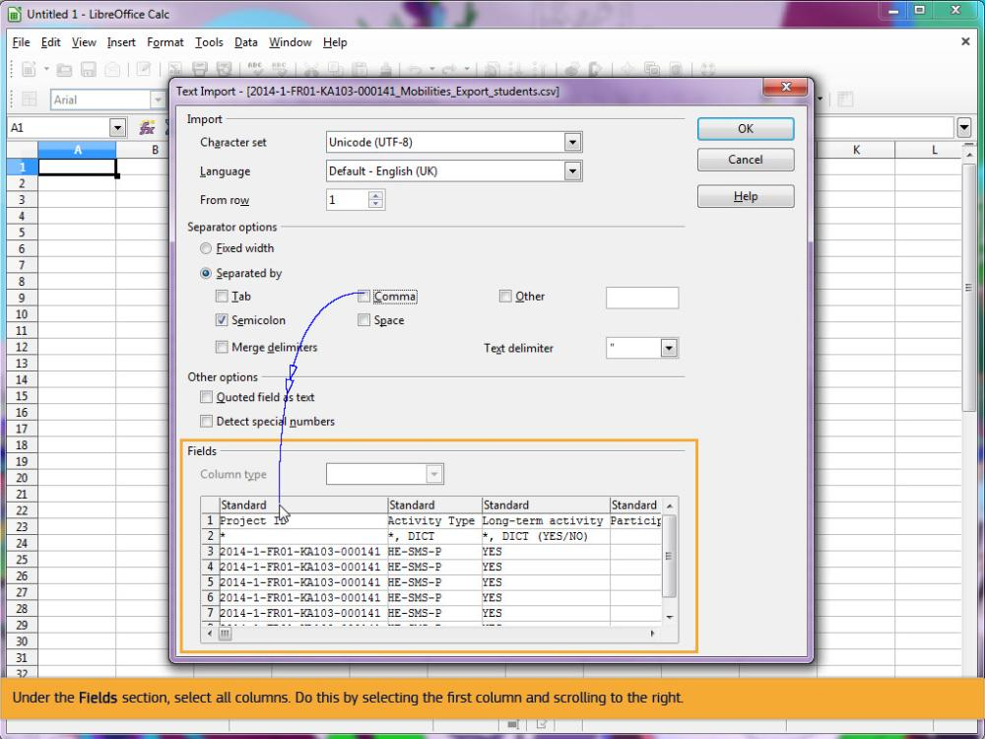
Text Captions

Under the Fields section, select all columns. Do this by selecting the first column and scrolling to the right.

Slide 40 - Slide 40
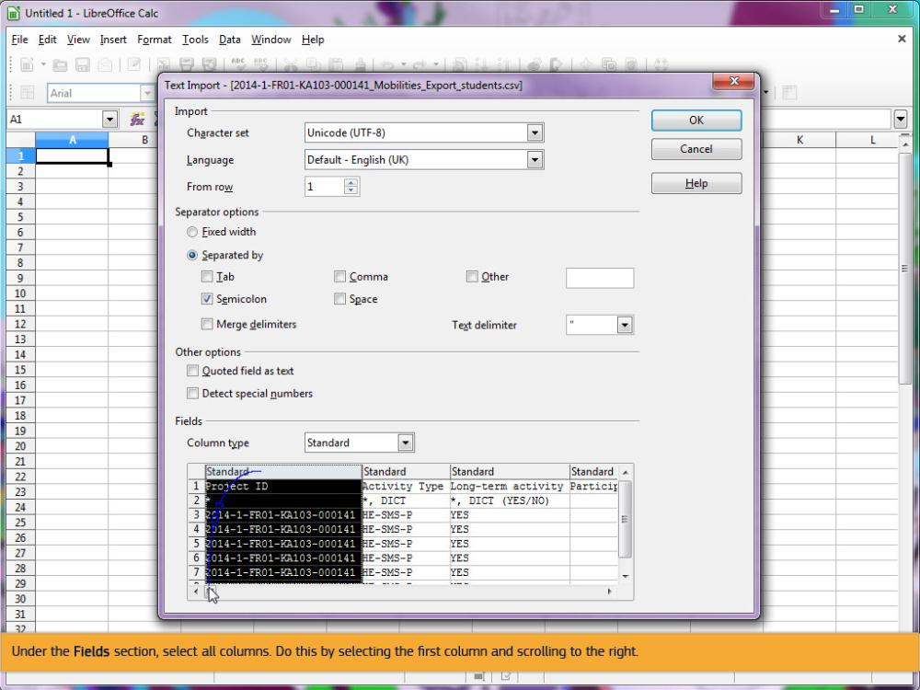
Text Captions

Under the Fields section, select all columns. Do this by selecting the first column and scrolling to the right.

Slide 41 - Slide 41
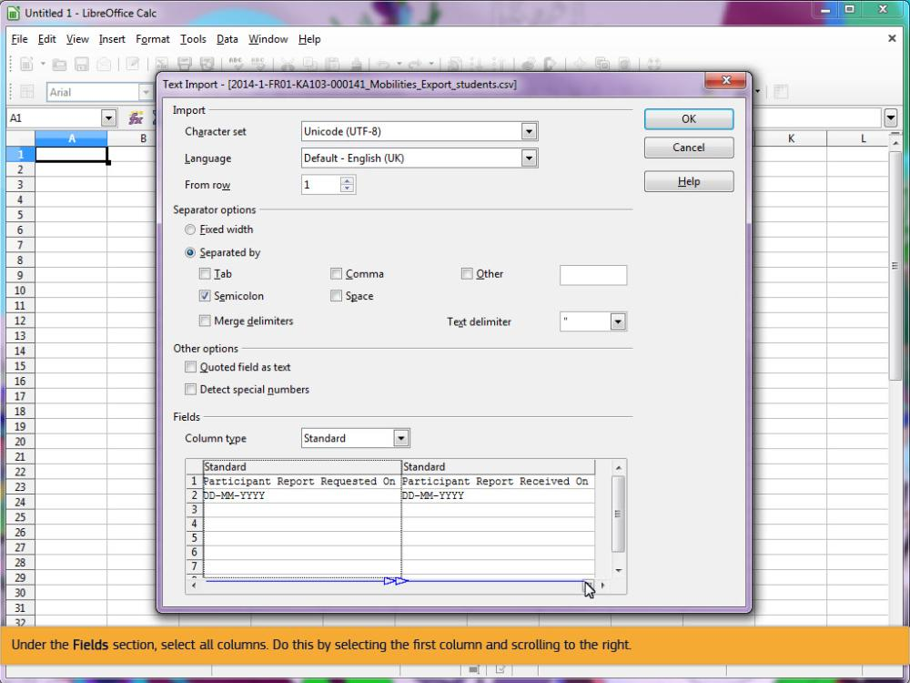
Text Captions

Under the Fields section, select all columns. Do this by selecting the first column and scrolling to the right.

Slide 42 - Slide 42
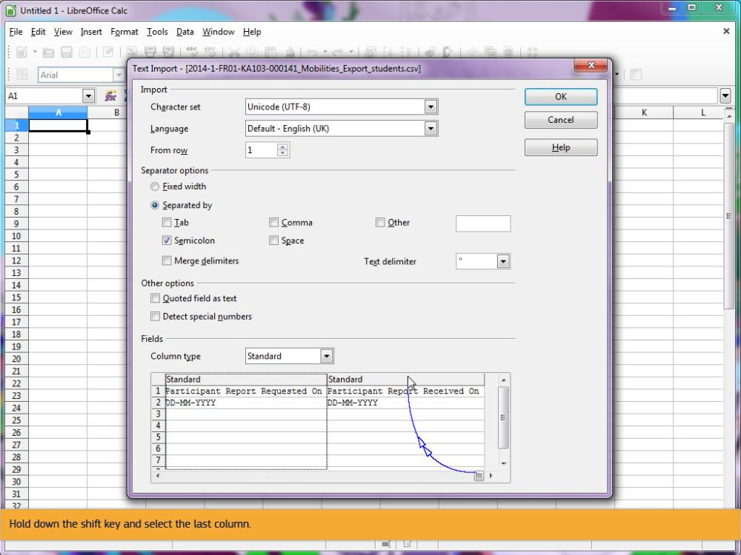
Text Captions

Hold down the shift key and select the last column.

Slide 43 - Slide 43
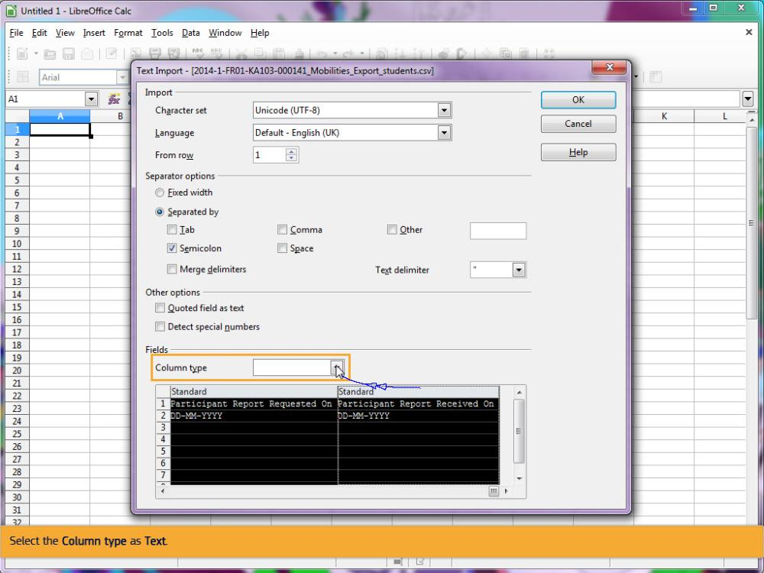
Text Captions

Select the Column type as Text.

Slide 45 - Slide 45
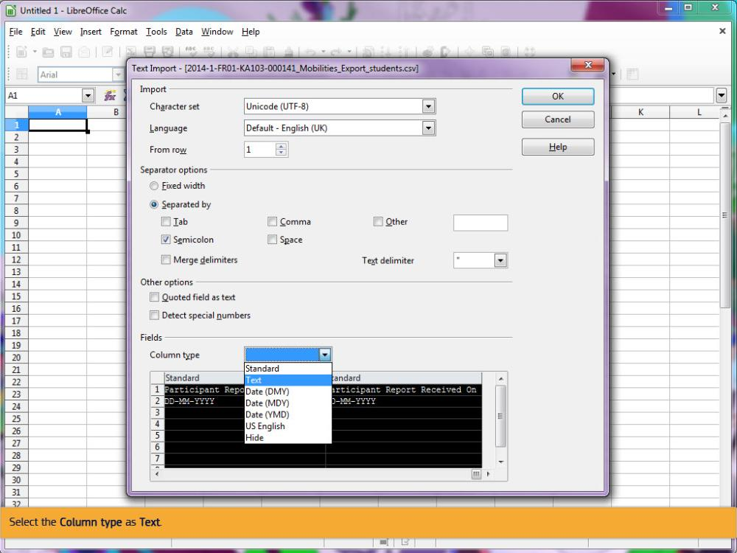
Text Captions

Select the Column type as Text.

Slide 46 - Slide 46
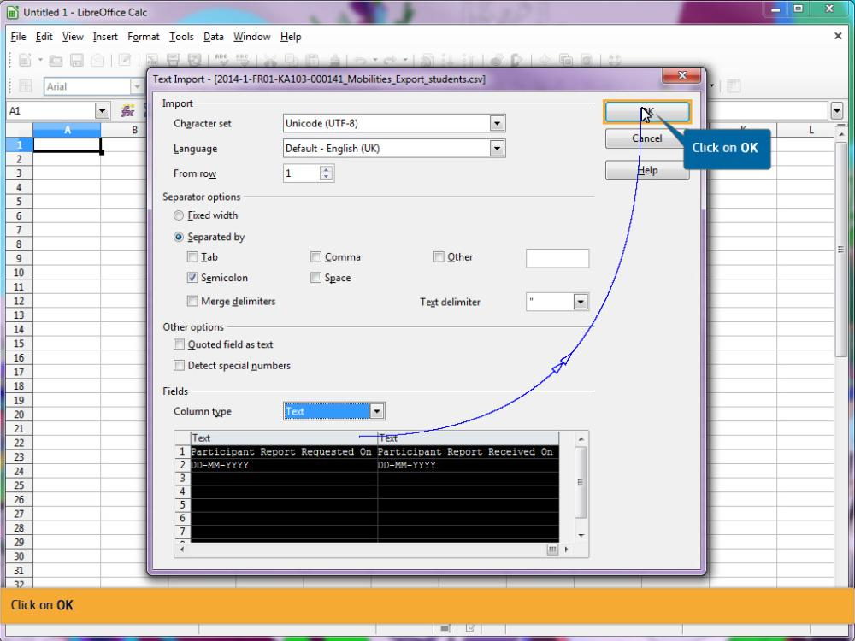
Text Captions

Click on OK.

Click on OK

Slide 47 - Slide 47
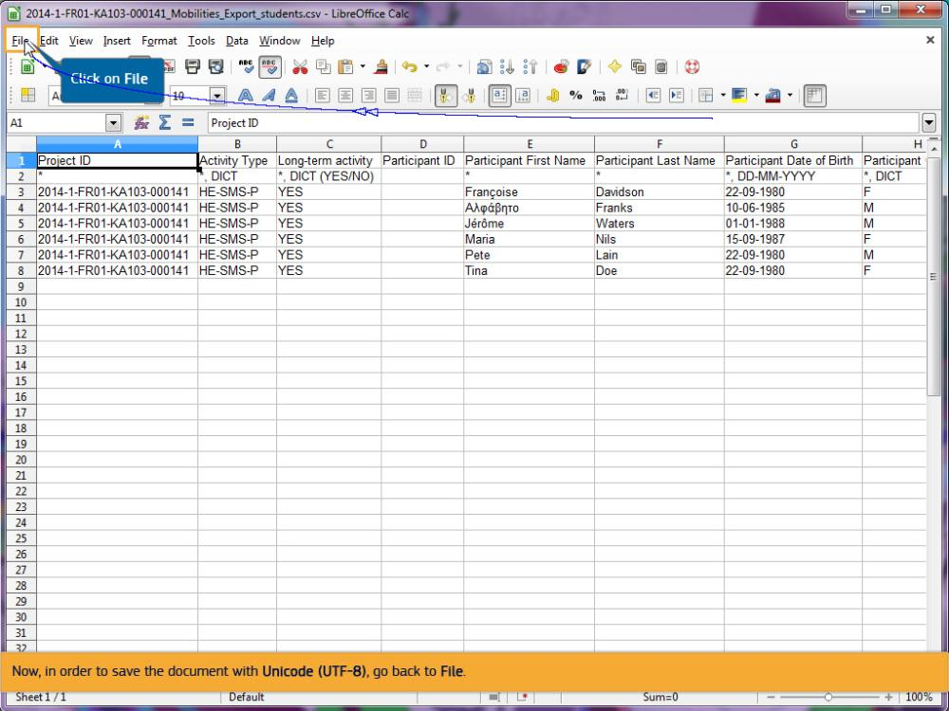
Text Captions

Now, in order to save the document with Unicode (UTF-8), go back to File.

Click on File

Slide 48 - Slide 48
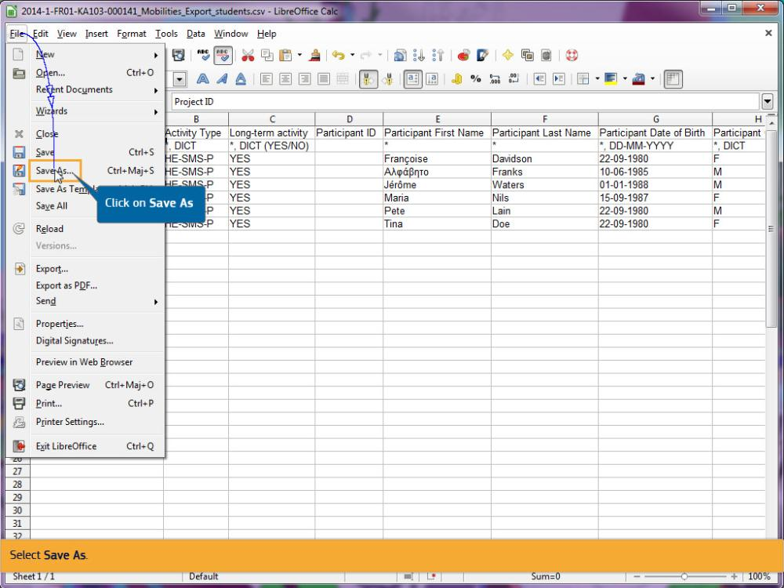
Text Captions

Select Save As.

Click on Save As

Slide 49 - Slide 49
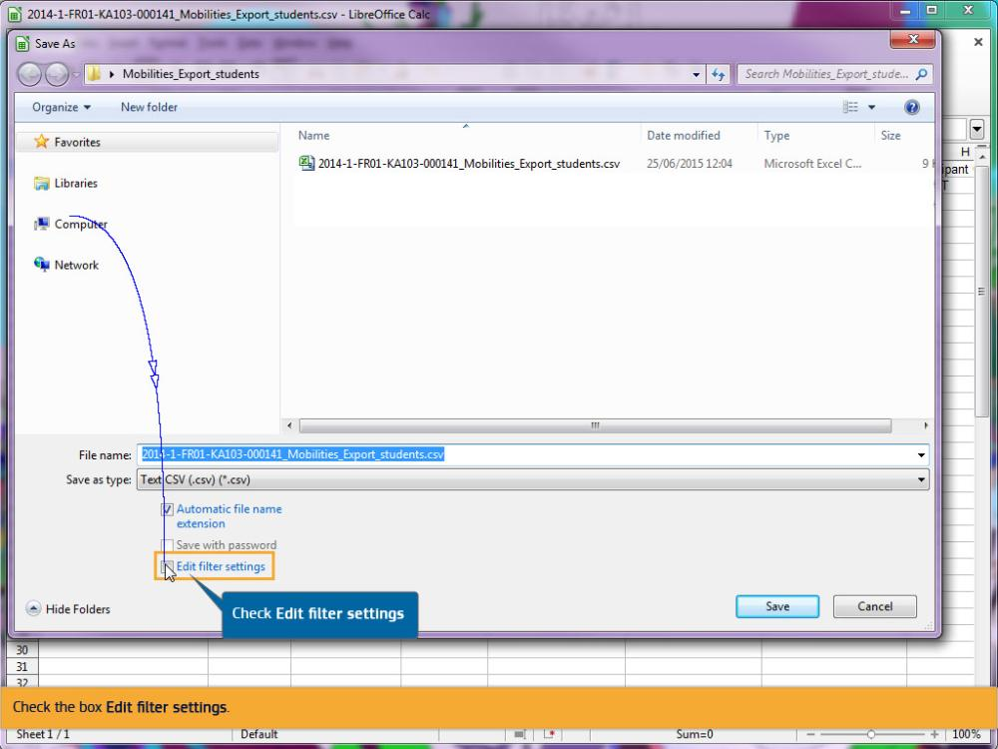
Text Captions

Check the box Edit filter settings.

Check Edit filter settings

Slide 50 - Slide 50
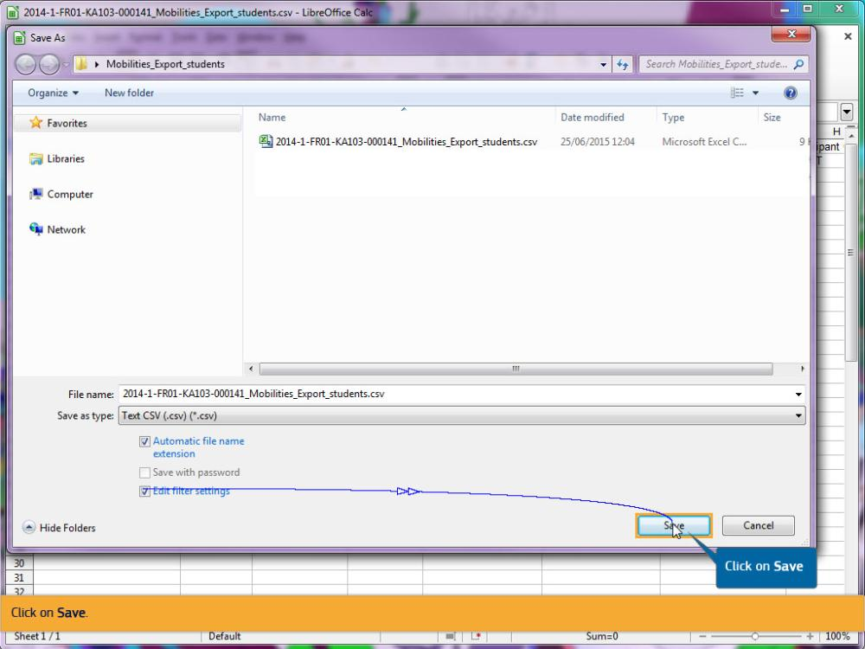
Text Captions

Click on Save.

Click on Save

Slide 51 - Slide 51
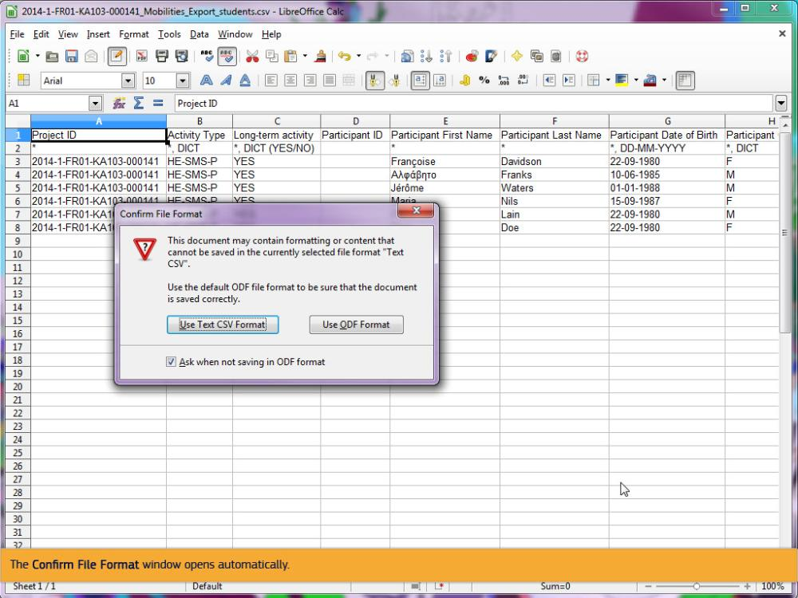
Text Captions

The Confirm File Format window opens automatically.

Slide 52 - Slide 52
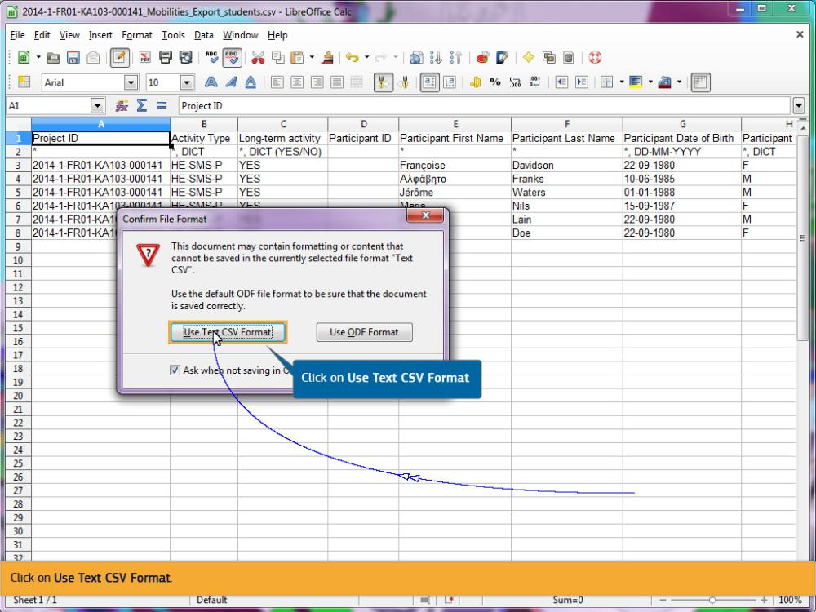
Text Captions

Click on Use Text CSV Format.

Click on Use Text CSV Format

Slide 53 - Slide 53
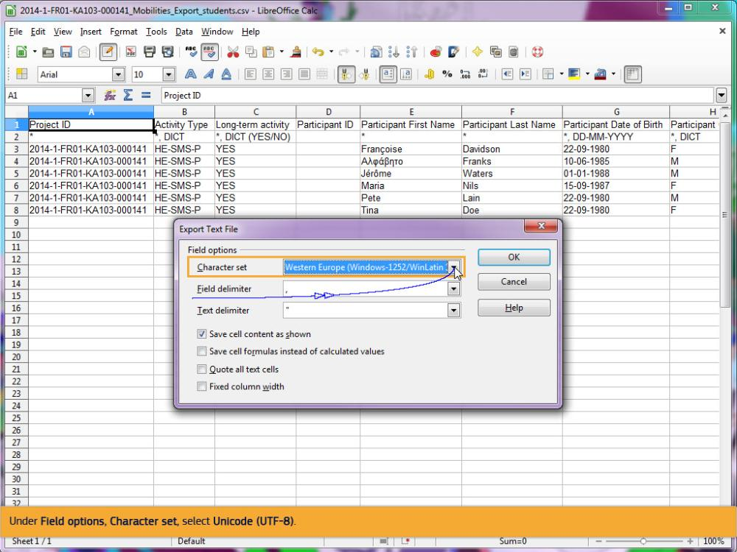
Text Captions

Under Field options, Character set, select Unicode (UTF-8).

Slide 54 - Slide 54
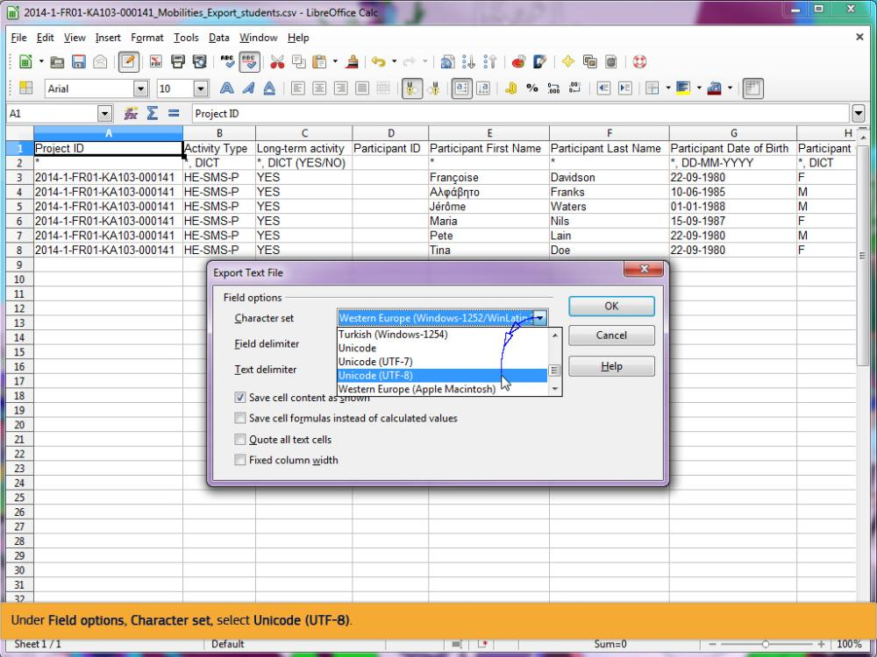
Text Captions

Under Field options, Character set, select Unicode (UTF-8).

Slide 55 - Slide 55
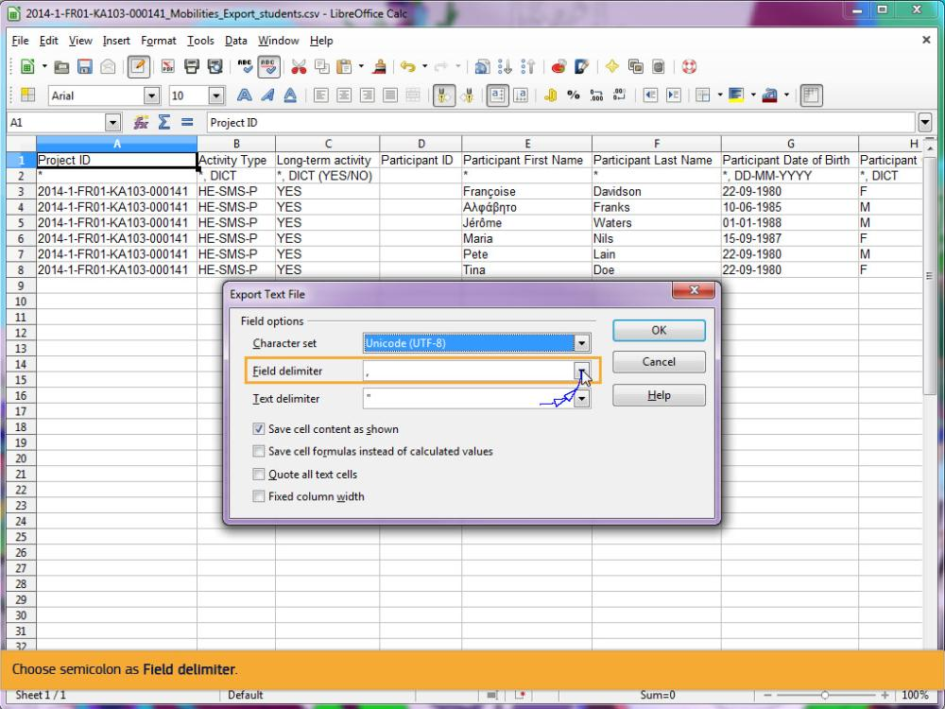
Text Captions

Choose semicolon as Field delimiter.

Slide 56 - Slide 56
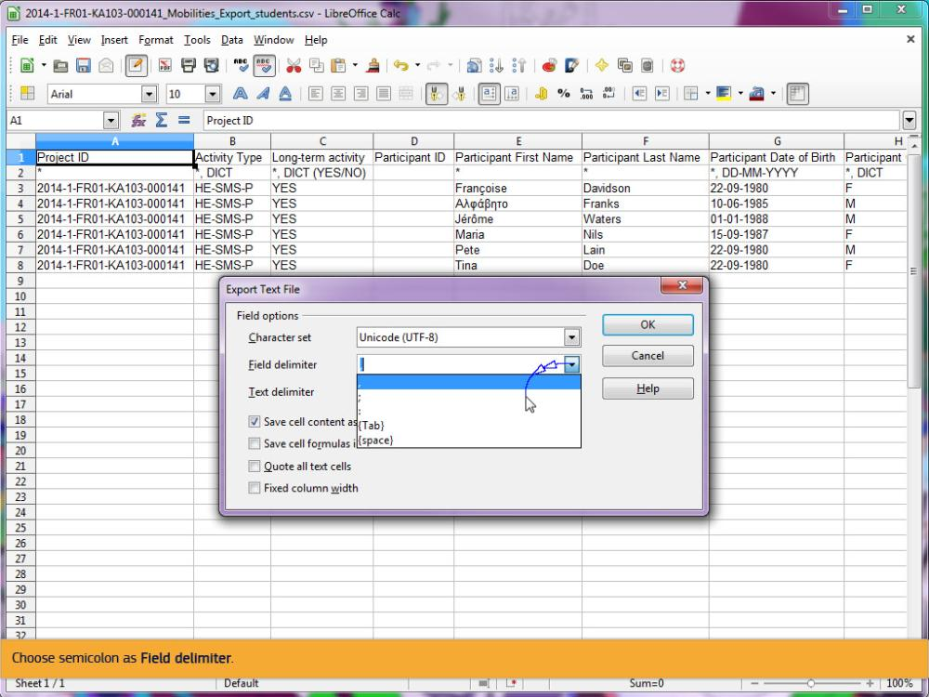
Text Captions

Choose semicolon as Field delimiter.

Slide 57 - Slide 57
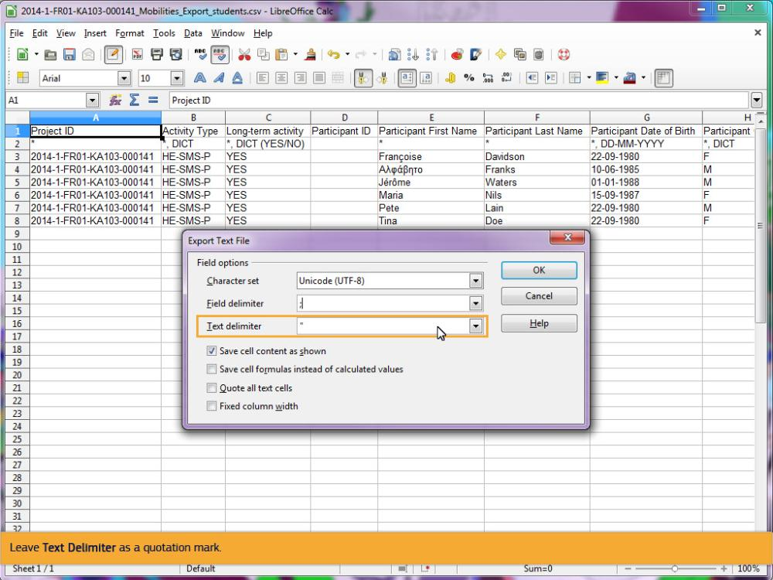
Text Captions

Leave Text Delimiter as a quotation mark.

Slide 58 - Slide 58
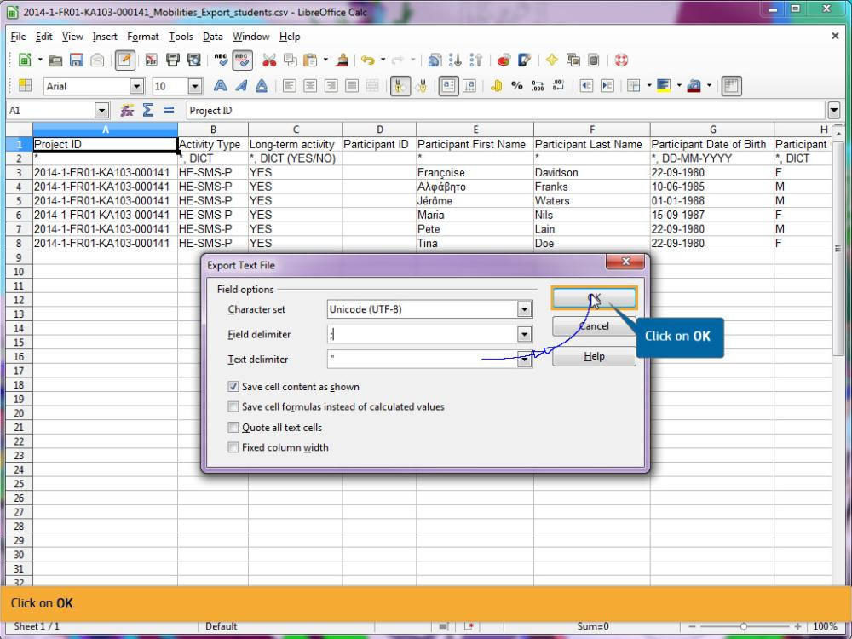
Text Captions

Click on OK.

Click on OK

Slide 59 - Slide 59
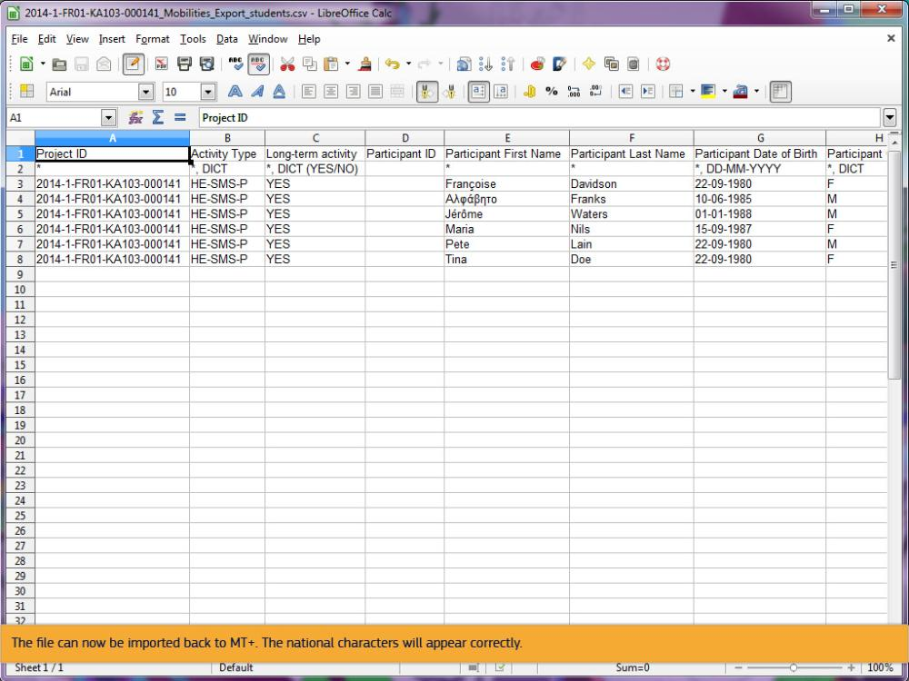
Text Captions

The file can now be imported back to MT+. The national characters will appear correctly.

Slide 60 - Slide 60
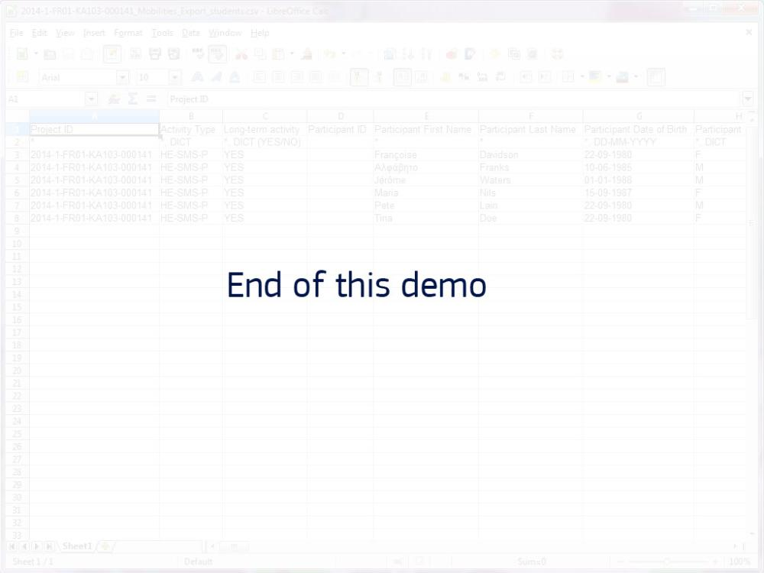
Text Captions

End of this demo

