Slide 1 - Slide 1
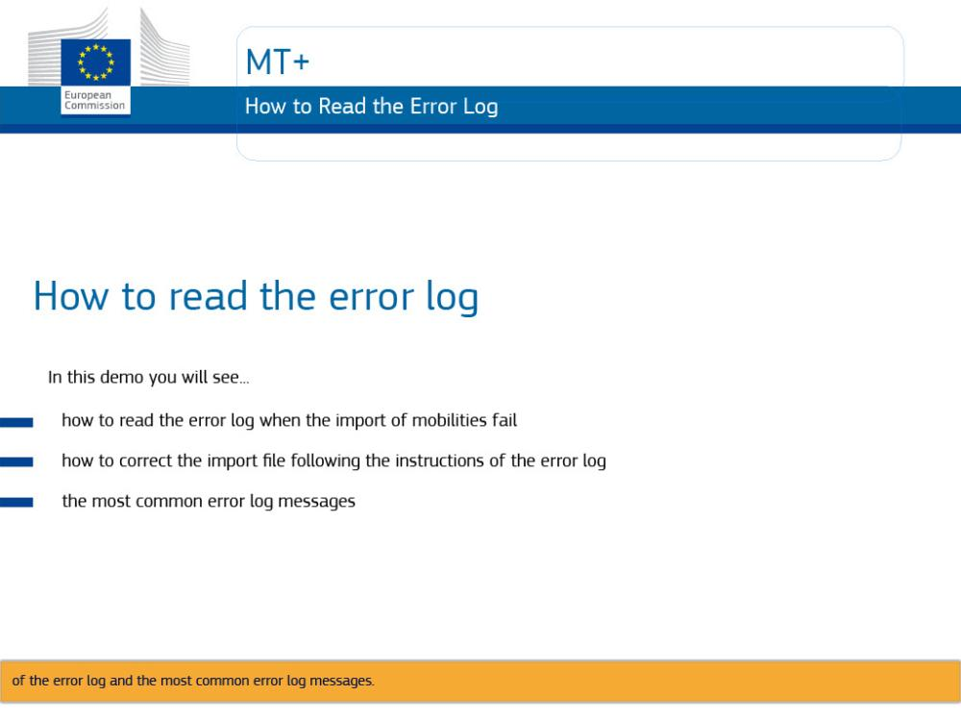
Text Captions

MT+

How to read the error log

In this demo you will see how to read the error log when the import of mobilities fail, how to correct the import file following the instructions of the error log and the most common error log messages.

Slide 2 - Slide 2
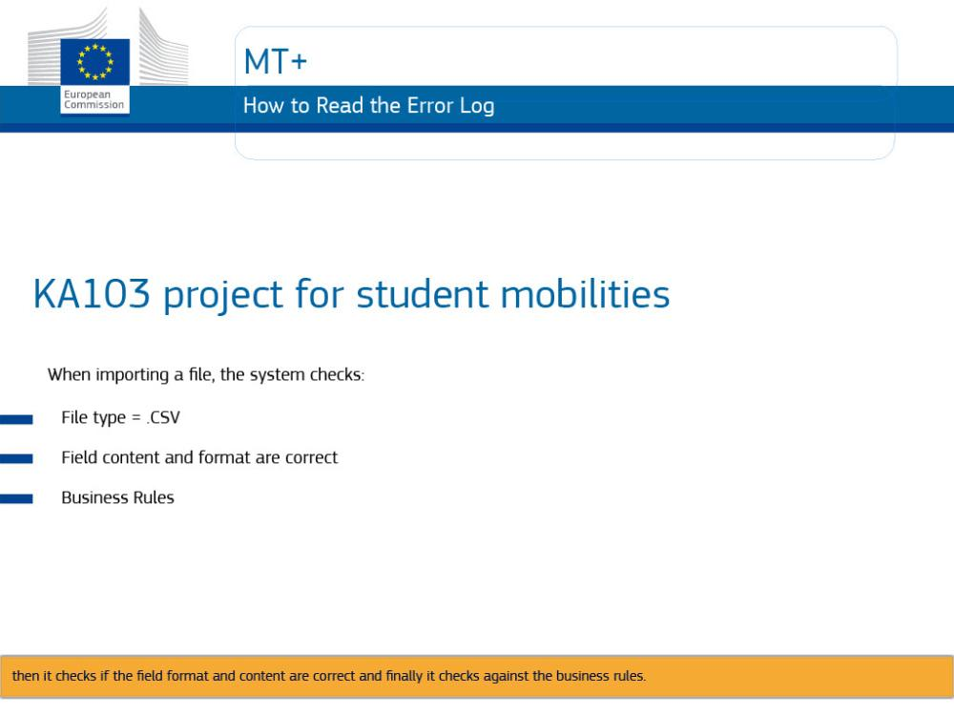
Text Captions

The scenario shown in this video demo, deals with the import for a KA103 project for student mobilities.

When importing a file, the system checks if the file is the right file type, then it checks if the field format and content are correct and finally it checks against the business rules.

Slide 3 - Slide 3
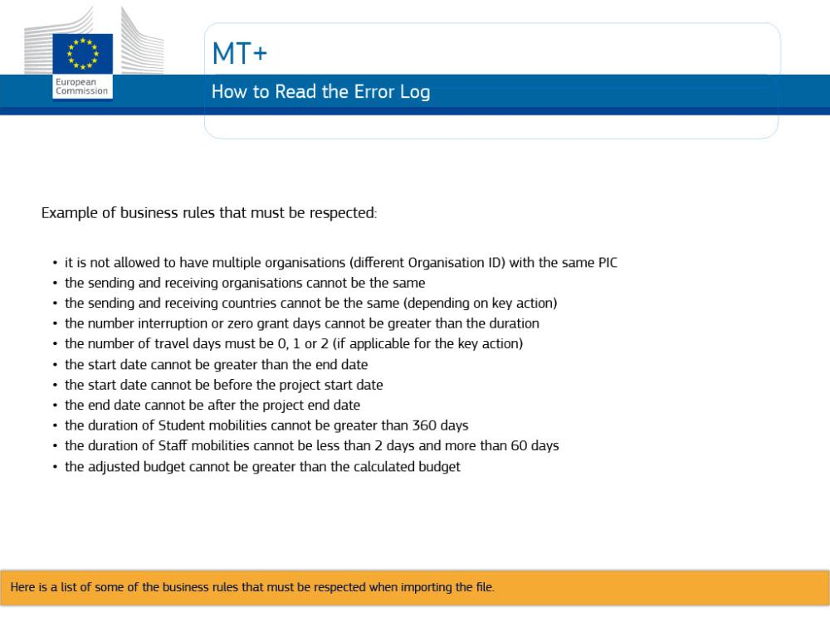
Text Captions

Example of business rules that must be respected:

- it is not allowed to have multiple organisations (different Organisation ID) with the same PIC
- the sending and receiving organisations cannot be the same
- the sending and receiving countries cannot be the same (depending on key action)
- the number interruption or zero grant days cannot be greater than the duration
- the number of travel days must be 0, 1 or 2 (if applicable for the key action)
- the start date cannot be greater than the end date
- the start date cannot be before the project start date
- the end date cannot be after the project end date
- the duration of Student mobilities cannot be greater than 360 days
- the duration of Staff mobilities cannot be less than 2 days and more than 60 days
- the adjusted budget cannot be greater than the calculated budget
Slide 4 - Slide 4
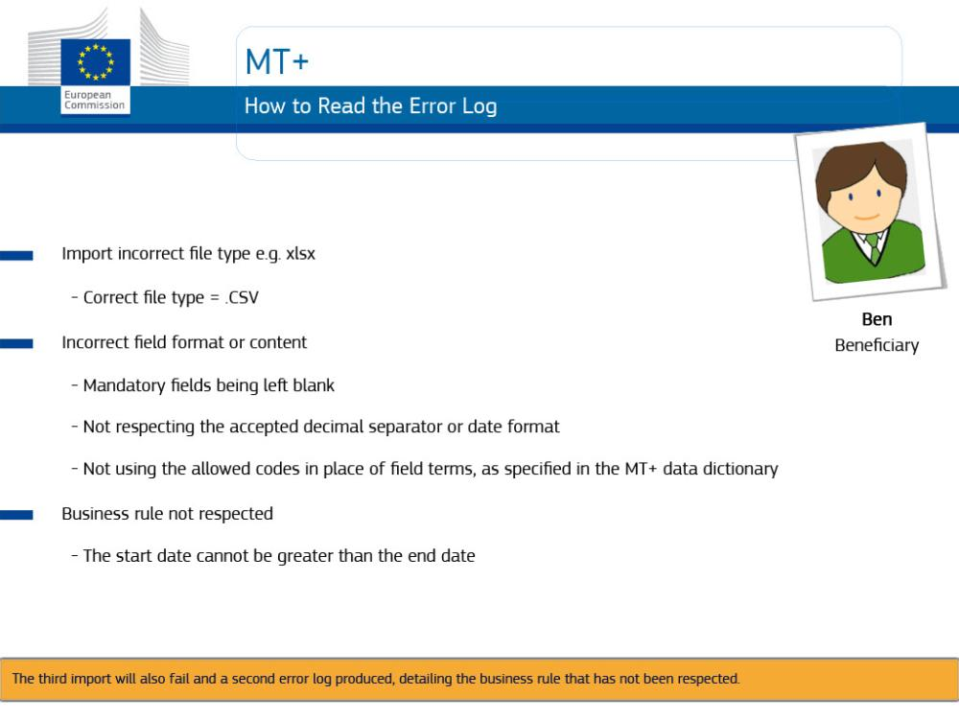
Text Captions

Ben is a beneficiary. You will see Ben attempting to import a file 4 times and it will fail 3 times.

The first time, the import will fail due to importing an incorrect file type.

The second import will fail due to validation rules for cell format and content, such as...

Mandatory fields being left blank, not respecting the accepted decimal separator or date format, not using the allowed codes in place of field terms, as specified in the MT+ data dictionary.

The third import will also fail and a second error log produced, detailing the business rule that has not been respected.

Slide 5 - Slide 5
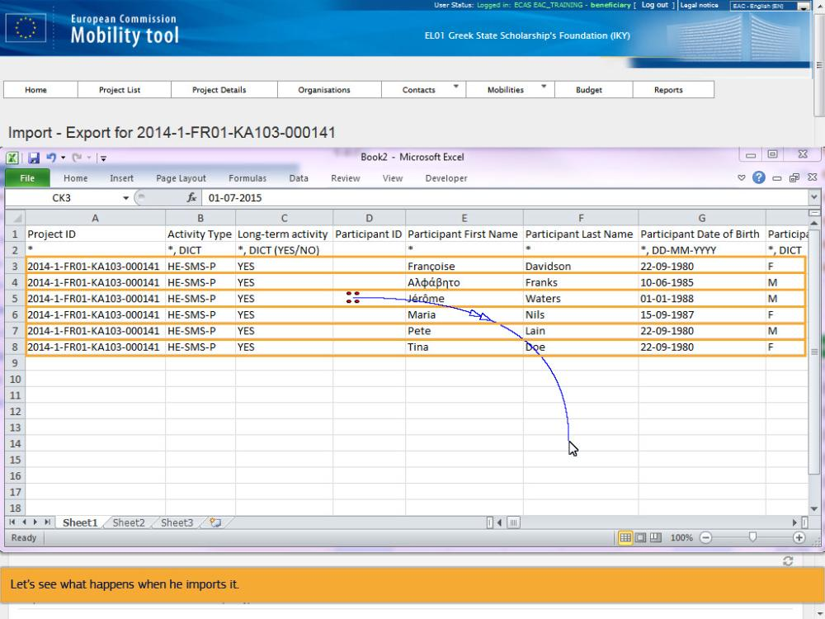
Text Captions

Ben has exported his template and has updated all of the mobility information but he did not save it as a CSV file type.

Let’s see what happens when he imports it.

Slide 6 - Slide 6
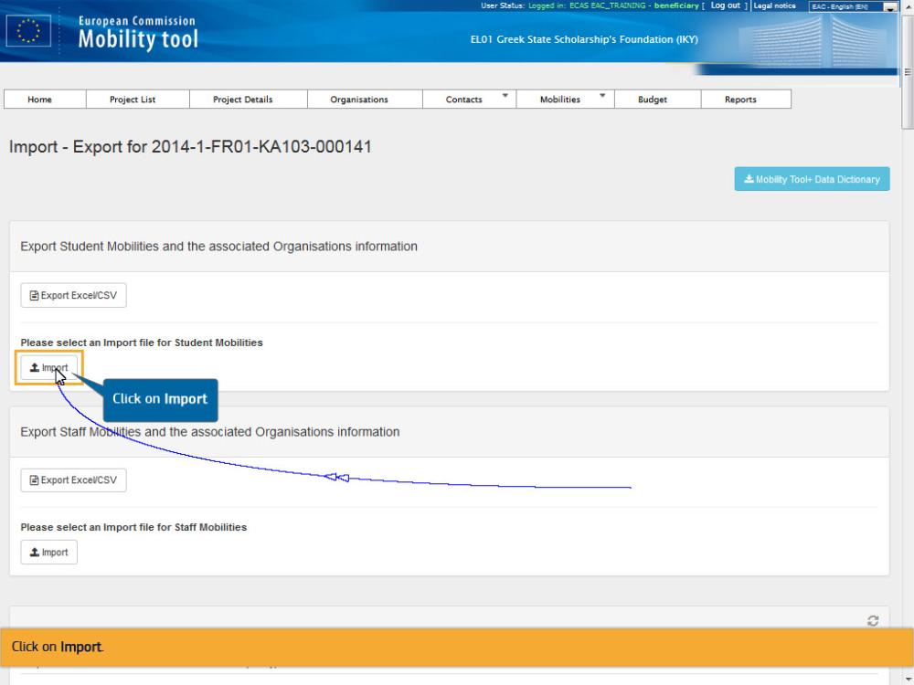
Text Captions

Click on Import.

Click on Import

Slide 7 - Slide 7
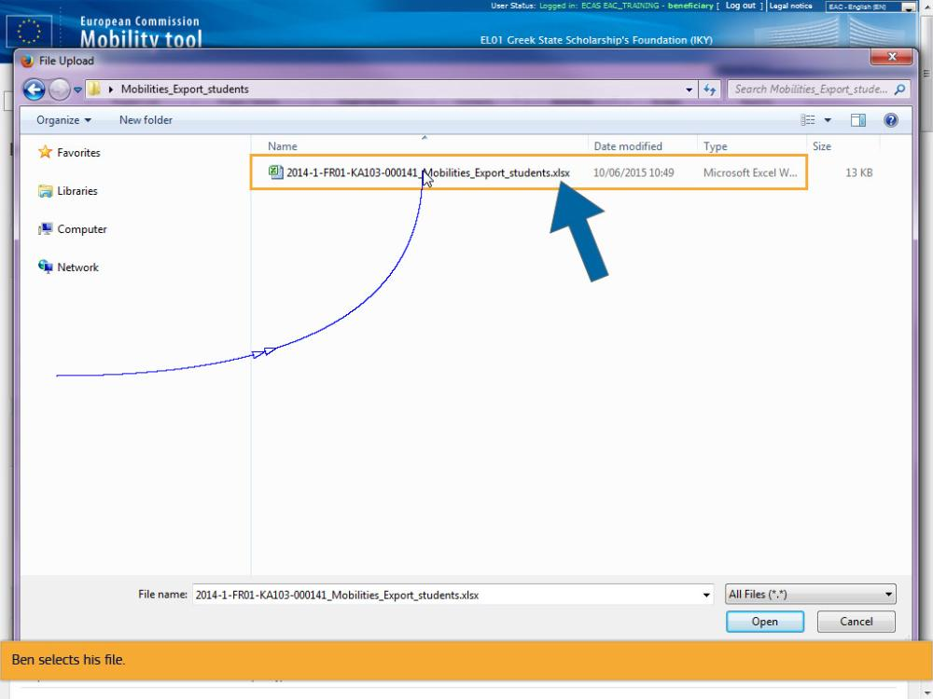
Text Captions

Ben selects his file.

Slide 8 - Slide 8
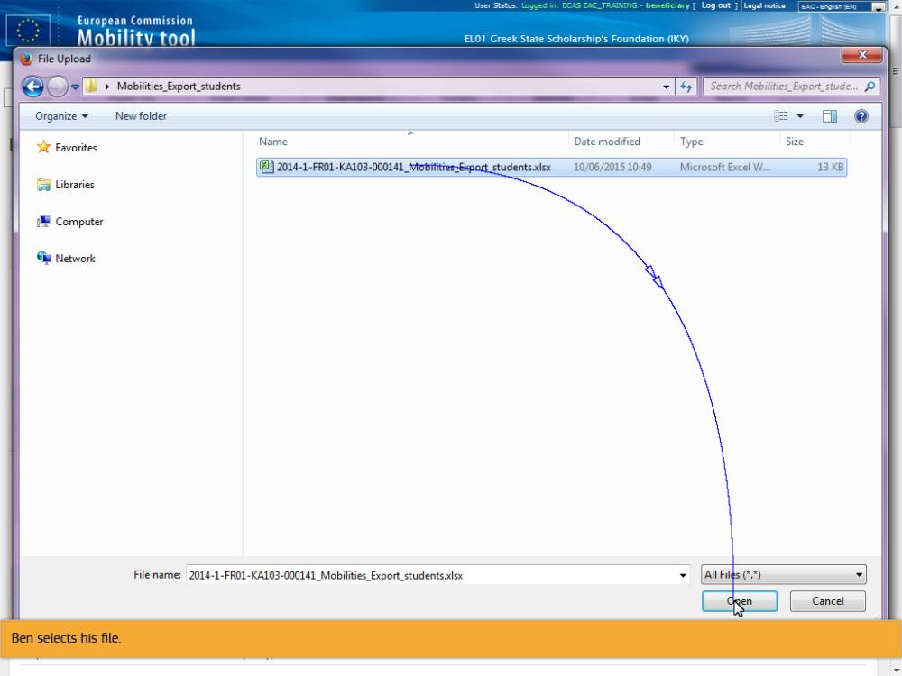
Text Captions

Ben selects his file.

Slide 9 - Slide 9
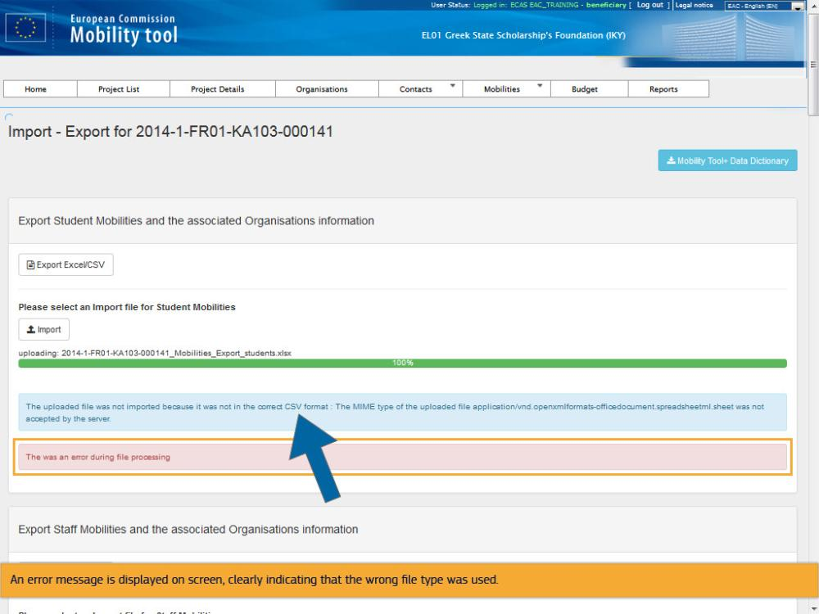
Text Captions

An error message is displayed on screen, clearly indicating that the wrong file type was used.

Slide 10 - Slide 10
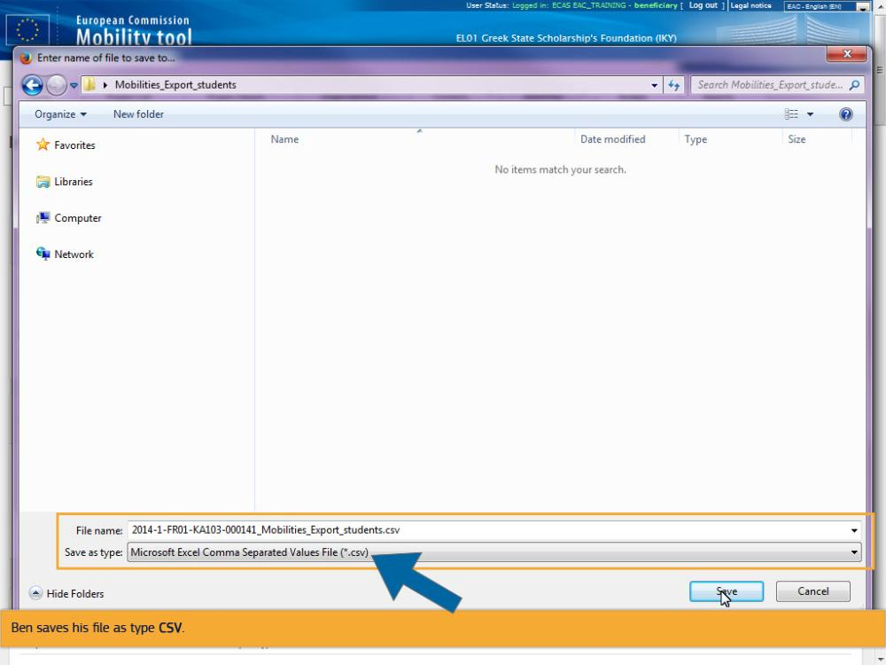
Text Captions

Ben saves his file as type CSV.

Slide 11 - Slide 11
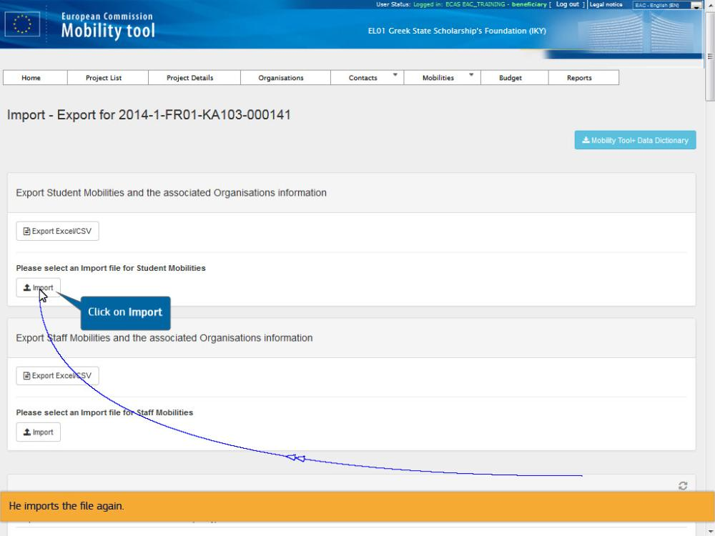
Text Captions

He imports the file again.

Click on Import

Slide 12 - Slide 12
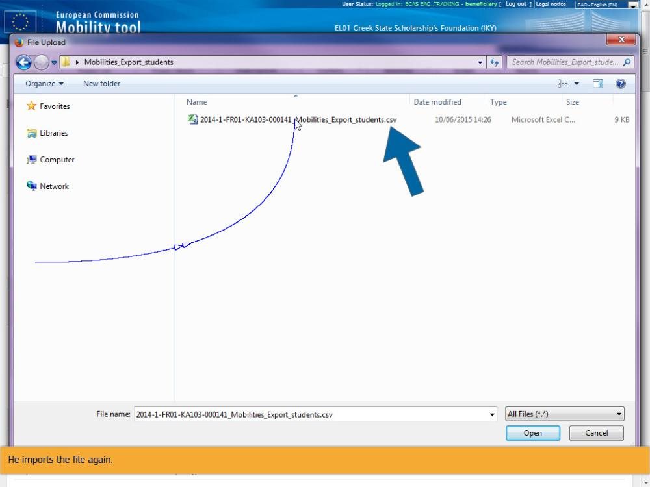
Text Captions

He imports the file again.

Slide 13 - Slide 13
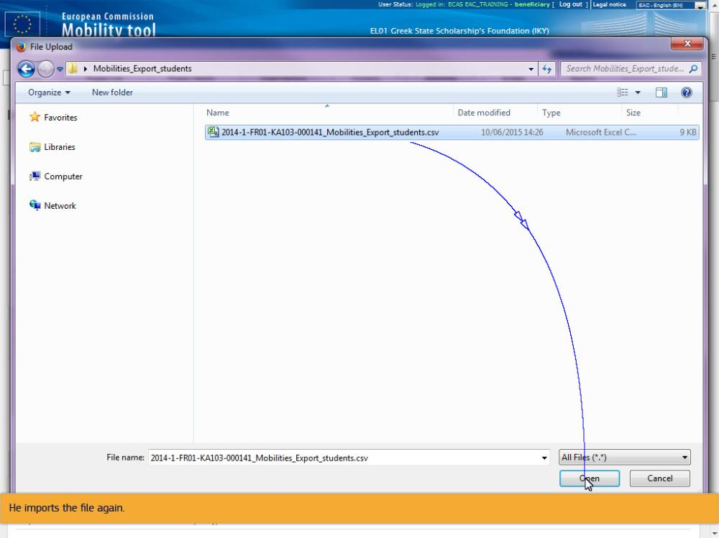
Text Captions

He imports the file again.

Slide 14 - Slide 14
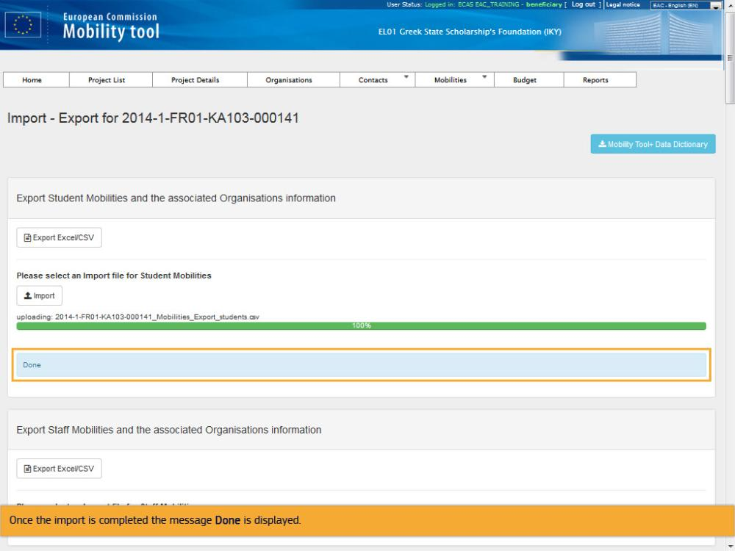
Text Captions

Once the import is completed the message Done is displayed.

Slide 15 - Slide 15
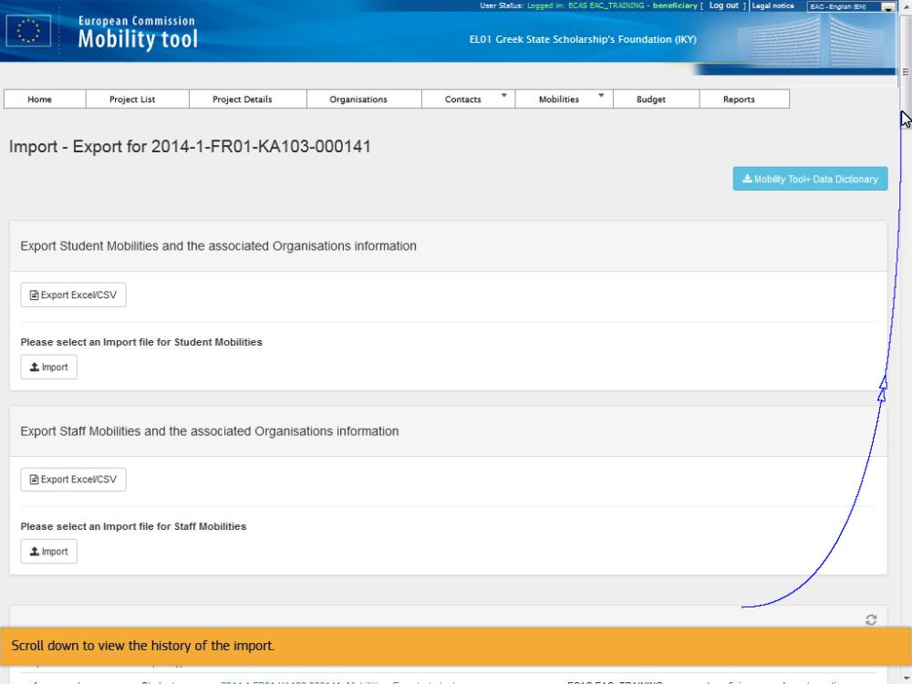
Text Captions

Scroll down to view the history of the import.

Slide 16 - Slide 16
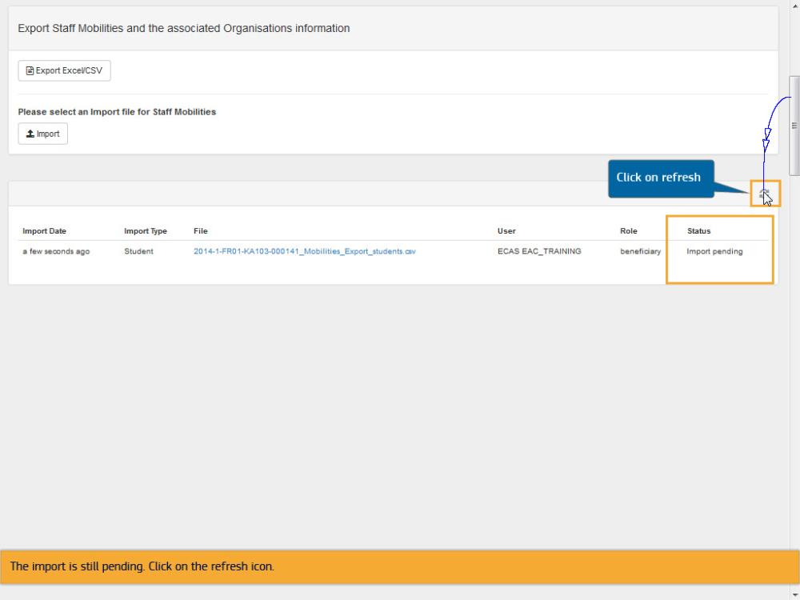
Text Captions

The import is still pending. Click on the refresh icon.

Click on refresh

Slide 17 - Slide 17
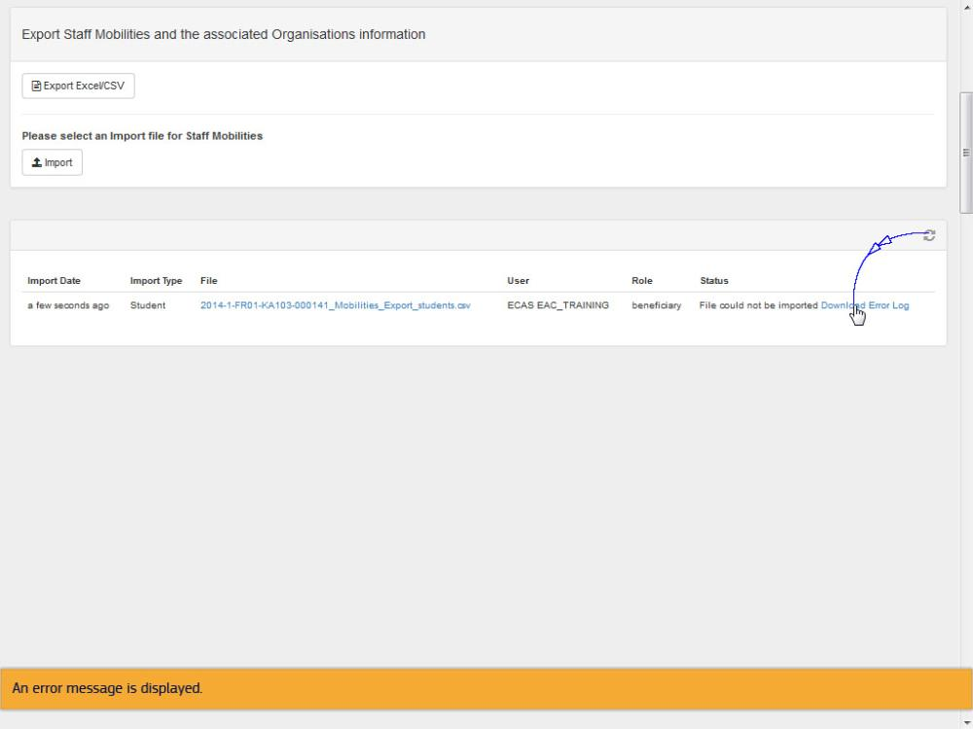
Text Captions

An error message is displayed.

Slide 18 - Slide 18
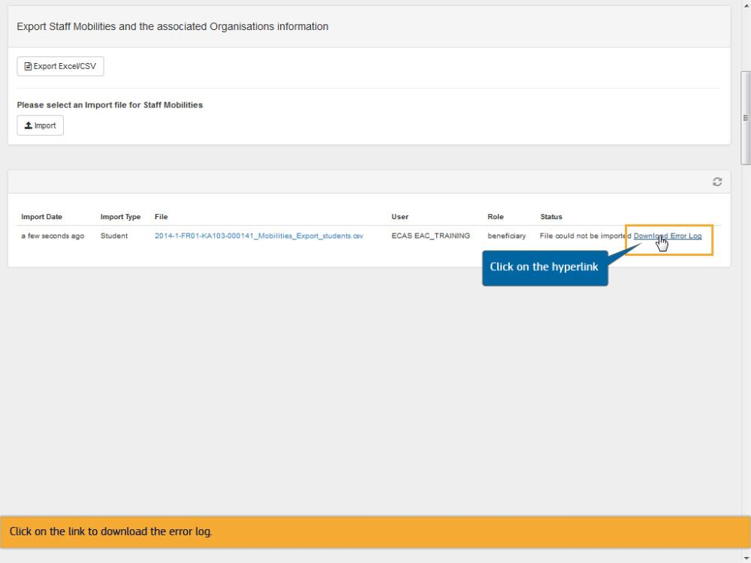
Text Captions

Click on the link to download the error log.

Click on the hyperlink

Slide 19 - Slide 19
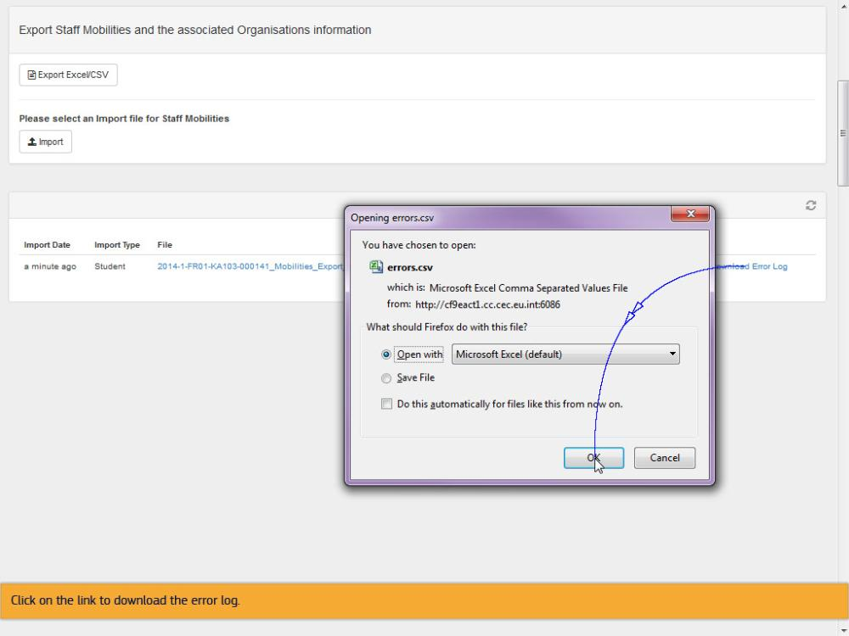
Text Captions

Click on the link to download the error log.

Slide 20 - Slide 20
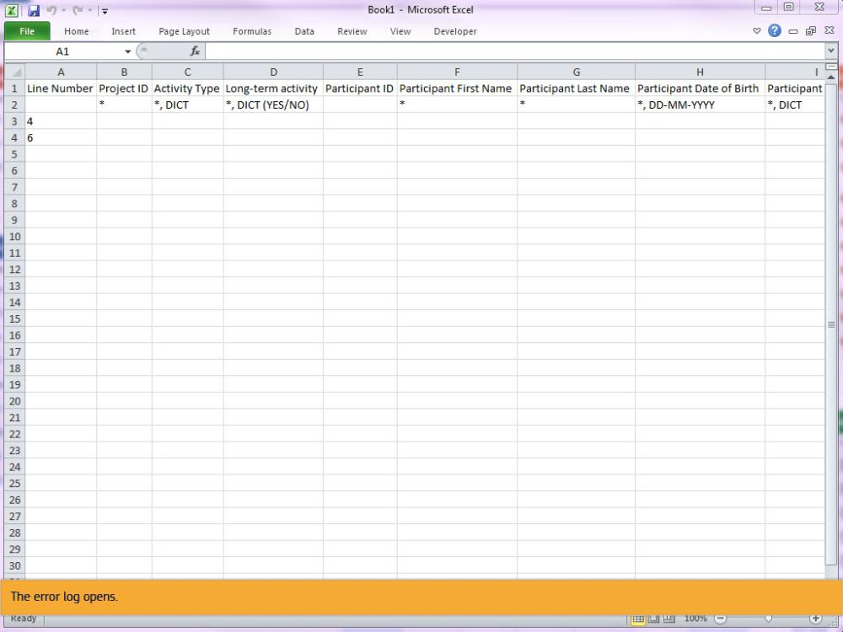
Text Captions

The error log opens.

Slide 21 - Slide 21
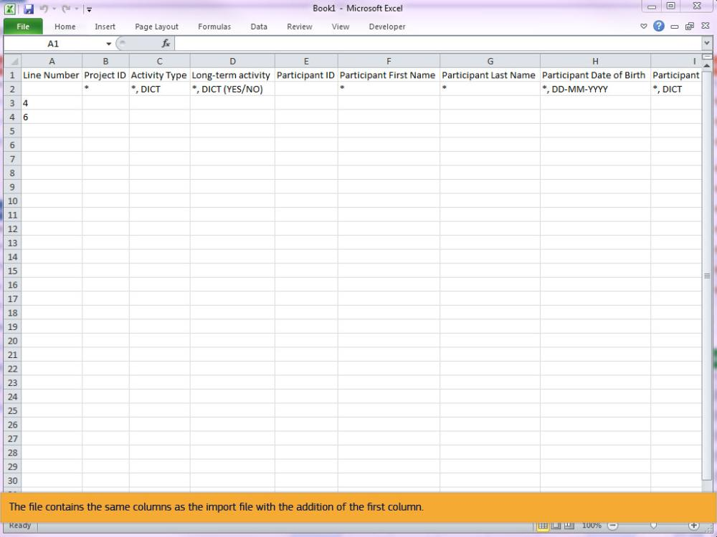
Text Captions

The file contains the same columns as the import file with the addition of the first column.

Slide 22 - Slide 22
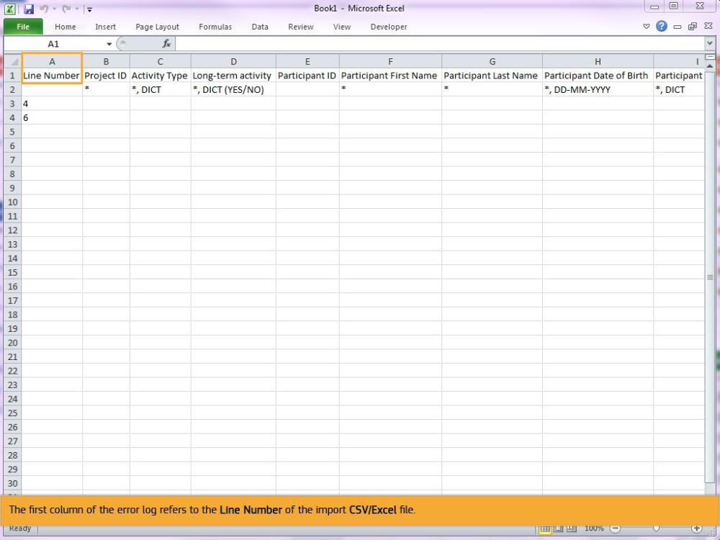
Text Captions

The first column of the error log refers to the Line Number of the import CSV/Excel file.

Slide 23 - Slide 23
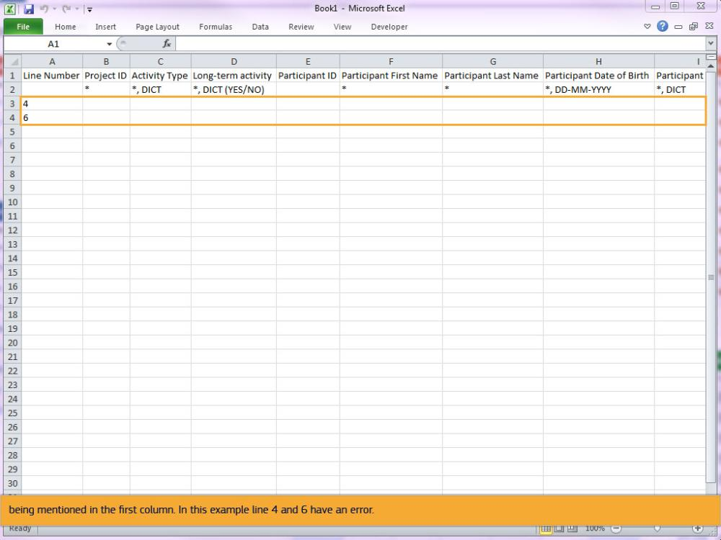
Text Captions

Only lines that have an error will be mentioned in the error log. This will be indicated by the line number of the import file being mentioned in the first column. In this example line 4 and 6 have an error.

Slide 24 - Slide 24
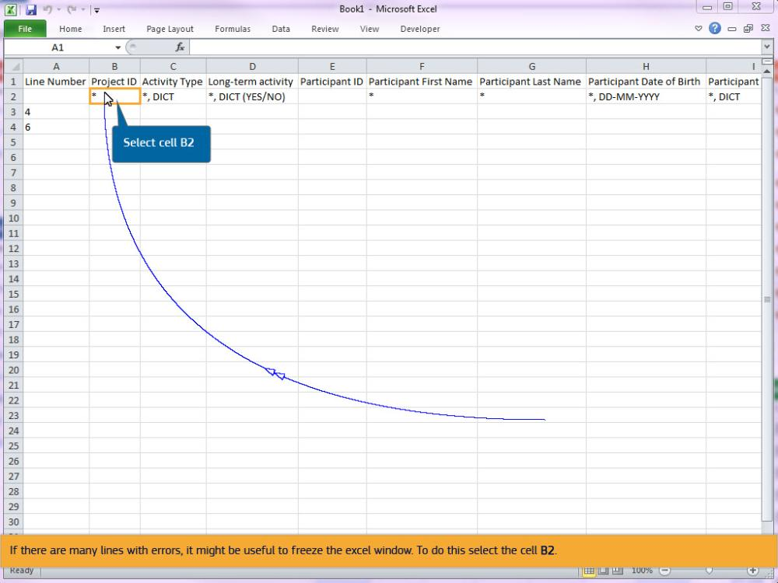
Text Captions

If there are many lines with errors, it might be useful to freeze the excel window. To do this select the cell B2.

Select cell B2

Slide 25 - Slide 25
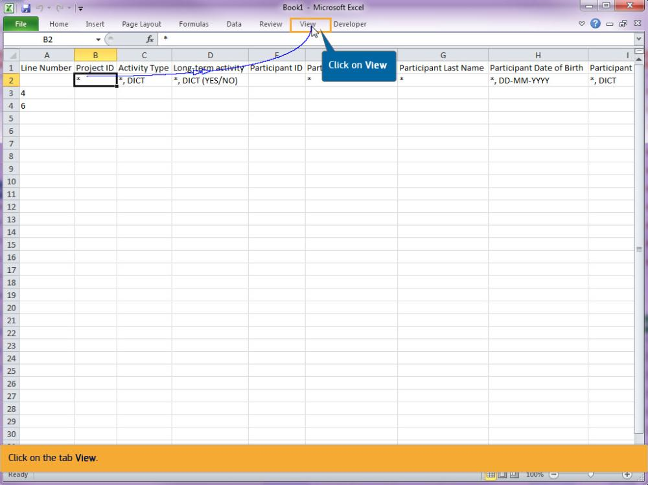
Text Captions

Click on the tab View.

Click on View

Slide 26 - Slide 26
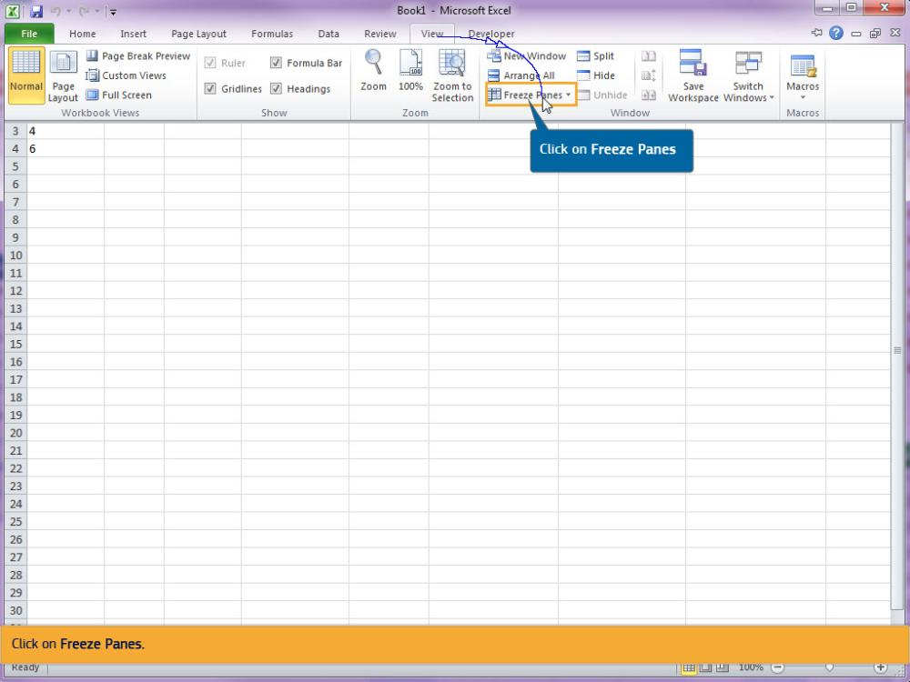
Text Captions

Click on Freeze Panes.

Click on Freeze Panes

Slide 27 - Slide 27
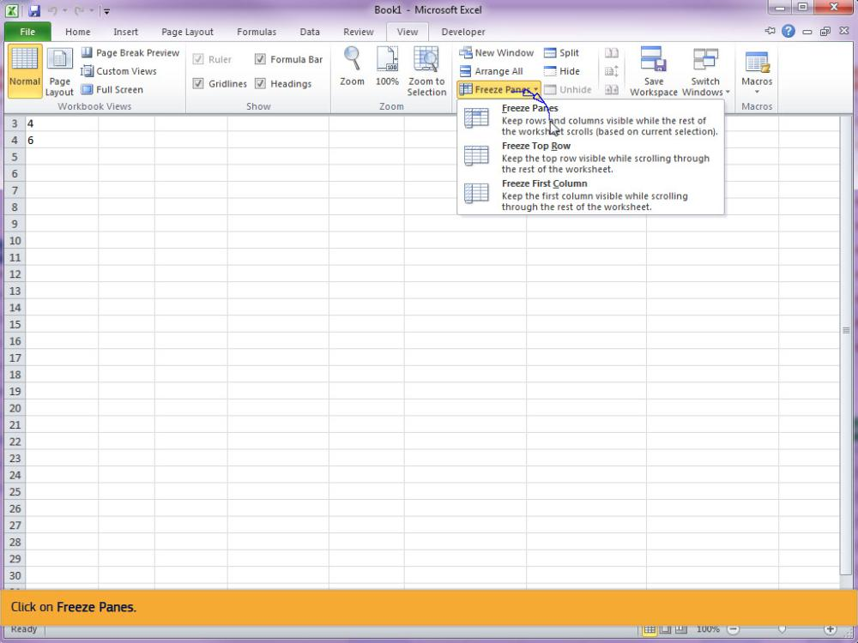
Text Captions

Click on Freeze Panes.

Slide 28 - Slide 28
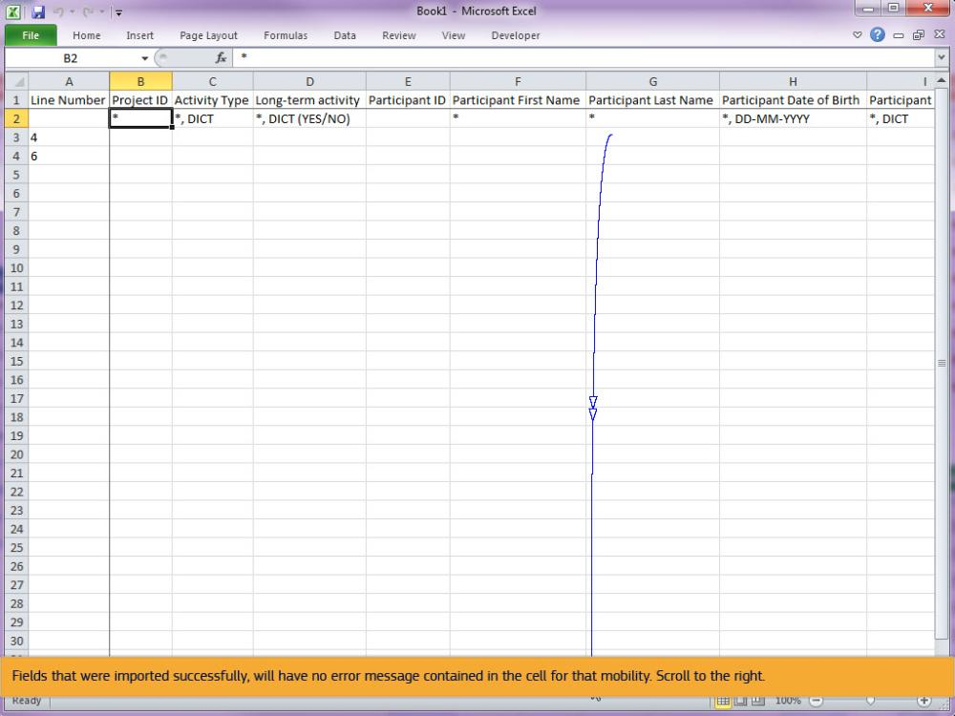
Text Captions

Fields that were imported successfully, will have no error message contained in the cell for that mobility. Scroll to the right.

Slide 29 - Slide 29
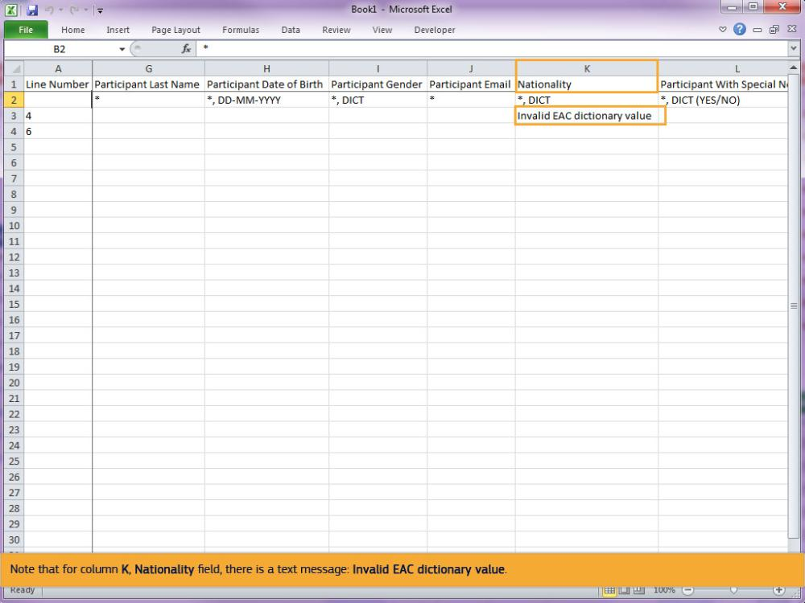
Text Captions

Note that for column K, Nationality field, there is a text message: Invalid EAC dictionary value.

Slide 30 - Slide 30
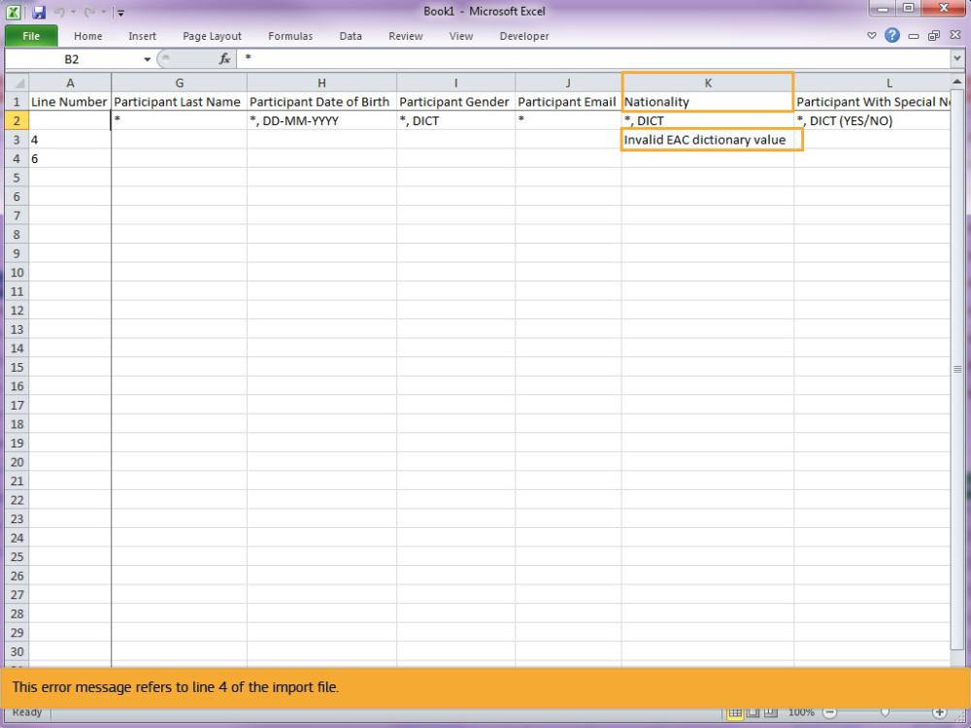
Text Captions

This error message refers to line 4 of the import file.

Slide 31 - Slide 31
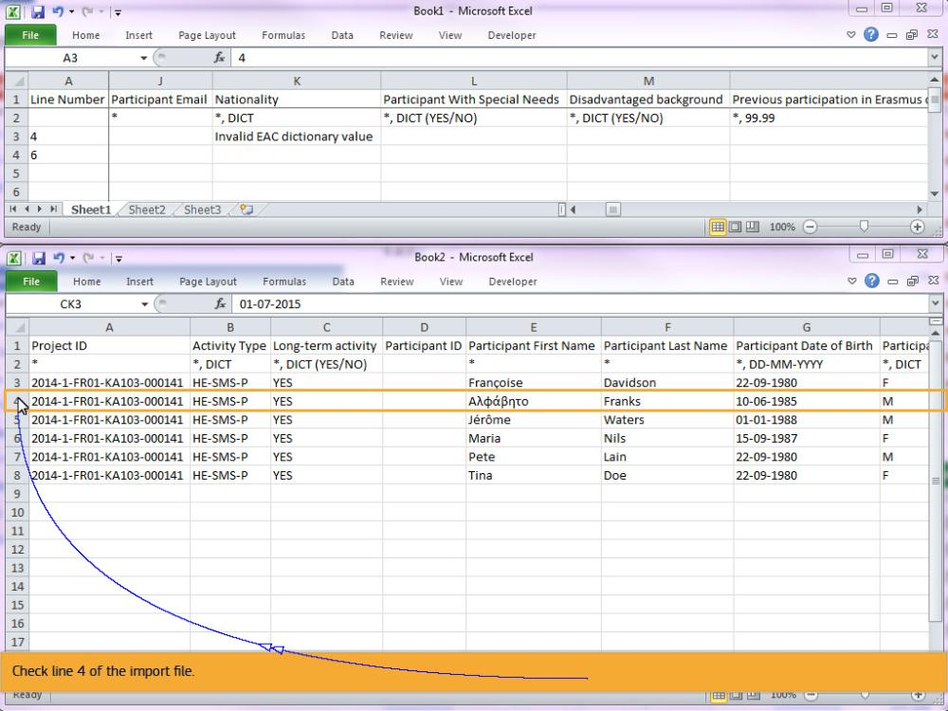
Text Captions

Check line 4 of the import file.

Slide 32 - Slide 32
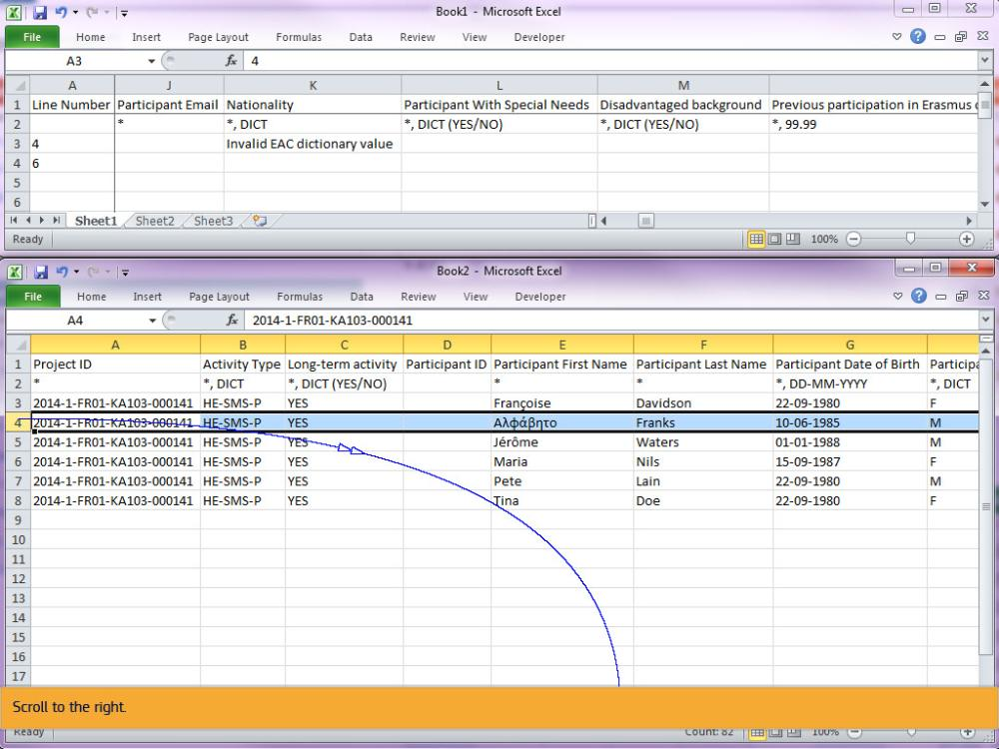
Text Captions

Scroll to the right.

Slide 33 - Slide 33
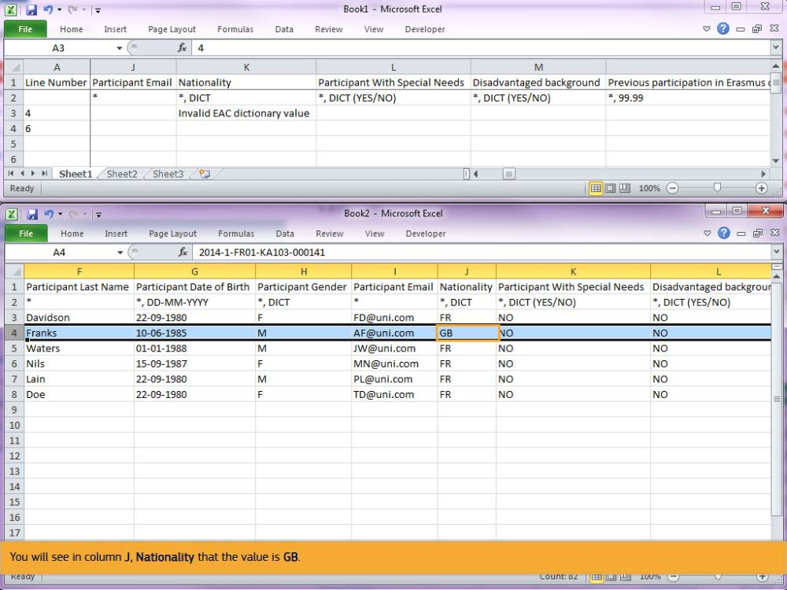
Text Captions

You will see in column J, Nationality that the value is GB.

Slide 34 - Slide 34
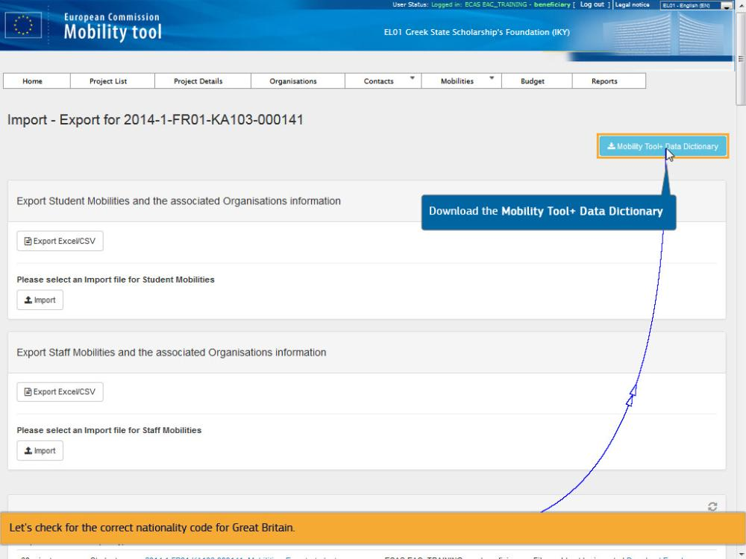
Text Captions

From the Import - Export screen, download the Mobility Tool+ Data Dictionary.

Let's check for the correct nationality code for Great Britain.

Download the Mobility Tool+ Data Dictionary

Slide 35 - Slide 35
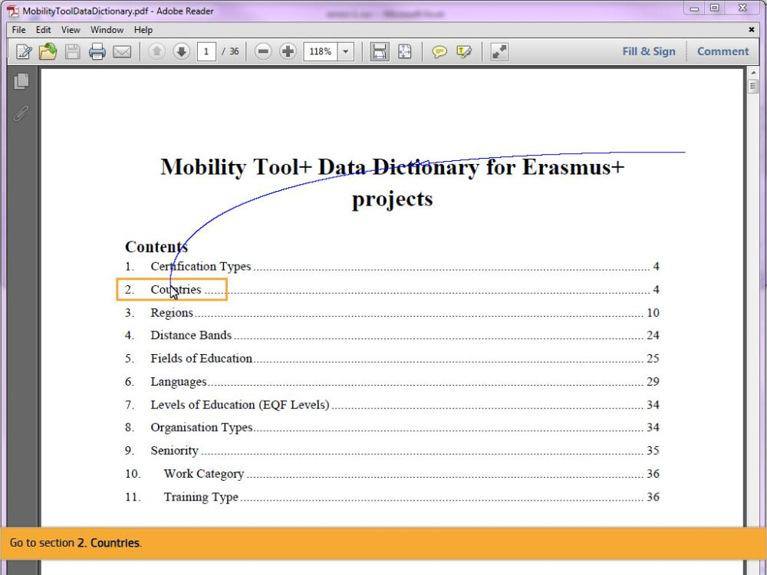
Text Captions

Go to section 2. Countries.

Slide 36 - Slide 36
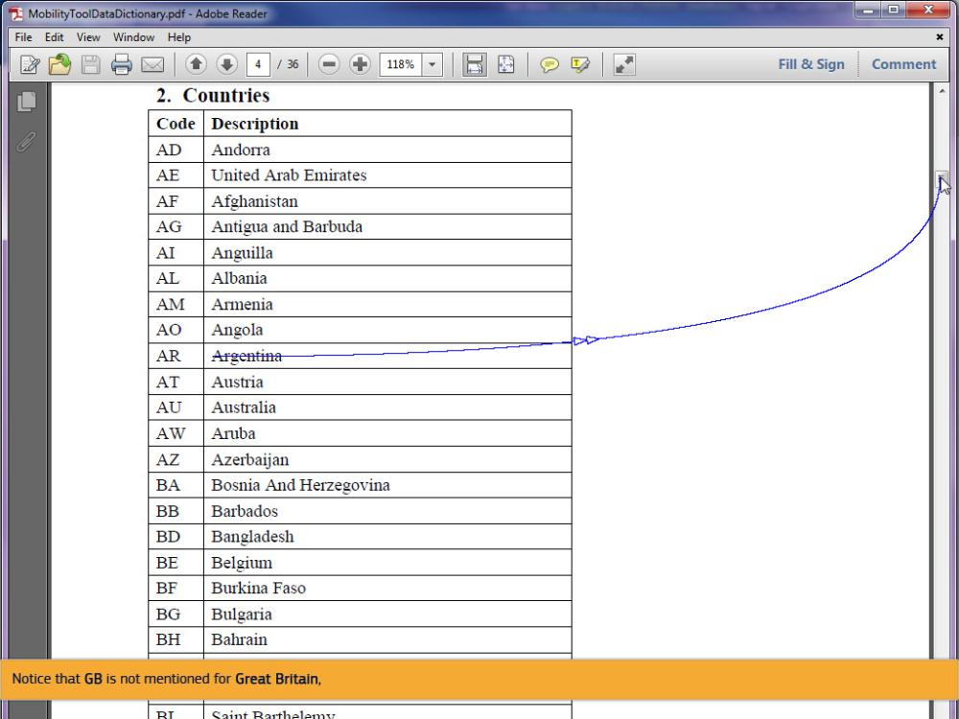
Text Captions

Notice that GB is not mentioned for Great Britain,

Slide 37 - Slide 37
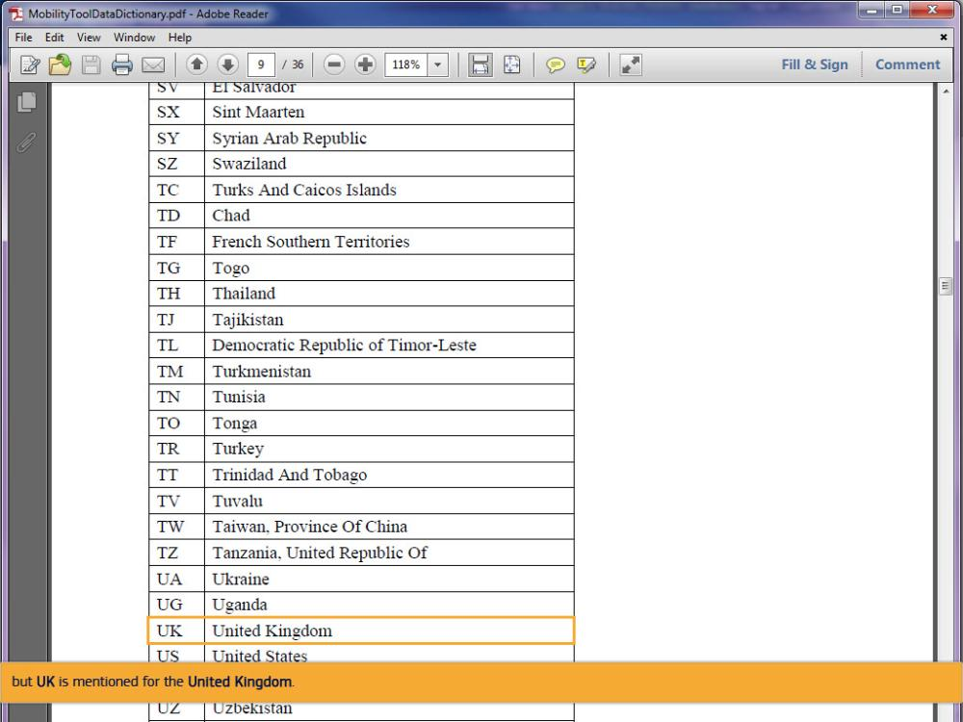
Text Captions

but UK is mentioned for the United Kingdom.

Slide 38 - Slide 38
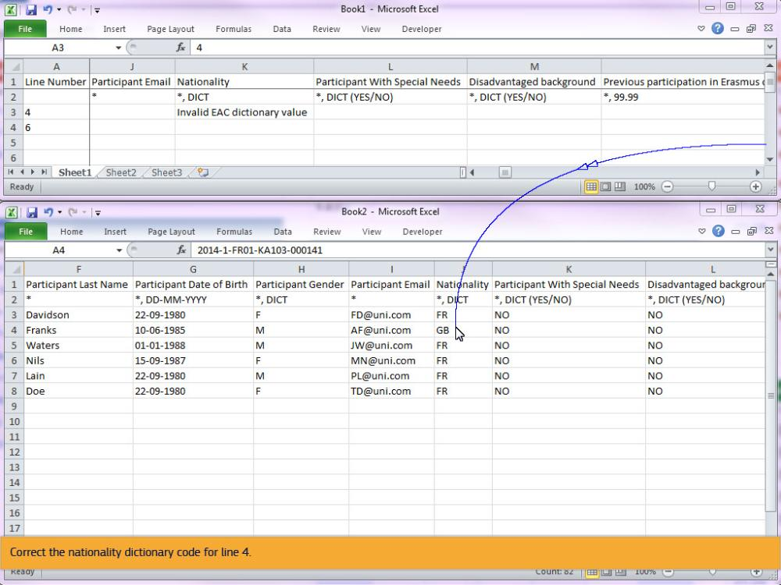
Text Captions

Correct the nationality dictionary code for line 4.

Slide 42 - Slide 42
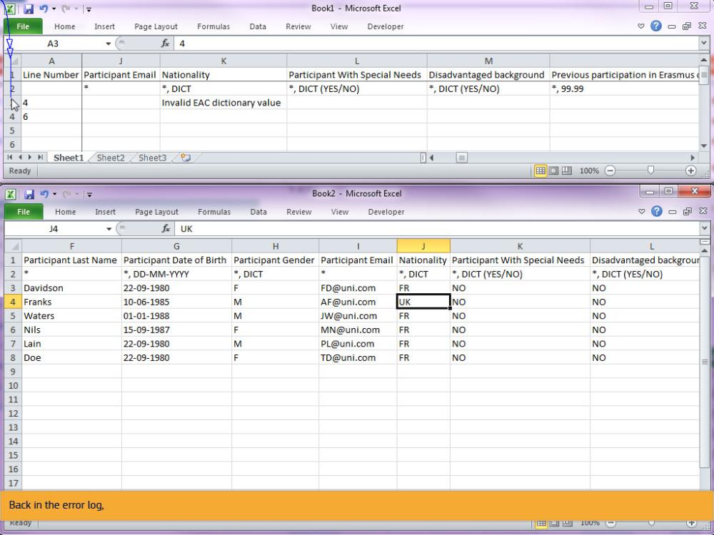
Text Captions

Back in the error log,

Slide 44 - Slide 44
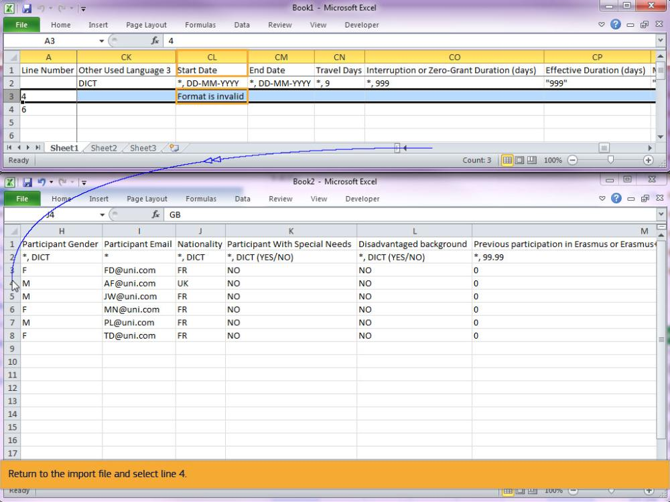
Text Captions

in column CL, Start Date of the mobility, the message displayed is Format is invalid.

Return to the import file and select line 4.

Slide 45 - Slide 45
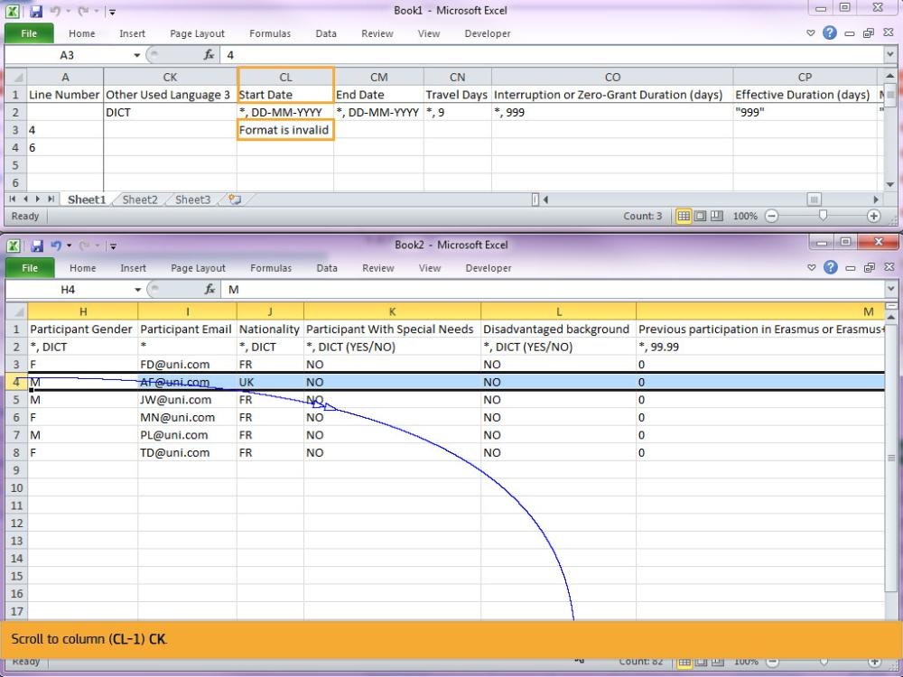
Text Captions

Scroll to column (CL-1) CK.

Slide 46 - Slide 46
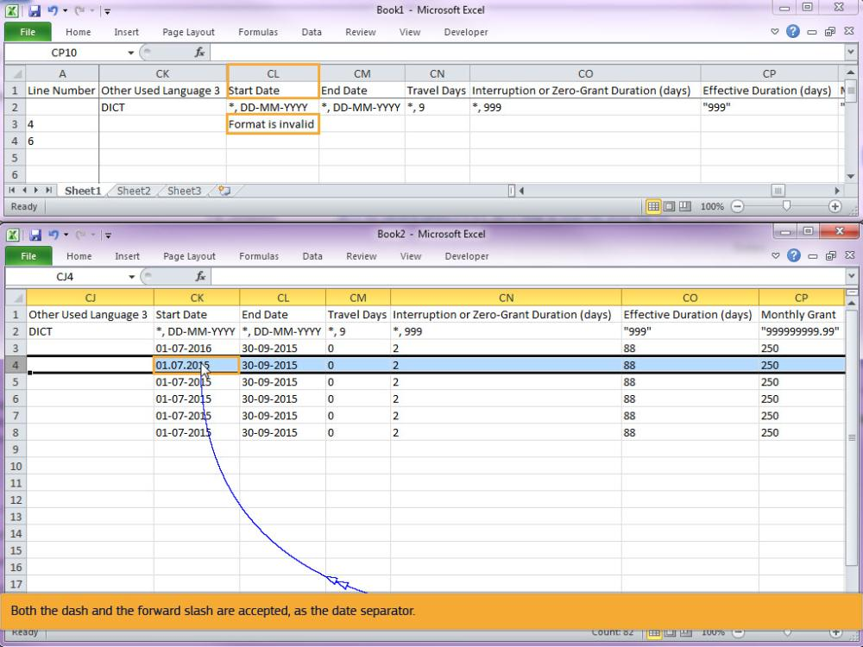
Text Captions

As you see, dots have been used to separate the date format. Correct the format of the date, replacing the dots with dashes.

Both the dash and the forward slash are accepted, as the date separator.

Slide 49 - Slide 49
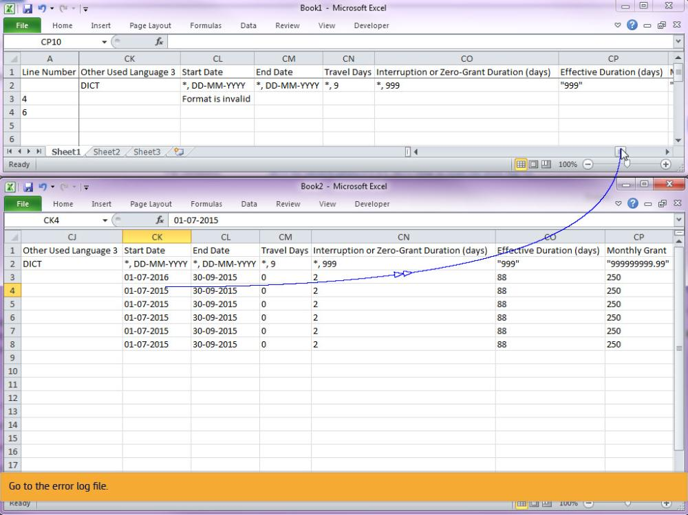
Text Captions

Go to the error log file.

Slide 50 - Slide 50
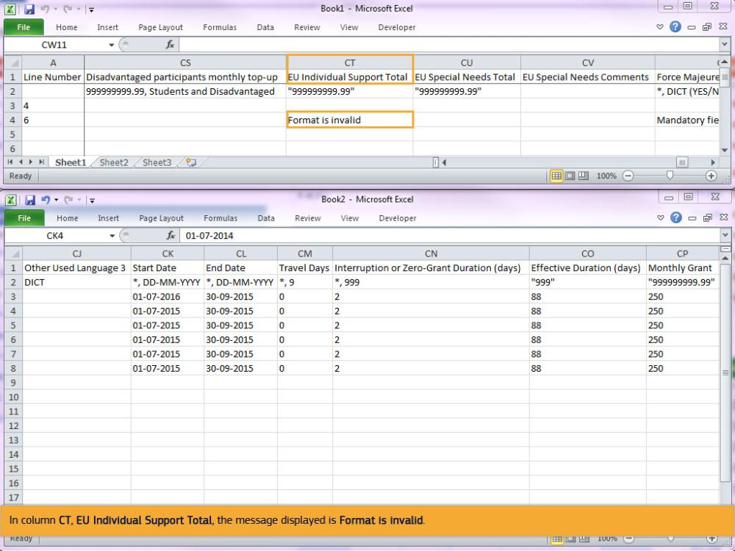
Text Captions

In column CT, EU Individual Support Total, the message displayed is Format is invalid.

Slide 51 - Slide 51
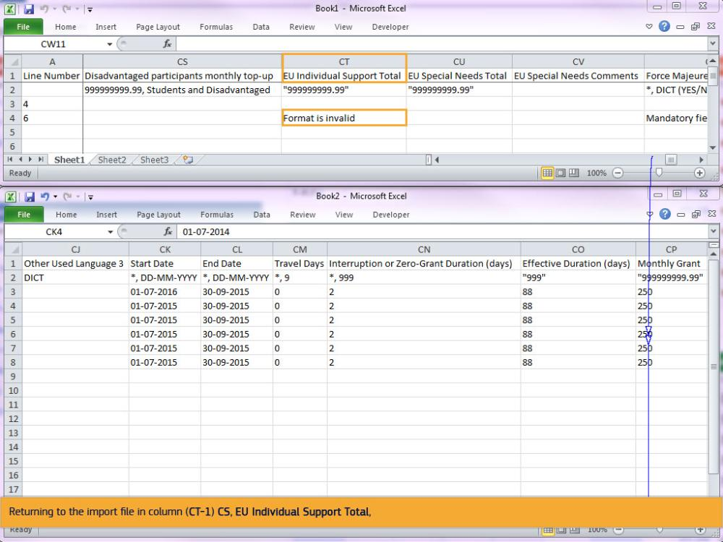
Text Captions

Returning to the import file in column (CT-1) CS, EU Individual Support Total,

Slide 52 - Slide 52
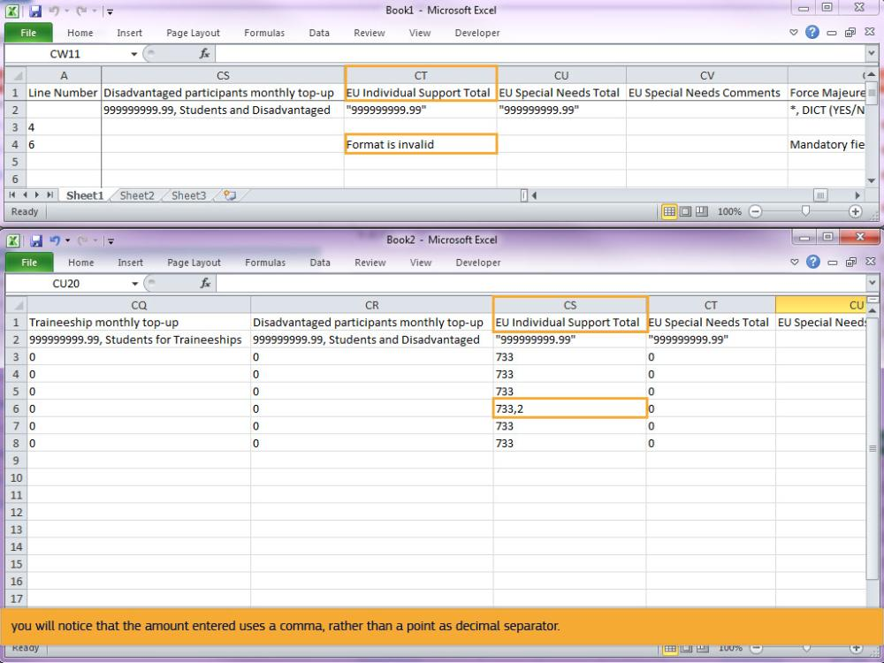
Text Captions

you will notice that the amount entered uses a comma, rather than a point as decimal separator.

Slide 53 - Slide 53
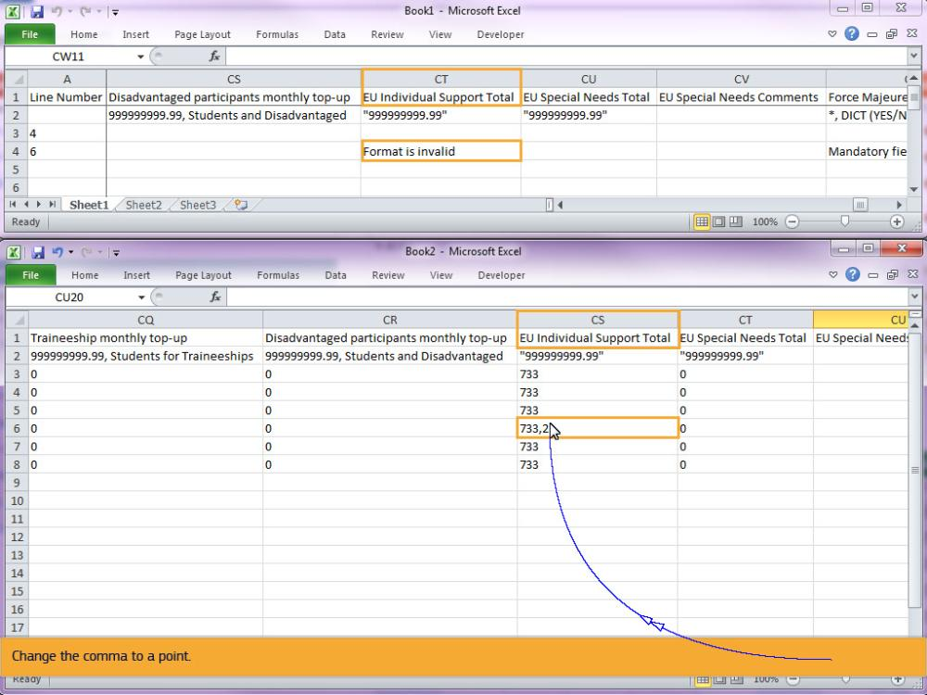
Text Captions

Change the comma to a point.

Slide 55 - Slide 55
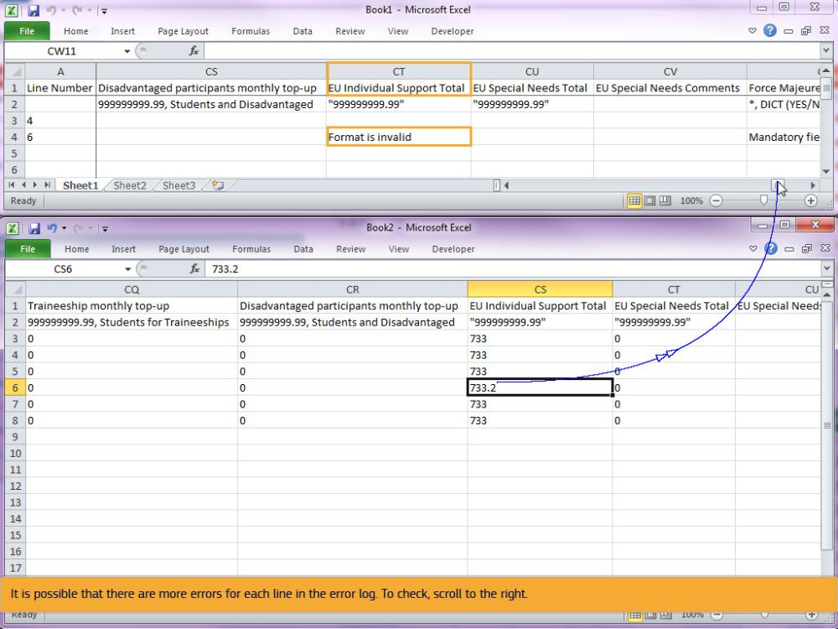
Text Captions

It is possible that there are more errors for each line in the error log. To check, scroll to the right.

Slide 56 - Slide 56
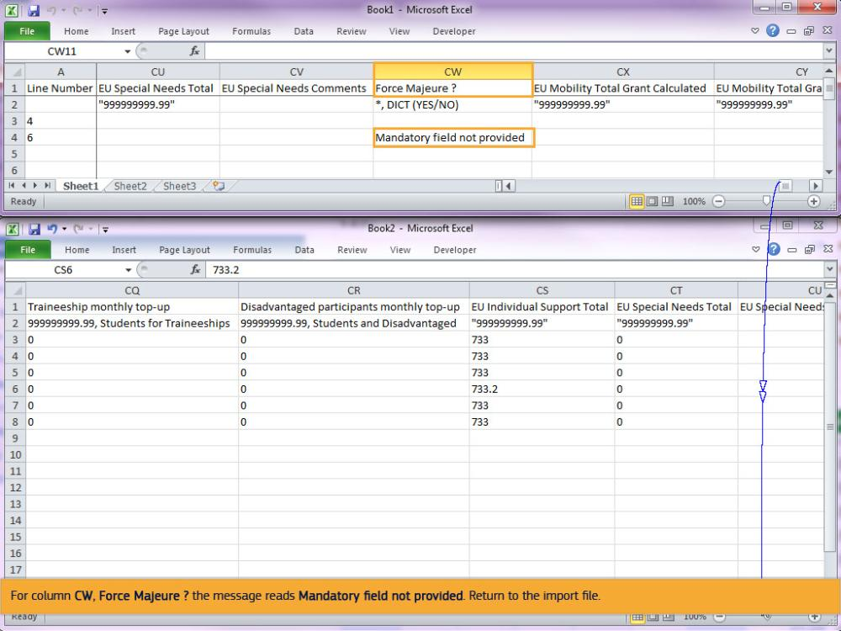
Text Captions

For column CW, Force Majeure ? the message reads Mandatory field not provided. Return to the import file.

Slide 57 - Slide 57
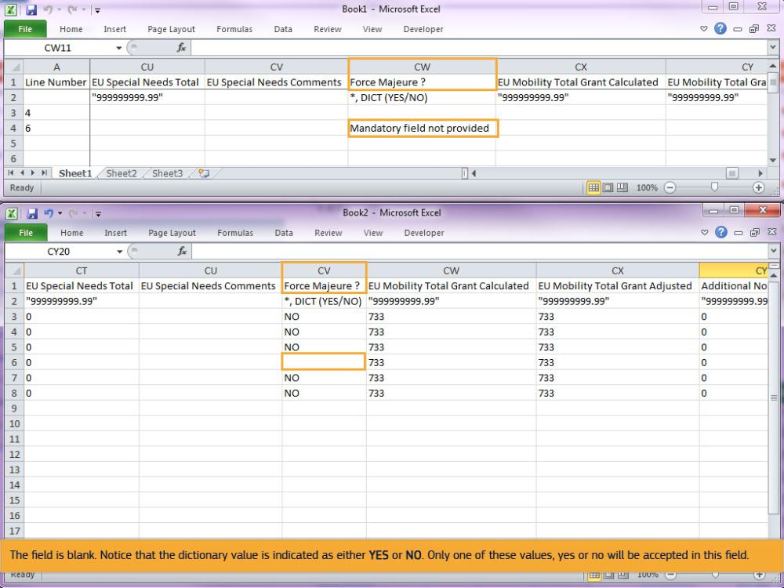
Text Captions

The field is blank. Notice that the dictionary value is indicated as either YES or NO. Only one of these values, yes or no will be accepted in this field.

Slide 59 - Slide 59
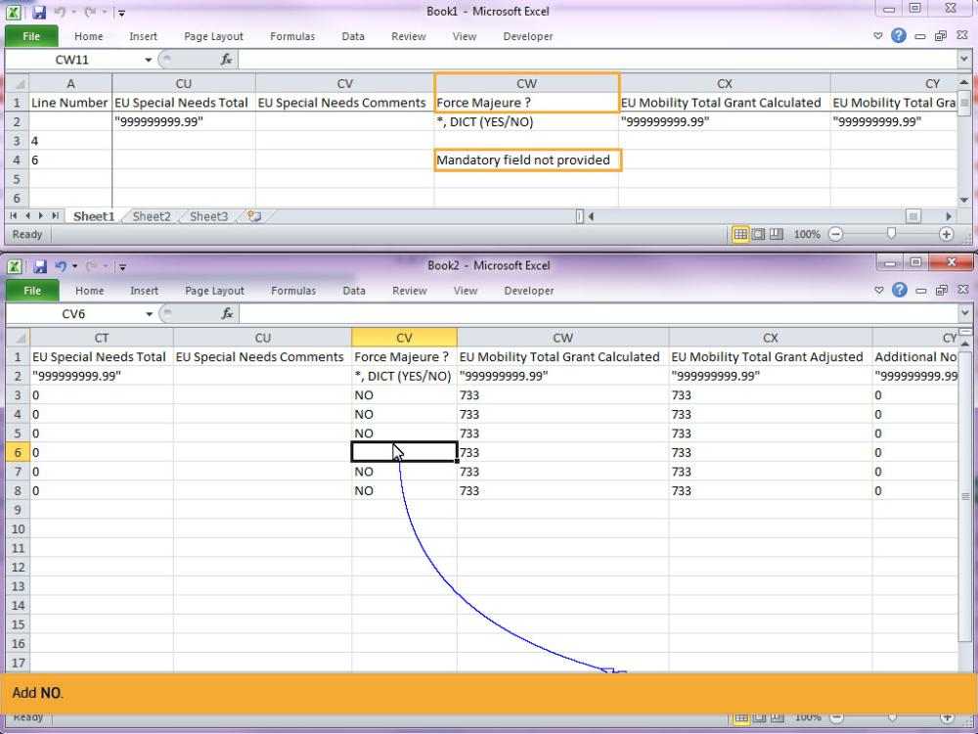
Text Captions

Add NO.

Slide 61 - Slide 61
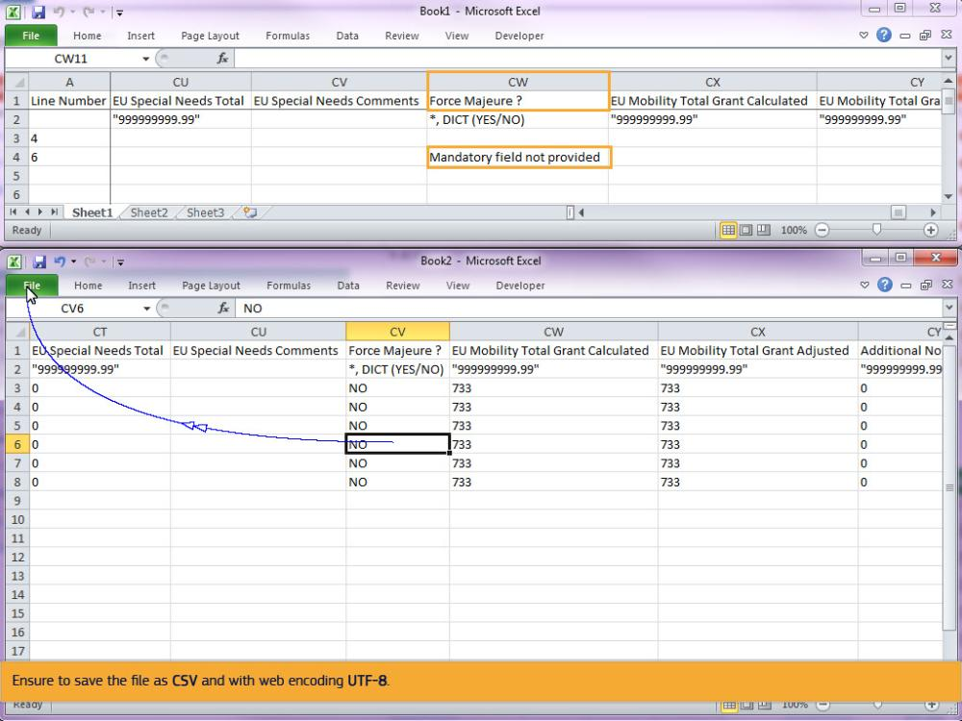
Text Captions

Ensure to save the file as CSV and with web encoding UTF-8.

Slide 62 - Slide 62
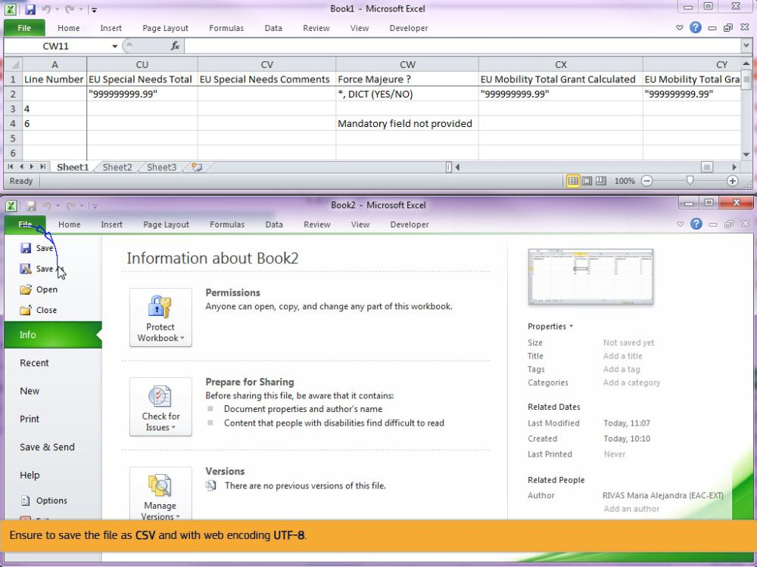
Text Captions

Ensure to save the file as CSV and with web encoding UTF-8.

Slide 63 - Slide 63
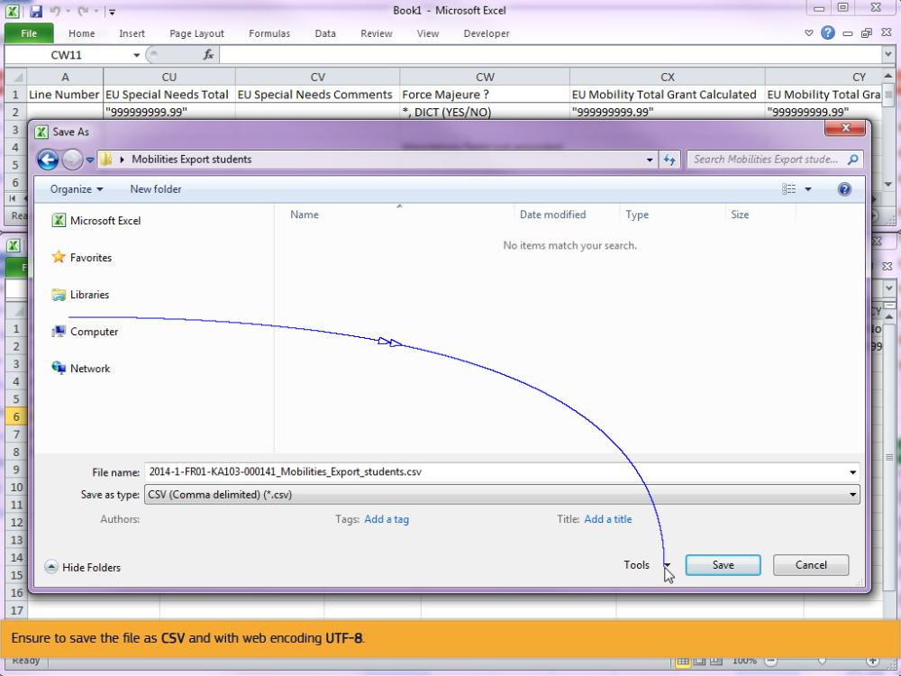
Text Captions

Ensure to save the file as CSV and with web encoding UTF-8.

Slide 64 - Slide 64
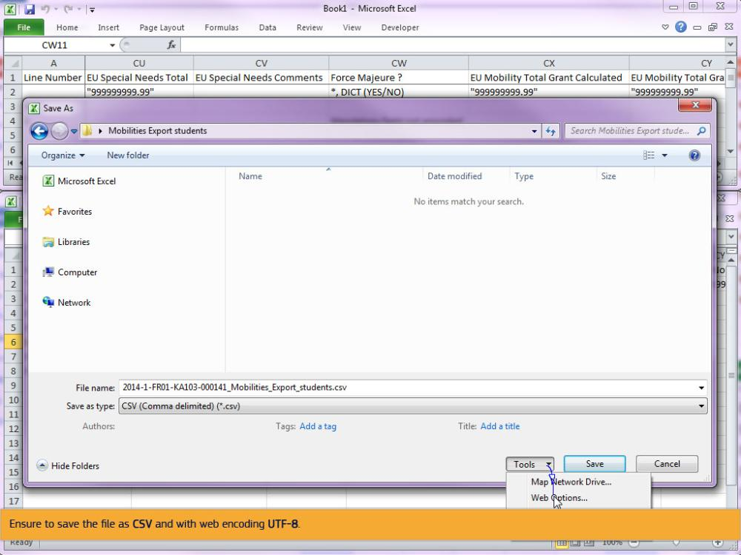
Text Captions

Ensure to save the file as CSV and with web encoding UTF-8.

Slide 65 - Slide 65
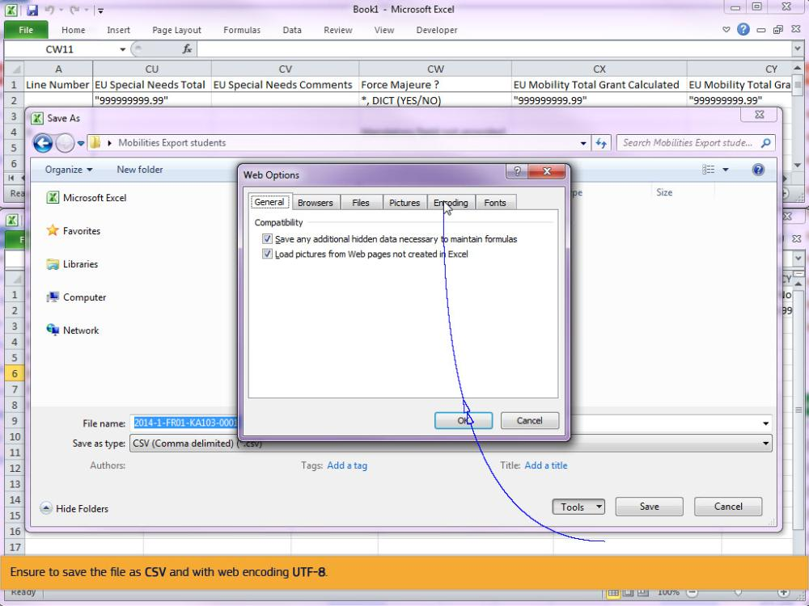
Text Captions

Ensure to save the file as CSV and with web encoding UTF-8.

Slide 66 - Slide 66
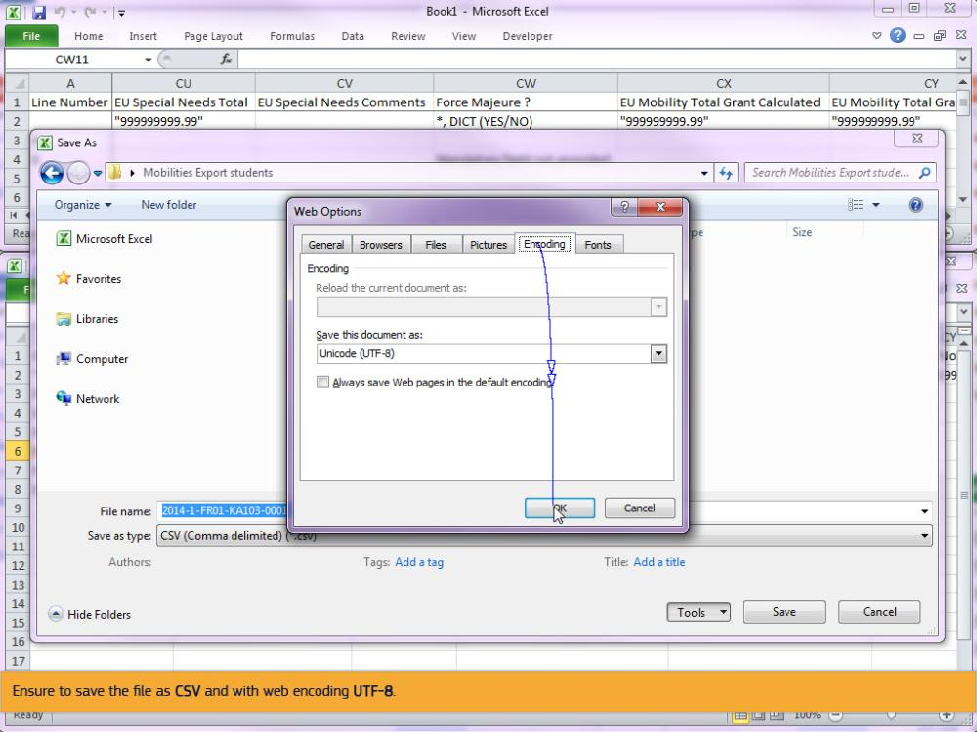
Text Captions

Ensure to save the file as CSV and with web encoding UTF-8.

Slide 67 - Slide 67
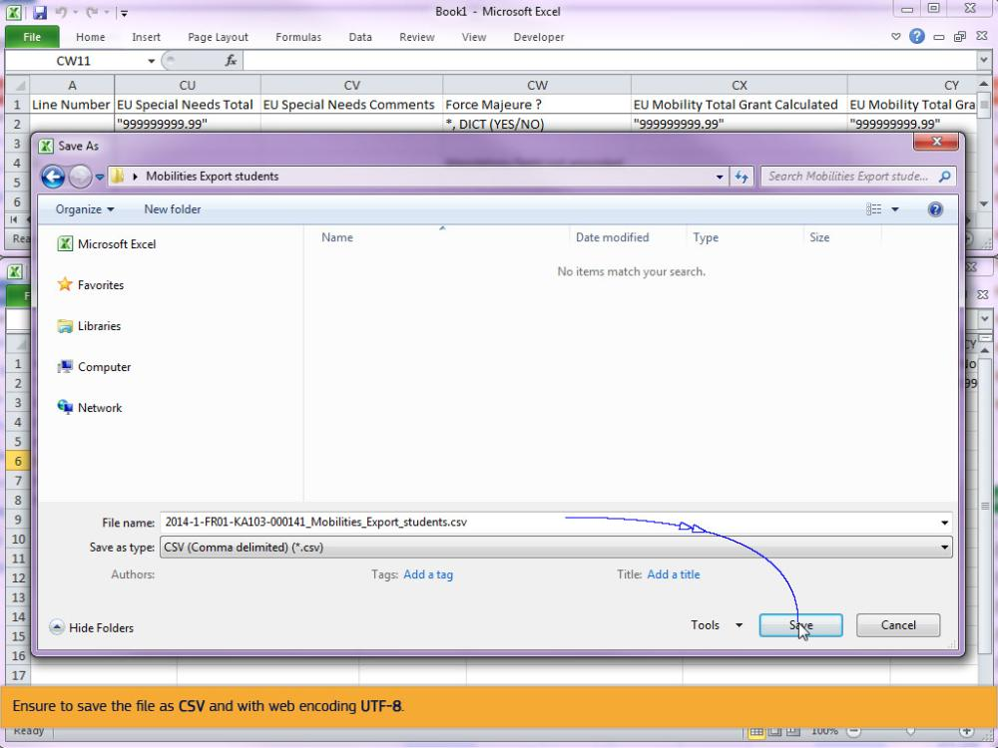
Text Captions

Ensure to save the file as CSV and with web encoding UTF-8.

Slide 68 - Slide 68
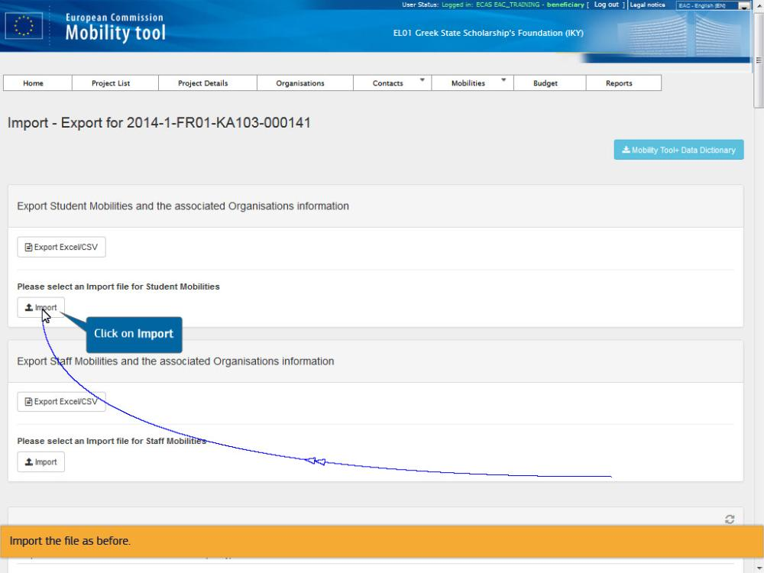
Text Captions

Import the file as before.

Click on Import

Slide 69 - Slide 69
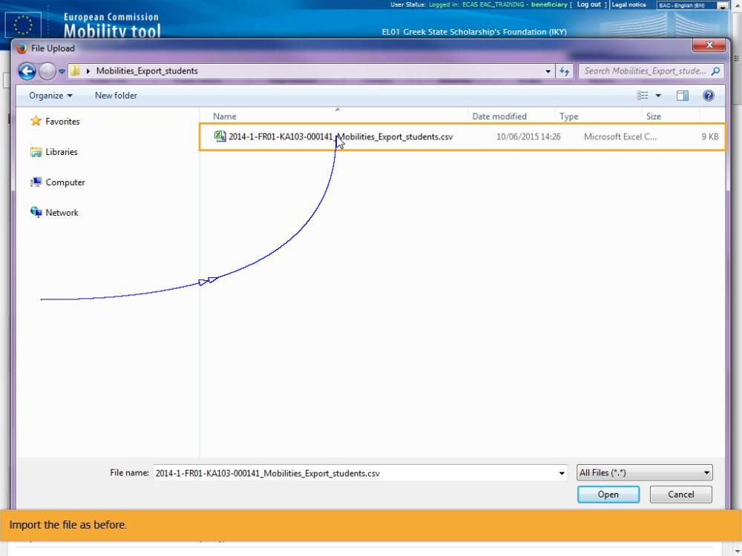
Text Captions

Import the file as before.

Slide 70 - Slide 70
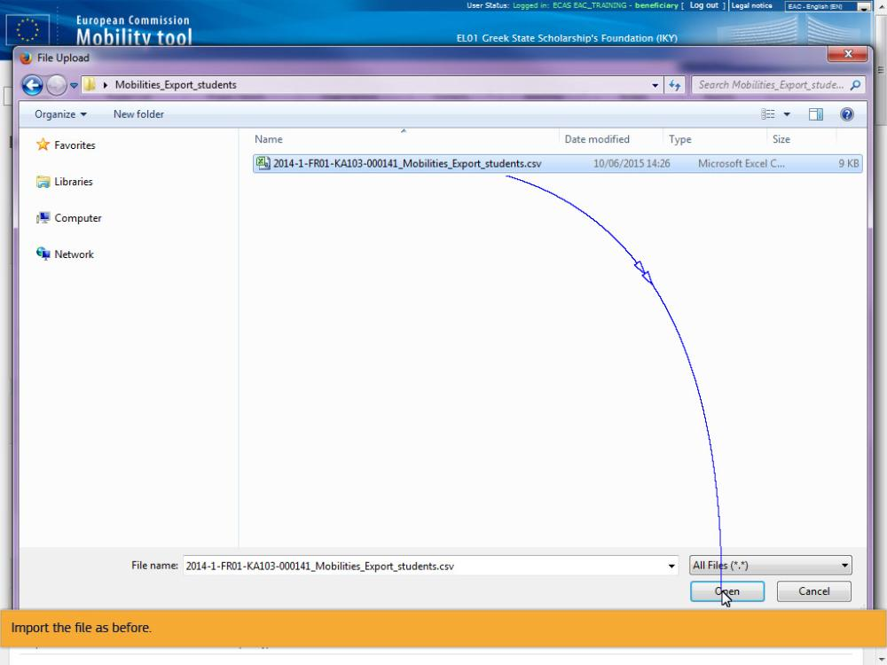
Text Captions

Import the file as before.

Slide 71 - Slide 71
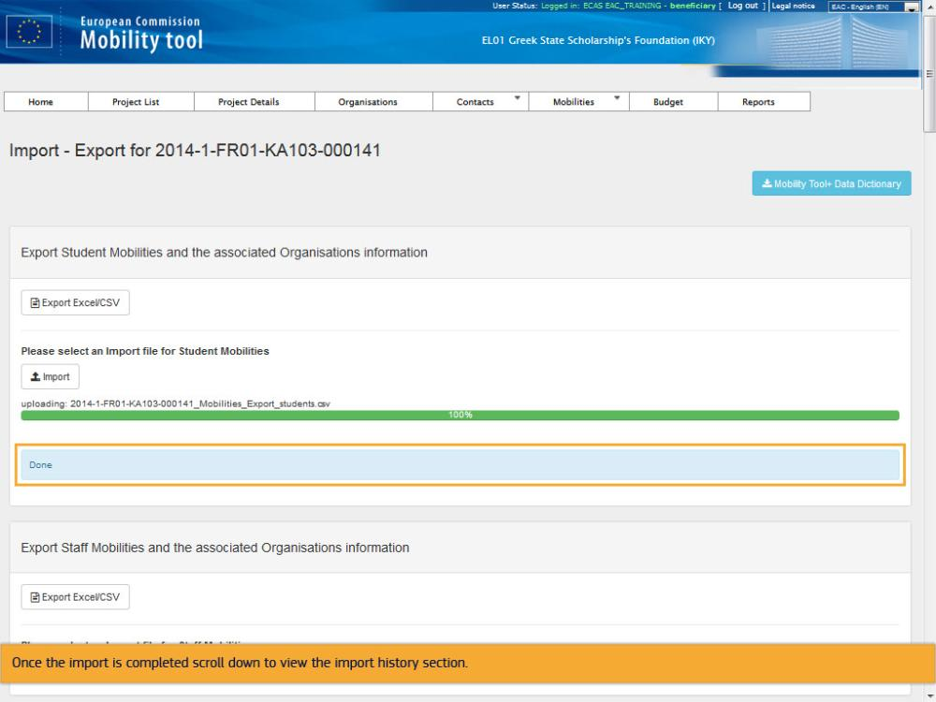
Text Captions

Once the import is completed scroll down to view the import history section.

Slide 72 - Slide 72
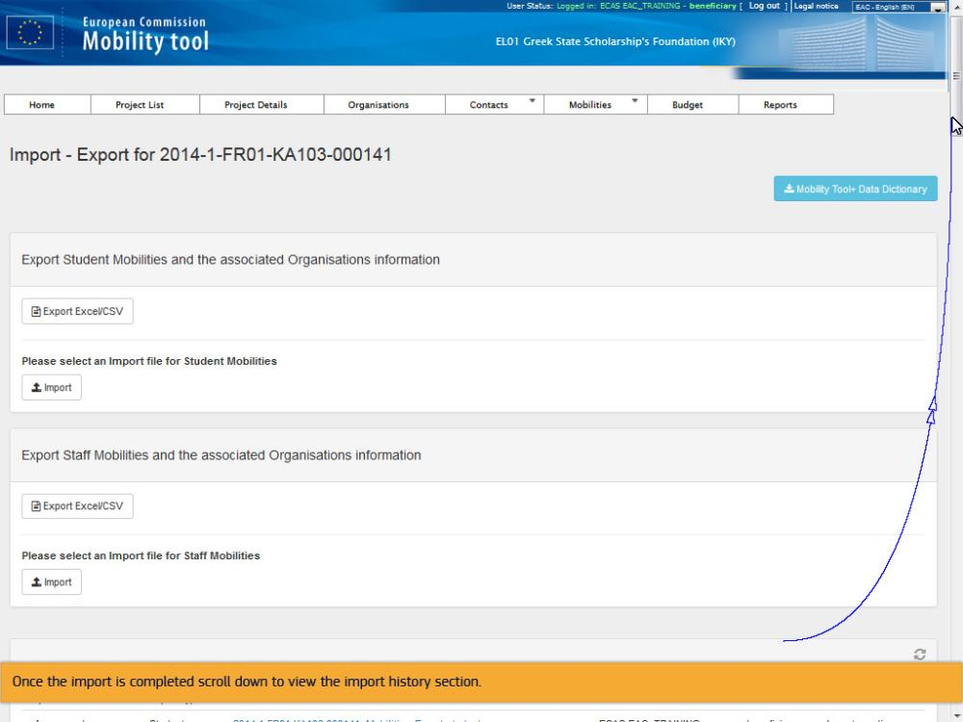
Text Captions

Once the import is completed scroll down to view the import history section.

Slide 73 - Slide 73
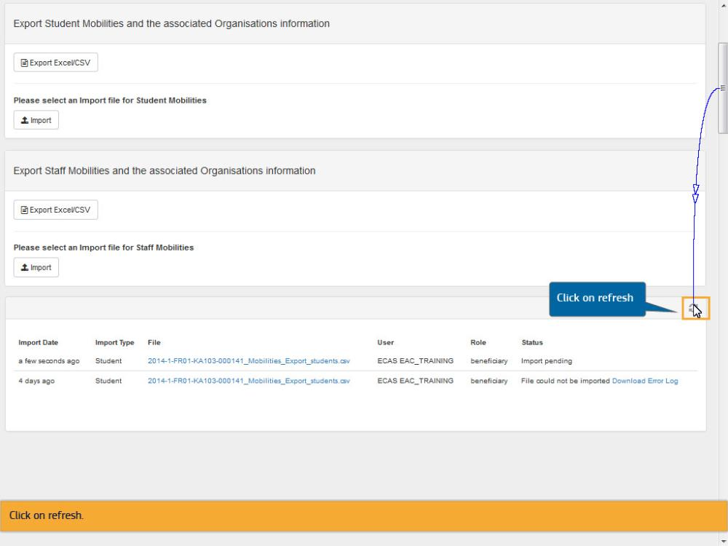
Text Captions

Click on refresh

Click on refresh.

Slide 74 - Slide 74
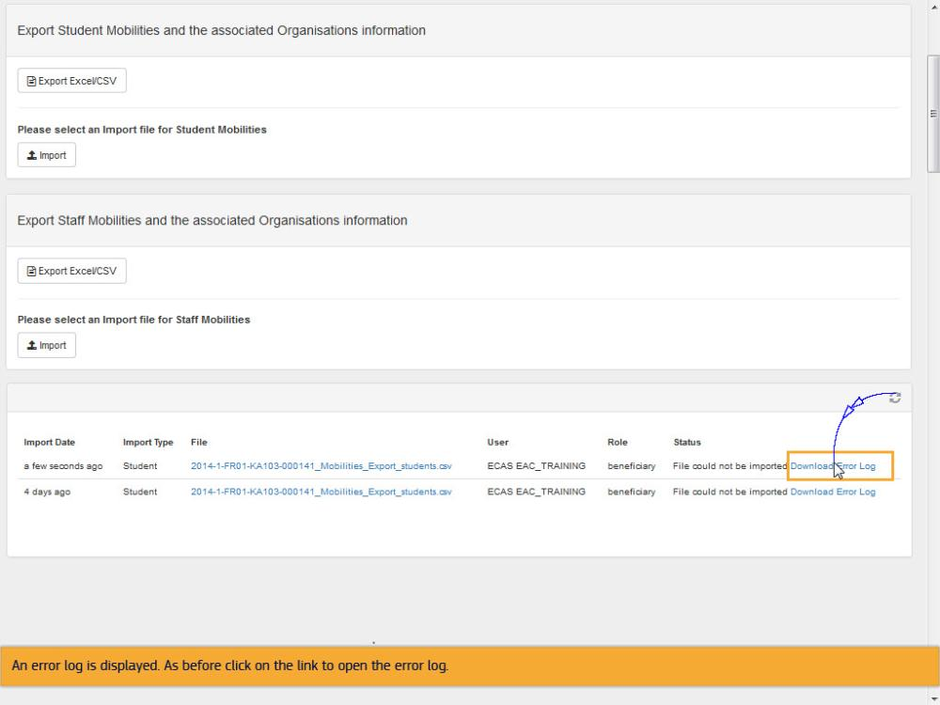
Text Captions

An error log is displayed. As before click on the link to open the error log.

Slide 75 - Slide 75
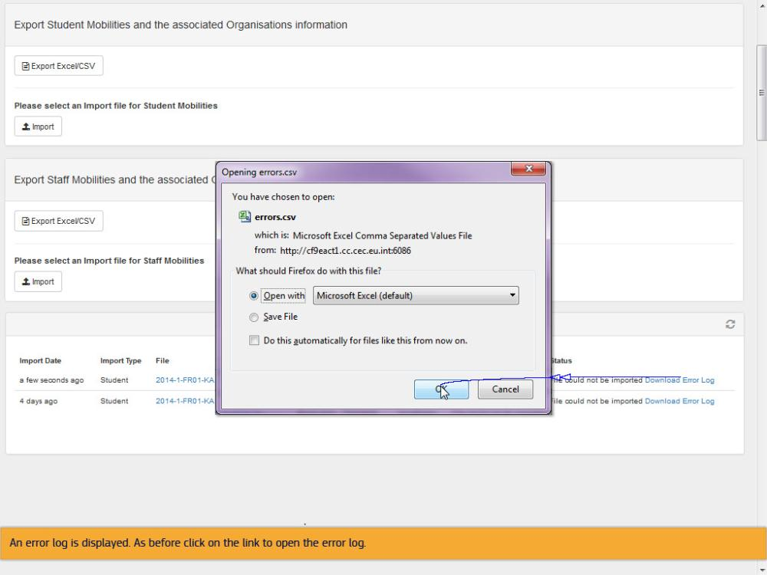
Text Captions

An error log is displayed. As before click on the link to open the error log.

Slide 76 - Slide 76
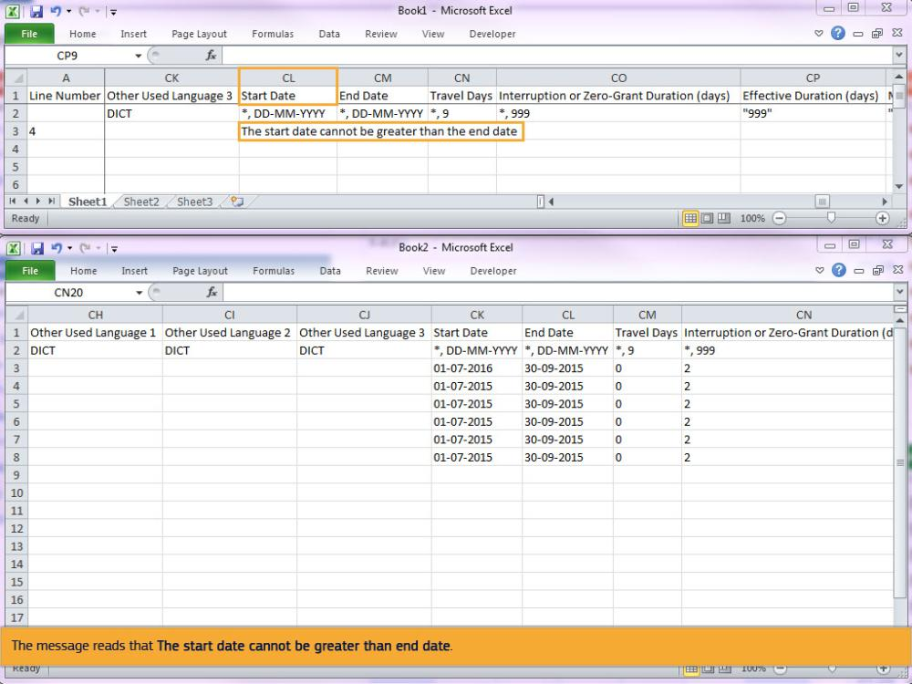
Text Captions

You will now see a message displayed for the Start Date of the mobility.

The message reads that The start date cannot be greater than end date.

Slide 77 - Slide 77
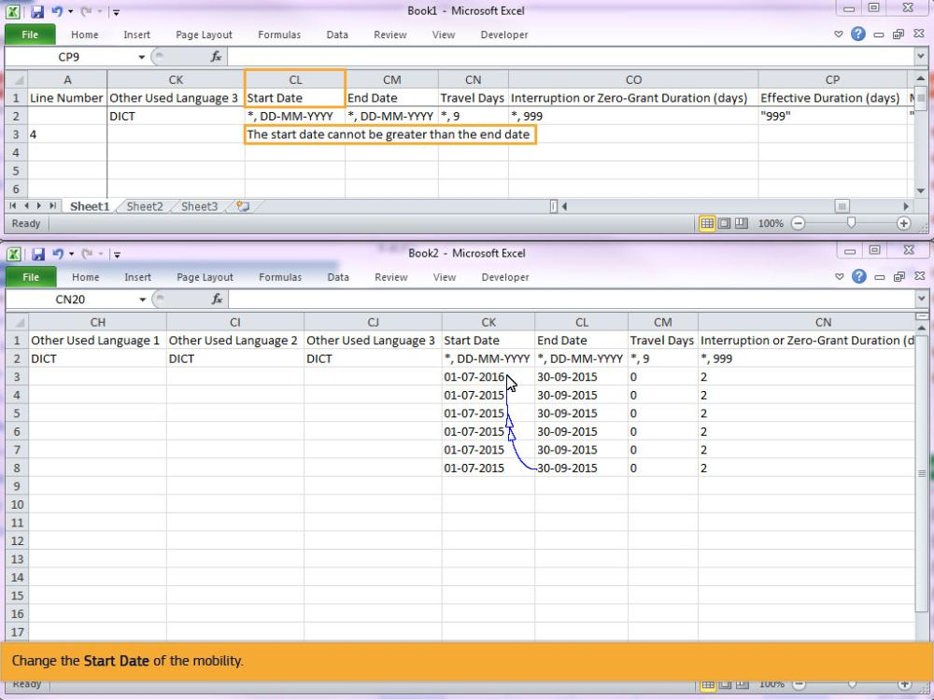
Text Captions

Change the Start Date of the mobility.

Slide 79 - Slide 79
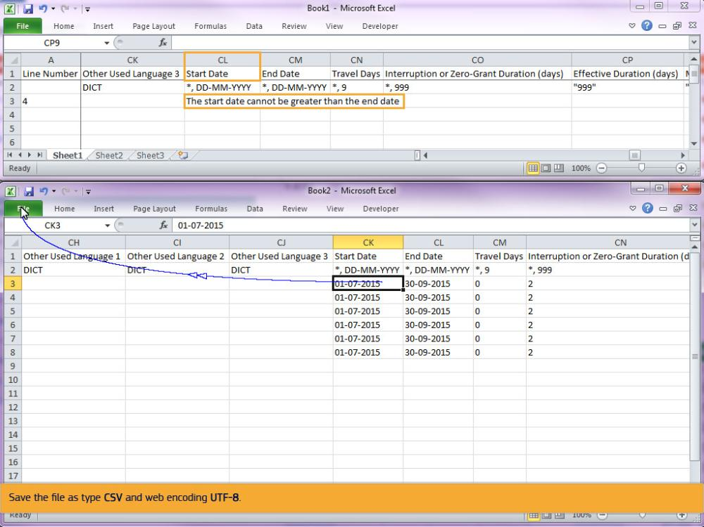
Text Captions

Save the file as type CSV and web encoding UTF-8.

Slide 80 - Slide 80
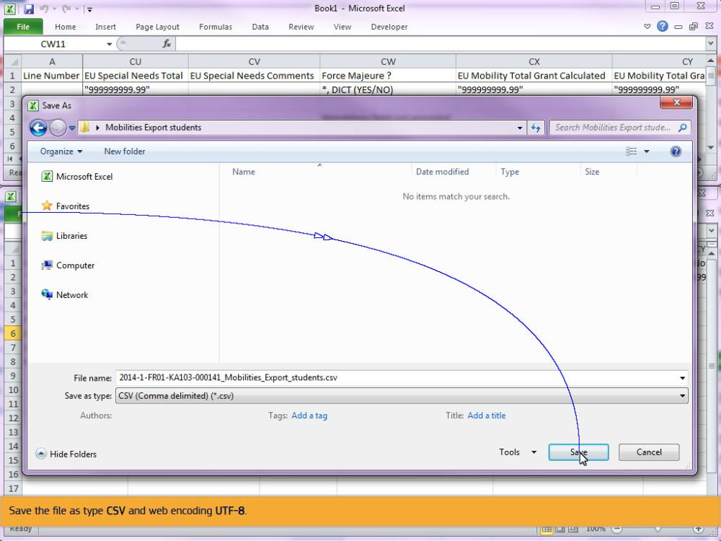
Text Captions

Save the file as type CSV and web encoding UTF-8.

Slide 81 - Slide 81
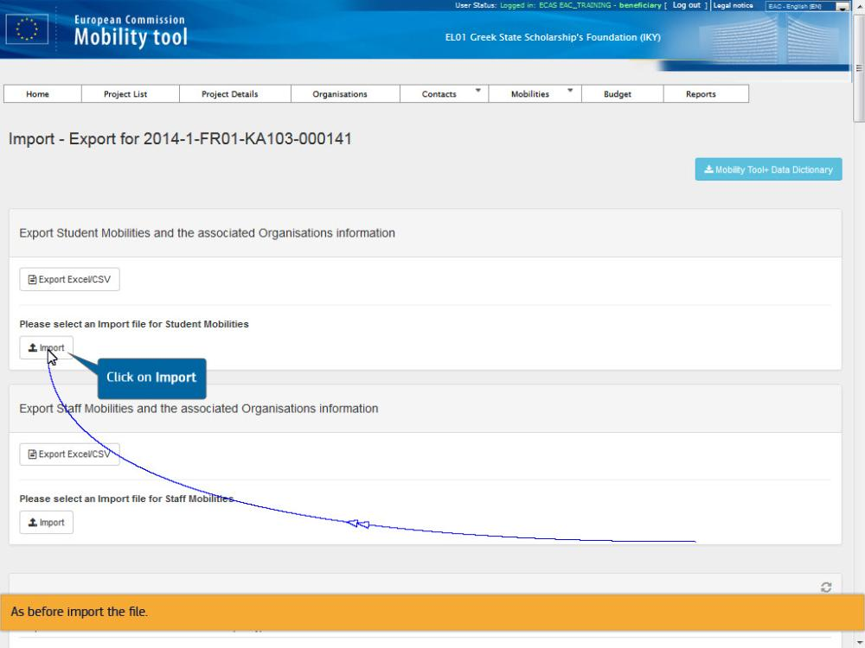
Text Captions

As before import the file.

Click on Import

Slide 83 - Slide 83
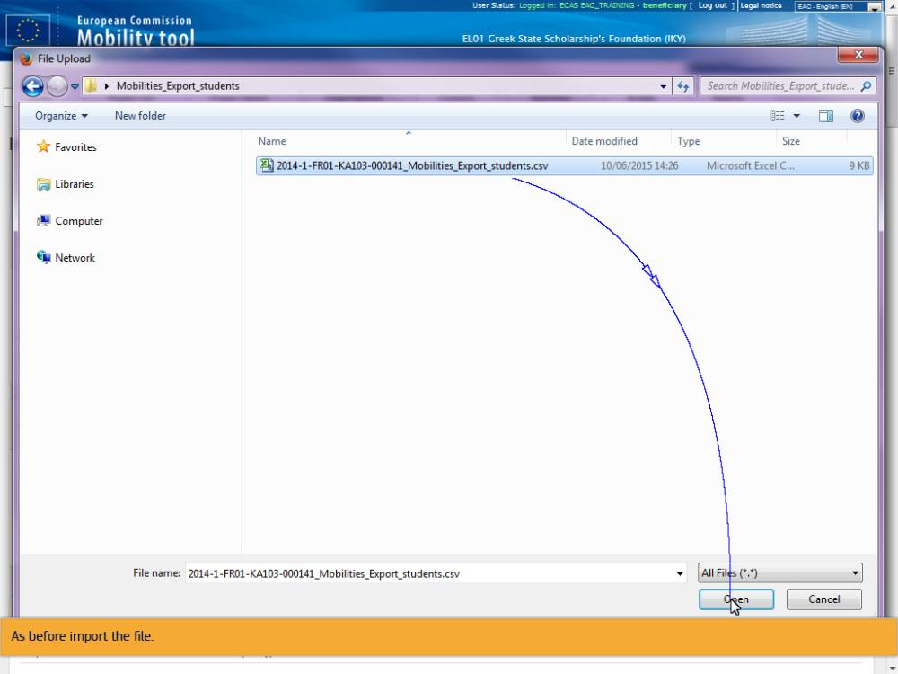
Text Captions

As before import the file.

Slide 84 - Slide 84
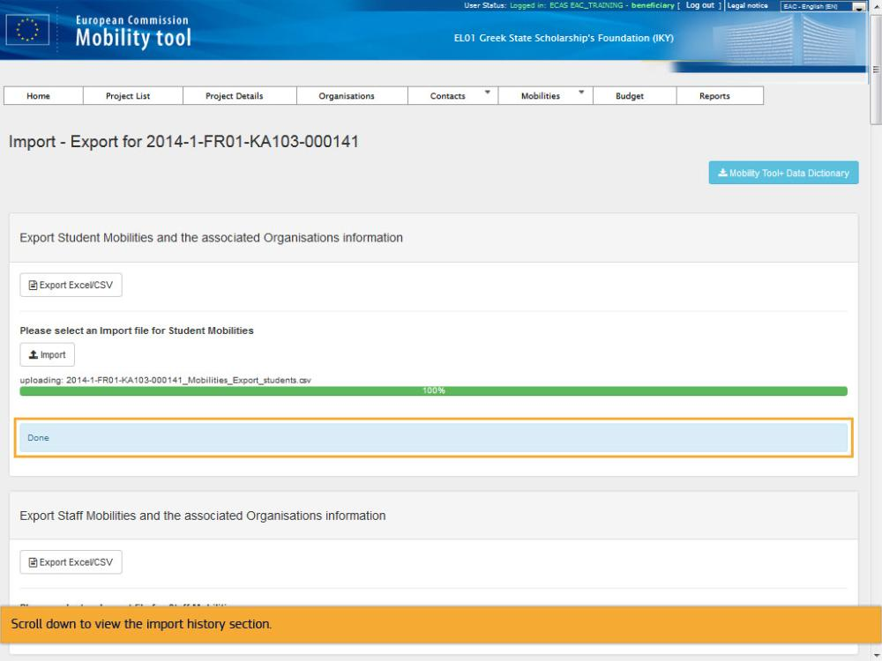
Text Captions

Scroll down to view the import history section.

Slide 85 - Slide 85
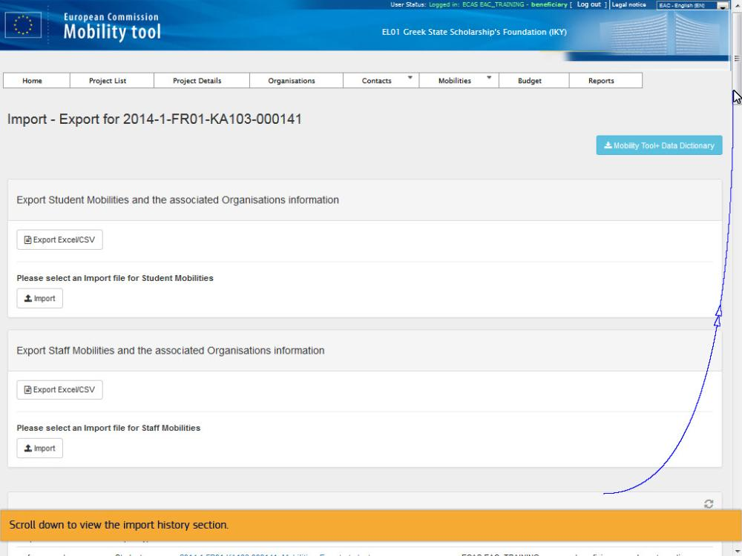
Text Captions

Scroll down to view the import history section.

Slide 86 - Slide 86
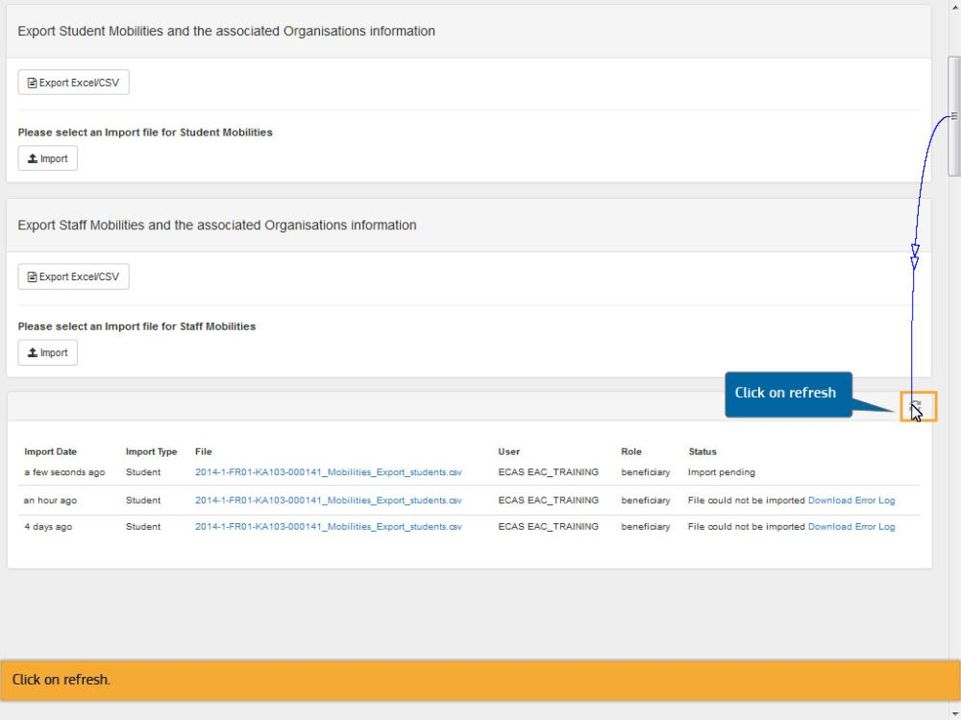
Text Captions

Click on refresh

Click on refresh.

Slide 87 - Slide 87
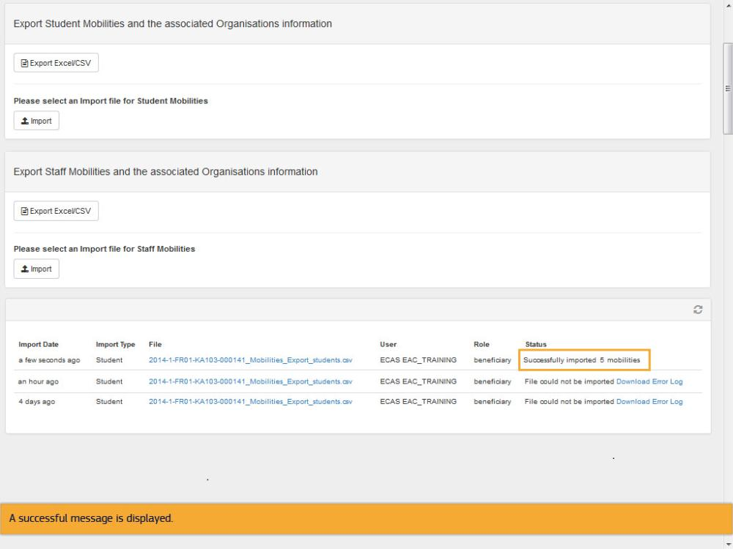
Text Captions

A successful message is displayed.

Slide 88 - Slide 88
Text Captions

End of this demo

